Committee on Poultry and Other Avian Species
Chair: Kayla Niel, PA
Vice Chair: Andrew Smith, IA

The Committee met virtually on September 30, 2024, from 9:00 AM to 11:36 AM, Central Daylight Time, and at the Gaylord on October 14, 2023, from 1:00 PM to 5:16 PM, Central Daylight Time. There were members beyond quorum in-person, up to 90 members and guests virtually, and many guests present in-person. Chair Kayla Niel presided, assisted by Vice Chair Andrew Smith. Niel welcomed the Committee on Poultry and Other Avian Species (CPAS) members, summarized the 2023 meeting and provided final responses from USDA-APHIS-VS to the 2023 resolutions:

Resolution 7, 24 Combined – US Compartmentalization Program Recognition
The United States Animal Health Association (USAHA) urges the United States Department of Agriculture (USDA), Animal and Plant Health Inspection Service (APHIS), Veterinary Services (VS) to prioritize efforts to seek recognition of poultry primary breeding compartments under the United States Department of Agriculture National Poultry Improvement Plan with the following countries as priorities based on feedback from the Association of Poultry Primary Breeder Veterinarians and are critical to the global supply of genetic stock of meat- and egg-type chickens: Brazil, United Kingdom, Australia, Mexico, New Zealand, the Netherlands, Canada and Argentina. USAHA also requests USDA-APHIS-VS to update the Global Animal Health and Trade, and the Poultry and Other Avian Species committees on a quarterly basis to seek input from these committees to help and support trade negotiating efforts by USDA-APHIS-VS.

USDA-APHIS-VS Response:
The United States Department of Agriculture (USDA), Animal and Plant Health Inspection Service (APHIS), Veterinary Services (VS) recognizes the concerns of the United States Animal Health Association (USAHA) and appreciates the opportunity to respond.

Since initiating HPAI compartments under NPIP, VS has worked diligently to negotiate trading partner acceptance of U.S. compartments to support primary breeder exports.

Until 2024, we had limited success in obtaining this acceptance for a variety of reasons, including a lack of trading partner understanding about the compartmentalization concept or regulations to allow the approval of foreign compartments, hesitation to accept compartments before they had been tested by an HPAI outbreak, requirements for a site visit before acceptance, and limited response to VS requests to engage about compartments.

Despite these challenges, VS efforts have led to advancements in trading partner acceptance. Since January 2024, five additional countries have accepted U.S. compartments, more than doubling the number of countries that accepted between 2019 and 2023. Trading partners currently accepting exports from compartments include Egypt, Indonesia, Hong Kong (transits only), Uruguay, Namibia, Colombia, Mozambique, and Chile. VS is dedicated to continuing negotiations with trading partners, including those listed as priorities above, and is hopeful that acceptance of U.S. compartments will continue to expand.

VS met with the poultry industry, including primary breeder representatives, in February, May, and June 2024 to specifically discuss compartmentalization and to provide status updates. VS commits to continuing these communications with industry stakeholders about the progress on acceptance of U.S. HPAI compartments by trading partners on at least a quarterly basis. VS would also be pleased to update the USAHA poultry committee upon request.

Additionally, VS continues to advance the understanding and acceptance of U.S. compartmentalization on a global level. In May 2024, APHIS presented a Special Session during the WOAH General Session on “Regionalization, Zoning, and Compartmentalization from a Trading Perspective” to increase trading partner and international stakeholder understanding of compartmentalization as a concept. The Special Session was very well received. In September/October 2024, APHIS will deliver a similar presentation at the International Avian Influenza and One Health Emerging Issues Summit Hybrid in Arkansas.

2024 Presentations and Reports:

Virtual Meeting (09-30-24):
AVBP Broiler Industry Report was given by Dr. Eric Heskett, Case Farms, Troutman, NC. A summary of the report is included in these proceedings.
2024 Layer Health Report was given by Dr. Eric Gingerich, Diamond V, Zionsville, IN. A summary of the report is included in these proceedings.
Turkey Industry Report was prepared by Dr. Steven Clark, Huvepharma, Peachtree City, GA and Dr. Lindy Chiaia, National Turkey Federation, Washington, DC. A summary of the report is included in these proceedings.
NVSL Poultry Salmonella, Mycoplasma, and Pasteurella Diagnostics at the NVSL was prepared by Ms. Brenda Morningstar-Shaw et al. and given by Dr. Kim Lehman, USDA-APHIS-VS-NVSL, Ames, IA. A summary of the report is included in these proceedings.
National Poultry Improvement Plan (NPIP) 2024 Annual Report was presented by Drs. Elena Behnke and Katy Burden, USDA-APHIS-VS-ASEP-NPIP, Conyers, GA. A summary of the report is included in these proceedings.
AI and NDV Disease Subcommittee Report was given by Dr. David Suarez, USDA-ARS-SEPRL, Athens, GA. A summary of the report is included in these proceedings.
Live Bird Market System Report was given by Dr. Fidelis Hegngi, USDA-APHIS-VS, Riverdale, MD. A summary of the report is included in these proceedings.

In-person Meeting (10-14-24)
Poultry Depopulation AVMA Update was given by Dr. Cia Johnson, AVMA Director Animal Welfare Division, Schaumburg, IL. An abstract is included in these proceedings.
Poultry Depopulation USDA Update was given by Dr. Koren Custer, Associate Deputy Administrator, USDA-APHIS-VS Strategy & Policy, Riverdale, MD. A summary of the report is included in these proceedings.
HPAI Response Federal Update was given by Dr. Julie Gauthier, Executive Director, USDA-APHIS-VS Field Operations, Raleigh, NC. A summary of the report is included in these proceedings.
HPAI Response MI State Perspective was given by Dr. Nora Wineland, Michigan State Veterinarian, MDARD, Lansing, MI. A summary of the report is included in these proceedings.
HPAI Response CO State Perspective was given by Dr. Maggie Baldwin, Colorado State Veterinarian, CDA, Broomfield, CO. A summary of the report is included in these proceedings.
HPAI Epidemiology Report Update was given by Drs. Kammy Johnson and Col Vanicek, USDA-APHIS-VS CEAH, Riverdale, MD. A summary of the report is included in these proceedings.
Secure Poultry Supply Update was given by Dr. Rosemary Marusak, Risk Analyst, University of Minnesota, Chetek, WI. A summary of the report is included in these proceedings.
Overview of AMPV in the USA was given by Dr. Ben Wileman, Select Genetics, Willmar, MN. A summary of the report is included in these proceedings.

Committee Business:

Subcommittee Report: The Avian Influenza/Newcastle Disease Subcommittee Report as presented by Dr. David Suarez was motioned to approve by Dr. Julie Helm, seconded by Dr. Yuko Sato, and approved by the CPAS Committee.

Old Committee Business: A poll will be sent out via email to the committee to vote on the 2023 resolution response from USDA-APHIS-VS. The general consensus at the time of the meeting was that the response was sufficient, but an official response from the committee will be provided to USAHA in the next few weeks.

New Committee Business: Dr. Andrew Smith, IA, will take over Vice Chair position as Dr. Jane Lewis, NY, has moved from a position with the state of CT to a position with USDA.
Committee Resolutions:
There were four resolutions that were brought before the Committee, three of which were approved unanimously following discussion and minor amendments by the Committee:
Resolution 1 – Audit of the USDA-APHIS-VS Import/Export Staff

Resolution 2 – Increased funding for USDA-ARS-NADC

Resolution 3 – H5N1 influenza in cattle

One resolution was approved by a majority vote (21 in favor, 3 opposed) following discussion by the Committee:

Resolution 4 – AMPV live vaccine

A motion to adjourn the meeting was initiated by Dr. Alex Hamberg and seconded by Dr. Alberto Torres. There being no further business the Committee on Poultry and Other Avian Species adjourned at 5:16 PM.

AVBP Broiler Industry Report
Dr. Eric Heskett, Case Farms, Troutman, NC.

Survey demographics: A survey with free text was conducted with the members of the AVBP from September 3-20, 2024. Respondents to the survey oversee the health and wellbeing of a combined 118 million birds per week, 68.6% of the U.S. broiler weekly production. These individuals regularly practice in 21 states: AL, AR, CA, CO, DE, GA, KY, LA, MD, MO, MS, NC, OH, OK, OR, SC, TN, TX, VA, WA, WV.

Broiler Production^{1,2}: Broiler live weight increased slightly to 6.55 pounds per bird (+0.06 pounds per bird)¹ in 2023 (+0.92%) while the number of birds placed declined by 106 million chicks² (-1.1%). This decline in number of chicks placed resulted in the number of birds processed to have declined by 51 million less birds processed¹ in 2023 versus 2022. Despite fewer birds placed and processed, 2023 ready-to-cook (RTC) pounds increased by 177 million pounds (+0.38%) to a total of 46.383 billion RTC pounds of chicken meat in 2023¹.

Livability^{2, 3}: Average total livability for 2023 increased to 94.66% in U.S. broilers, an increase of 0.98% compared to 2022. First week mortality increased slightly in 2023 to 1.67% compared to 1.63% in 2022, a decrease in livability in the first 7-days of 0.04%³. Chick quality/early mortality dropped to number three (2023 – Non-Disease Concerns) from number two (2022) in the AVBP survey conducted with its members from September 3-20, 2024.

Condemnations¹: Condemnations (ante- and post-mortem) decreased by 0.03% from 0.74% in 2022 to 0.71% in 2023. New vaccination strategies in 2022 and 2023 have improved respiratory health and protection towards DMV 1639, a new strain of Infectious Bronchitis Virus (IBV).

Key Broiler Disease Issues: Among the major disease-related issues that broiler production veterinarians are concerned with currently, Infectious Laryngotracheitis Virus (ILTV) ranked first, rising five spots from number six in 2023. For the first time, Avian Metapneumovirus (aMPV) emerged on the survey at number two. Rounding out the top three, Gangrenous Dermatitis, became a top three disease concern for broiler veterinarians increasing from number four last year. While high-pathogenic avian influenza (HPAI) fell out of the top three disease concerns, it was ranked number four and took on a different concern. While HPAI is still a concern, the impact of dairy cattle on HPAI was also mentioned.

Key Non-Disease Broiler Issues: The top three non-disease issues in the 2024 survey were, in order of importance, Hatchability/Fertility, Food Safety Regulations / Salmonella, and Chick Quality / 7-day Mortality. Hatchability/fertility appeared for the first time as a non-disease issue. Increased food safety regulations is back to its second spot ranking this year as it was second in 2022. The USDA Food Safety Inspection Service published the, “Salmonella Framework for Raw Poultry Products,” Proposed rule and proposed determination⁴. Chick quality / 7-day mortality rounded out the top three non-disease concerns for broiler veterinarians who responded to the survey, dropping one spot from last year.

References

1 - https://downloads.usda.library.cornell.edu/usda-esmis/files/3197xm04j/sq87dd84m/t148h477f/psla0124.pdf (Accessed 20 Sept 2024).

2 – https://www.nass.usda.gov/Statistics_by_Subject/result.php?488402C1-790C-36F8-8B07-133F73BA04B&sector=ANIMALS%20%26%20PRODUCTS&group=POULTRY&comm=CHICKENS (Accessed 20 Sept. 2024)

3 - Agristats, Inc. 6.6c

4 - https://www.fsis.usda.gov/sites/default/files/media_file/documents/FSIS-2023-0028.pdf (Accessed 20 Sept. 2024)
projected
projected

2024 Layer Health Report
Dr. Eric Gingerich, Diamond V, Zionsville, IN.

Summary:

Highly pathogenic avian influenza (HPAI) losses increased significantly at the end of 2023 and increased in the spring and summer of 2024 due to connections with dairy herd infected with HPAI.

Avian metapneumovirus began affecting egg layers in early 2024 along with meat chickens and turkeys. The impact on egg layer health has been minimal compared the meat chicken and turkey industries.

Overall layer health is good due to several factors as follows:

- Continued good supply of high-quality biologics.
- Readily available veterinary technical assistance from primary breeder, vaccine company, diagnostic laboratory, feed additive suppliers, and consulting veterinarians.
- Flock supervision by professional, well-trained flock service technicians.
- High quality nutrition provided by professional nutritionists.
- Housing is of good quality in general supplying feed, lights, air quality, water, and space in the needed quantities and quality.
- Use of ever-improving biosecurity practices.
- Continual surveillance for foreign animal diseases or potentially highly pathogenic agents such as Newcastle and avian influenza by our state and federal laboratory system.

2024 AVEP Disease Survey:

A poll of selected members of the Association of Veterinarians in Egg Production (AVEP) was conducted within the last month. These members were asked to categorize a list of common diseases of caged and cage-free pullets (20+ conditions listed) and caged layers, cage-free layers indoor only, and cage-free layers outdoor access (30+ conditions listed) as to their importance in their area of service on a scale of 0 to 4 with the following categories:

- 0 = Little or no importance to flock health or profitability. Very little effort to control.
- 1 = Some importance to flock health or profitability. Moderate effort to control on some farms.
- 2 = Moderate importance to flock health or profitability. Moderate effort needed to control on most farms.
- 3 = High importance to flock health or profitability. Significant effort to control on some farms.
- 4 = Very high importance to flock health or profitability. Significant effort to control on most farms.

24 of 37 (65%) targeted AVEP members answered the survey.

Non-starter mortality (formerly called starve outs) and yolk infections of chicks during the first week continue to be of some to moderate importance indicating there is still work to be done in breeder hatch egg sanitation, hatchery operations, and brooding management.

 | Caged Pullets |  |  |  | Cagefree Pullets
 | 2021 | 2022 | 2023 | 2024 | 2021 | 2022 | 2023 | 2024
Non-Starter Chicks | 1.41 | 1.95 | 1.76 | 1.54 | 1.35 | 2.11 | 1.95 | 1.83
Yolk infections | 1.64 | 2.11 | 2.14 | 1.83 | 1.65 | 1.94 | 2.00 | 1.78

The results showing the top diseases and conditions for the different classes of egg layers with their average ranking are shown below. I consider any disease that averaged 2 or above to be of definite significance.

Caged Pullets |  |  | Cagefree Pullets
Rank | Disease | Score | Rank | Disease | Score
1 | Coryza | 2.04 | 1 | Piling | 2.39
2 | Coccidiosis | 1.83 | 2 | Coccidiosis | 1.96
3 | Infectious Bronchitis | 1.63 | 3 | Necrotic Enteritis | 1.87
4 tie | Infectious Laryngotracheitis (ILT) | 1.54 | 4 | Infectious Coryza | 1.74
4 tie | Necrotic Enteritis | 1.54 | 5 tie | ILT | 1.57
6 | Post Bacterin Hepatopathy | 1.42 | 5 tie | E coli 2 weeks + | 1.57
7 | Infectious Bursal Disease (IBD) | 1.33 | 7 | Infectious Bronchitis | 1.48
8 | E coli + 2 weeks | 1.29 | 8 | Post Bacterin Hepatopathy | 1.26
9 | Avian Metapneumovirus | 1.25 | 9 | IBD | 1.17
10 | Mycotoxicosis | 1.00 | 10 | Avian Metapneumovirus | 1.04

Caged Layers |  |  | Cagefree Layers Indoor Only
Rank | Disease | Score | Rank | Disease | Score
1 | E coli | 2.46 | 1 | E coli | 2.74
2 | Infectious coryza | 2.08 | 2 | Piling | 2.35
3 | Cannibalism/Peckouts | 1.96 | 3 | Cannibalism/Peckouts | 2.22
4 | Infectious Bronchitis | 1.92 | 4 | Late Lay Mortality | 2.00
5 | Avian Metapneumovirus | 1.75 | 5 tie | Infectious Coryza | 1.96
6 | Late Lay Mortality | 1.71 | 5 tie | Roundworms | 1.96
7 | ILT | 1.63 | 7 | Infectious Bronchitis | 1.57
8 | Calcium Depletion | 1.58 | 8 tie | ILT | 1.48
9 | Necrotic Enteritis | 1.54 | 8 tie | Fowl Cholera | 1.48
10 | Focal Duodenal Necrosis | 1.46 | 10 | Northern Fowl Mites | 1.39

Cagefree Layers Outdoor Access
Rank | Disease | Score
1 | E coli | 2.88
2 tie | Cannibalism/Peckouts | 2.38
2 tie | Roundworms | 2.38
4 | Cholera | 2.19
5 | Infectious Coryza | 2.13
6 tie | Piling | 1.94
6 tie | Late Lay Mortality | 1.94
8 tie | ILT | 1.88
8 tie | Spotty Liver Disease | 1.88
10 tie | Erysipelas | 1.80
10 tie | Infectious Bronchitis | 1.80

Note that the outdoor access cagefree layer category scores are much higher in general and include more bacterial diseases of concern than the cagefree layers with indoor access only.

Infectious coryza continues to remain at the top of the lists as it results in a carrier state in multi-age complexes that serve as sources of infection similar to Mycoplasma gallisepticum. This is the reason it remains endemic in California, Arizona, Colorado, Florida, Pennsylvania, south Texas, Ohio, and eastern Indiana. Specialty egg layer flocks in northeast Indiana, northern Illinois, northeast Iowa, Minnesota, and Colorado were affected by coryza due to a pullet source in northeast Indiana that contracted both coryza and Mg. They had very poor peaks in production ending up losing more than 30 eggs per hen housed from the disease.

Coccidiosis and necrotic enteritis continue to be high on the lists of pullets due to the hardy nature of coccidial oocysts once they are established in a house. Vaccination of caged pullets is done to control the disease in the layer house and is a challenge due to difficulty in cycling sporulated vaccinal oocysts. A relatively new method of dosing flocks, called “trickle dosing”, at 7, 14, and 21 days with vaccinal oocysts (sporulated) at 1/3 dose each time is working well. Cagefree pullet outbreaks are usually due to breakdowns in litter management leading to wet litter which overrides coccidiostat and gut health medication programs. Apparently, prevention of coccidiosis in layers has been successful as this disease has not shown up on these lists this year as they have in the past.

Infectious bronchitis (IB) continues in the top ten for layers due to the high number of variant serotypes producers must attempt to prevent. False Layer Syndrome incidence has dropped dramatically due to the widespread use of hatchery or day-old application of effective IB vaccines and improved maternal antibody levels in chicks from the breeder companies. There continue to be occasional flocks with False Layer Syndrome due to apparent overwhelming early exposure in multi-age pullet units. Infections with variant IBVs during grow or lay may result in reduced feed consumption, higher mortality due to secondary bacterial infections, and loss of shell quality.

Colibacillosis in layer flocks continues as highly important. The live E coli vaccine does a good job of preventing the problem of early lay onset, but immunity is short-lived and does not provide sufficient protection for the late lay onset problems. Some producers are beginning to administer the live vaccine in mid-lay as a booster vaccination. An increase in the usage of killed vaccines during grow is also foreseen as new products come into the market. Different live E coli vaccine application routes are being used as well; eyedrop application of the live vaccine or adding the live vaccine to the inactivated 3-way ND-IB-SE vaccine from Zoetis.

Cannibalism/Peckout mortality of caged and cagefree layers continues as well as an important issue. Genetic predilection, lighting, beak trim quality, and behavioral management is often at the root of the problem. Some pressure is on to move to intact beaks for some cagefree programs which may be a real challenge in some operations.

Piling/suffocation has become a significant problem in cagefree production both during grow and during lay. Most cases occur without an obvious cause. Maintaining uniform house conditions, proper training of aviary birds to move within the aviary system, and walking flocks often during the day helps to reduce the incidence of the problem.

The control of roundworms in egg layers got a boost as the product AquaSol (fenbendazole) was cleared for use in egg layers in production in 2018. Organic layers continue to be without a highly effective product to use for this condition.

Late Lay Mortality Syndrome in cagefree systems is a significant concern and partly due to problems associated with poor feathering like E coli, erysipelas, fowl cholera, and cannibalism. The other main cause is due to peck order in these large, cagefree groups. The smaller birds in a flock are not able to compete with the more aggressive birds for feed and water and cull out.

Survey of Food Safety, Foreign Animal Diseases, and Other Issues of Concern:

The AVEP members were asked to rate their concerns on various topics according to the following scale:

- 0 = little importance, concern, or effort to prevent
- 1 = some importance, concern, or effort to prevent
- 2 = moderate importance, concern, or effort to prevent
- 3 = high importance, concern, or effort to prevent
- 4 = very high importance, concern, or effort to prevent

The results are summarized as follows:

Disease or Issue | 2022 Rating | 2023 Rating | 2024 Rating | Level of Concern 2024
Avian influenza | 3.95 | 3.57 | 3.54 | Very High
Virulent Newcastle Disease | 1.58 | 1.14 | 0.75 | Very Low
Lack of approved, effective treatments/antibiotics | 3.74 | 3.48 | 3.13 | Very High
Salmonella enteritidis (SE)/FDA Egg Safety Rule compliance | 2.53 | 2.30 | 1.96 | Moderate
Group C or other non-SE serotypes resulting in egg recalls | 2.68 | 1.90 | 1.46 | Moderate
Lack of effective vaccines | 2.58 | 2.19 | 2.46 | Moderate
Lack of effective diagnostics | 2.05 | 1.71 | 1.43 | Low
Welfare Issues
- Possibility of banning beak trimming | 2.84 | 2.12 | 2.17 | Moderate
- Inability to use maceration for of male chicks after hatched | 2.47 | 2.24 | 1.96 | Moderate
- Continued misuse of MAK carts for on-farm euthanasia of spent fowl | 2.50 | 2.43 | 2.13 | Moderate
- Lack of guidance regarding emergency depopulation of layers | 3.84 | 3.33 | 3.25 | Very High
- Cagefree management challenges | 3.00 | 3.05 | 2.70 | High

The concern for HPAI is obvious. The lack of effective treatments, the lack of guidance for emergency depopulation, and cagefree management challenges continue as high concerns from the survey.

Avian Influenza:

This past year saw a high number of positive premises infected with highly pathogenic H5N1 avian influenza (HPAI) in the winter months of November through February felt to be due to migratory bird exposure. A number of outbreaks then occurred in the spring and summer of 2024.

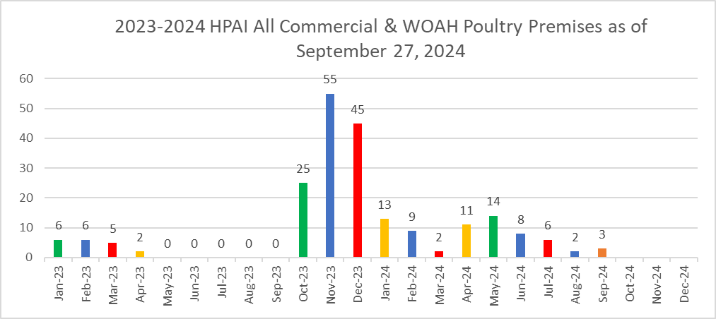
From USDA - https://www.aphis.usda.gov/aphis/ourfocus/animalhealth/animal-disease-information/avian/avian-influenza/hpai-2022/2022-hpai-commercial-backyard-flocks
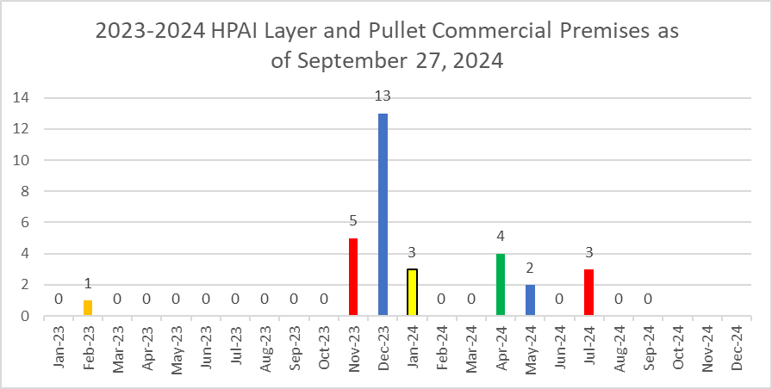
From USDA - https://www.aphis.usda.gov/aphis/ourfocus/animalhealth/animal-disease-information/avian/avian-influenza/hpai-2022/2022-hpai-commercial-backyard-flocks
The positive premises experiencing HPAI in the spring and summer of 2024 were for the most part due to links with positive dairy herds.

It is theorized that the H5N1 HPAI virus in wild birds infected dairy cows in Texas, mutated, and had gene reassortments that allowed cow-to-cow transmission. The virus is designated as H5N1, Eurasian lineage goose/Guangdong clade 2.3.4.4b., genotype b3.13. The disease in dairy animals is not deadly but causes a temporary febrile disease that reduces production. The milk was found to contain very high levels of virus leading to spread via milking equipment. Dairy animals from Texas moved to several states where the disease spread within the state to numerous herds. It is felt poultry flocks become exposed to this virus through contaminated wild birds or house workers who either worked at dairy farms or cohabitated with dairy workers.

The chart below shows the timeline for the 255 positive dairy herds found positive in 2024 starting in March:

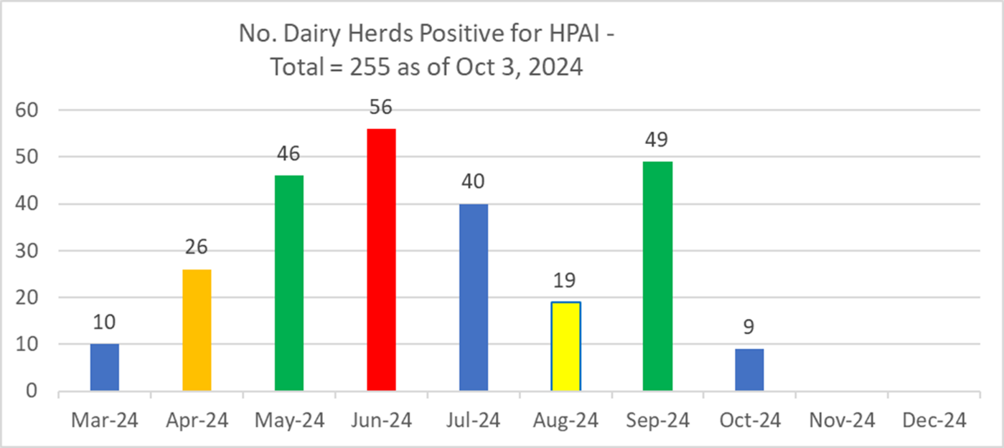
From USDA - https://www.aphis.usda.gov/livestock-poultry-disease/avian/avian-influenza/hpai-detections/hpai-confirmed-cases-livestock

The chart below shows the number of positive dairy herds in which states:

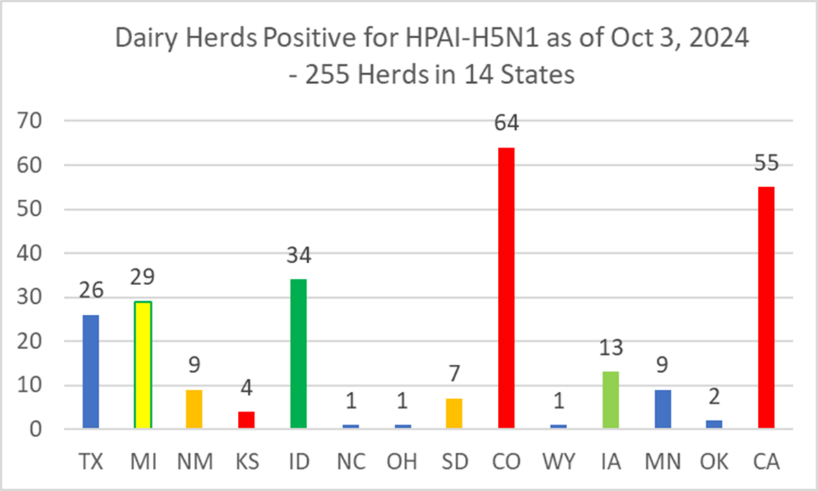
From USDA - https://www.aphis.usda.gov/livestock-poultry-disease/avian/avian-influenza/hpai-detections/hpai-confirmed-cases-livestock

The chart below shows the losses of poultry in 2024. Over 18.7 million pullets and layers have died or depopulated due to HPAI so far in 2024.
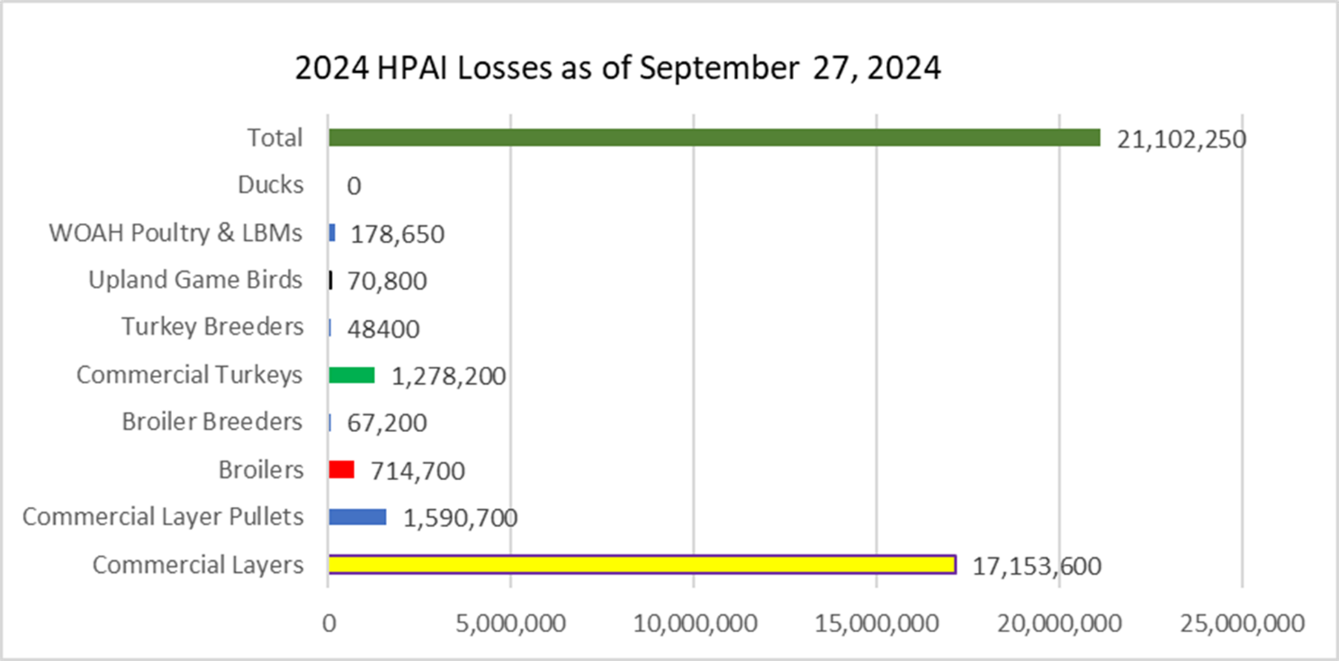
From USDA - https://www.aphis.usda.gov/aphis/ourfocus/animalhealth/animal-disease-information/avian/avian-influenza/hpai-2022/2022-hpai-commercial-backyard-flocks

Regional or Emerging Diseases:

These are diseases that result in serious losses but only seen in a small region or number of flocks. They are as follows:

- The new disease this year starting in early 2024 was avian metapneumovirus (aMPV). aMPV spread very rapidly from the east coast to the Midwest in a matter on two months mostly affecting meat chickens and turkeys. This paramyxovirus results in an upper respiratory disease leading to secondary bacterial infections – sinusitis, meningitis, otitis interna, cranial subcutaneous cellulitis, caseous pericarditis, caseous peritonitis, caseous perihepatitis, etc. The cranial bacterial infections can lead to high mortality and neurologic signs. The impact of the disease was minimal compared to meat birds. Layer flocks infected with aMPV have variable signs depending on existing conditions at the time of infection. Some drop in egg production, two to 20% for three to four weeks, some have high mortality, 0.3 to 3% per week mortality for several weeks, and some flocks experience both. Layer flocks infected with aMPV were reported in PA, GA, NC, IN, OH, Most flocks affected were in areas of high concentration of infected meat birds.

- Egg Drop Syndrome (EDS) – Since last year’s meeting, EDS is now under control in northeast Indiana (see chart below) due to the use of vaccine from Europe (CEVA, Merck, and Vaxxinova). Beginning in May of 2022, affected sites could vaccinate pullets on the lay site. Beginning in July of 2022, pullets could be vaccinated at the grow farm to be moved to affected lay sites as it was found that vaccination at housing was not effective since immunity from vaccination did not develop fast enough to preclude infection from on site. The flock with EDS in July 2024 was not vaccinated as the company was not allowed to vaccinate as they had not had EDS in the past.

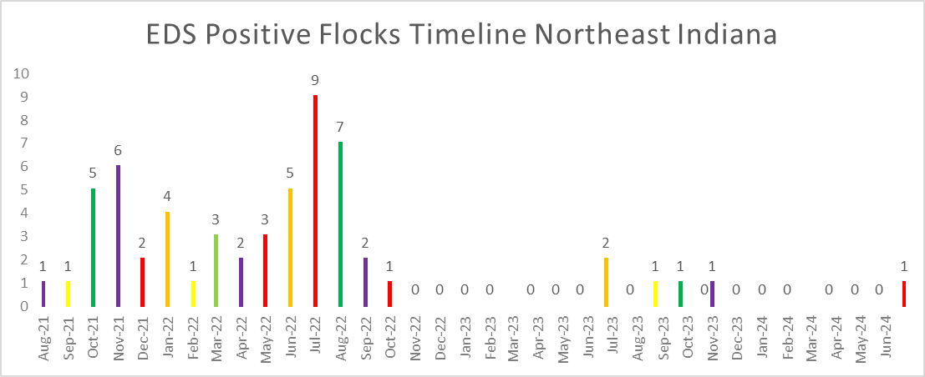

Pennsylvania continues to control EDS by vaccination as well.

- Spotty Liver Disease (SLD) – Flocks with this condition experience a five to 20% drop in egg production over a three to four-week period and have 0.5 to 5% mortality. Missouri and Arkansas have most of the cases although breaks have been seen in other high density cagefree, outdoor access areas. This is also a major problem in pastured flocks in Australia where the cause was determined to be due to Campylobacter hepaticus. Two major vaccine companies are producing autogenous vaccines that are proving effective in reducing losses due to this disease.

- Erysipelas - This bacterial disease caused by Erysipelothrix rhusiopathae has caused serious mortality (up to 50% in some flocks) in numerous cagefree brown egg flocks in the northeast, Midwest, and South. The disease usually strikes flocks over 50 weeks of age and is more prevalent and serious in poorly feathered flocks. Vaccination with live turkey or swine vaccines and/or autogenous bacterin has been successful in preventing the problem.

- Focal Ulcerative Dermatitis Syndrome (FUDS) – This syndrome continues to cause losses in not only brown cagefree flocks but also in white egg cagefree flocks in western OH. Purina/Land ‘O Lakes conducted microbiome studies of the skin of affected and non-affected birds and determined the causative agent to likely be Staphylococcus agnetis. The disease is characterized by an ulcer in the middle of the back. The open wound leads to bacterial infections and very high mortality rates from 0.5 to 4% per week. The problem will persist in a flock for 5 to 20 weeks. Some flocks have had a total of 50% mortality over a 20-week period. There has been no association found with scratches, nervous birds, rodent activity, insect activity. Two company’s probiotics using strains of Bacillus subtilis that inhibit the growth of S agnetis invitro are now available and helping to prevent the losses from this disease if used prior to exposure.

- Feed Refusal Syndrome – Cases of feed refusal due to mycotoxin intoxication were much less frequent than the last few years likely due to better crop growing conditions and the increased usage of mold inhibitors and mycotoxin binders.

- Fowl Cholera – This bacterial disease caused by Pasteurella multocida is associated with exposure to contaminated mammals like raccoons, possums, skunks, rats, cats, sheep, cattle, etc. Poor exclusion of these animals from poultry houses or exposure of outdoor access birds during their outdoor hours is the major transmission route. High mortality and morbidity can be seen in non-vaccinated flocks. Live, avirulent vaccines given by wingweb or injected bacterins are available and used for control in high-risk premises.

Food Safety Issues:

Two egg-associated outbreaks of human illnesses due to Salmonella enteritidis (SE) occurred in September 2024. The outbreak in Wisconsin led to 65 cases with 24 hospitalized while the outbreak in Maine had 5 ill people. These outbreaks led to recalls of eggs in both cases. Both cases were small, specialty egg producers, some below the cutoff of 3000 birds to be required to comply with the FDA Egg Safety Rule. It is not known if these flocks were vaccinated or if they followed an SE reduction program.

Egg Industry Economic Conditions:

The egg industry has had record profits this year due to low layer numbers from highly pathogenic avian influenza, good demand for eggs, and lower feed costs for this last year. The loss of 33.2 million layers since October 1, 2023 to October 1, 2024 has had a significant effect on the supply of eggs with demand remaining high.

Information and Graphs from the Egg Industry Center, September 2024
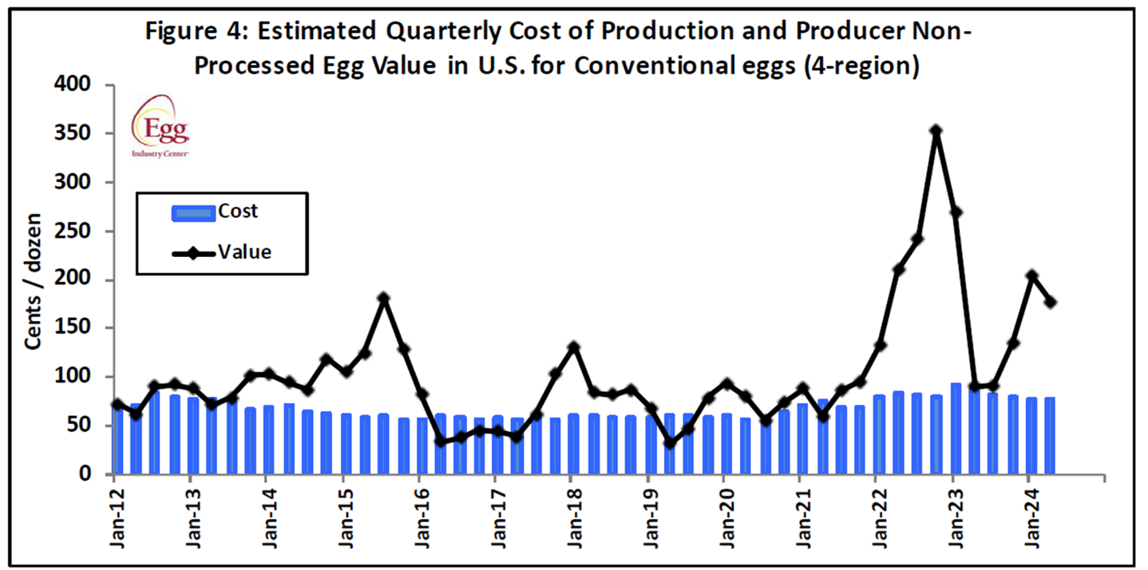

The table below shows the lowered layer numbers, 15 to 20 million lower than the 2019-2023 average, due to HPAI. This has had a big effect on the supply of eggs leading to higher retail egg prices.

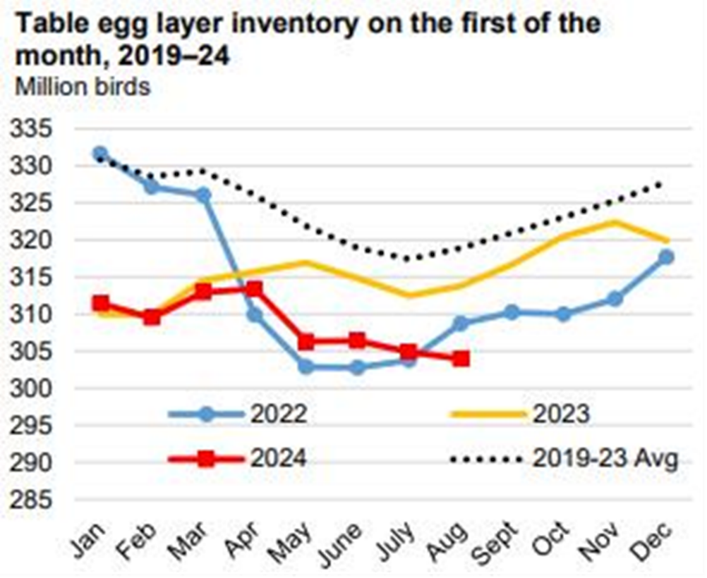

As can be seen from this graph below, the number of conventional, caged layers has stabilized with additional capacity continuing in the cagefree sector. The organic egg sector has remained stable.

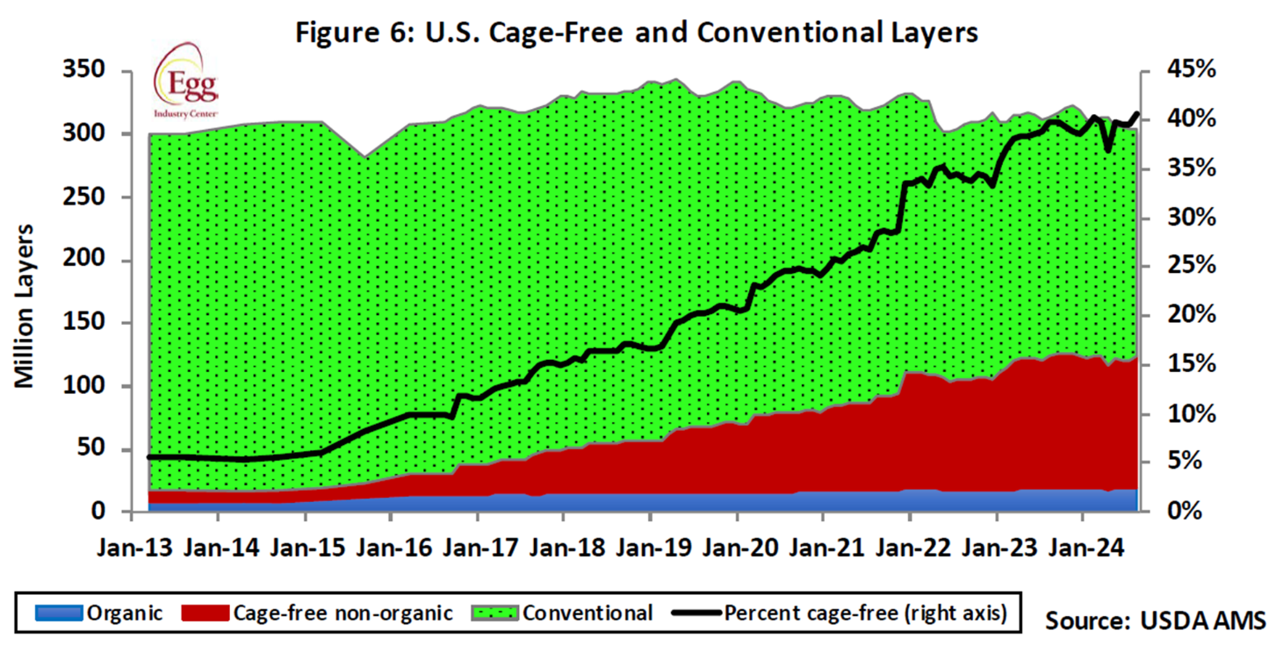

Respectfully submitted,
Eric Gingerich DVM, Diamond V, egingerich@diamondv.com

Turkey Industry Report
Dr. Steven R. Clark, Huvepharma, Inc., Peachtree City, GA.
Dr. Lindy Froebel Chiaia, National Turkey Federation, Washington, DC.

2024 Turkey Industry Annual Report - Current Health Issues Facing the US Turkey Industry

Steven R. Clark, DVM^{1,2*}
Professional Veterinary Services Manager, Turkeys
Huvepharma, Inc.
Peachtree City, Georgia

Lindy Chiaia, PhD
Vice President of Scientific and Regulatory Affairs
National Turkey Federation (NTF)
Washington, DC

¹Turkey Industry subcommittee chairman of the United States Animal Health Association Committee on Poultry and Other Avian Species.
²Clark, et.al. Turkey Industry Annual Report available since 2000 <www.usaha.org>
*Contact: steven.clark@huvepharma.us

In preparation for this annual report to the USAHA Committee on Poultry & Other Avian Species, the subcommittee chairman, Dr. Clark, surveyed turkey industry professionals and veterinarians representing (n = 21) the US turkey production regarding the health status of turkeys produced in August 2023 through August 2024. Surveys were collected by a third party, blinded, and provided to Clark for analysis. The turkey industry reported several disease challenges for this 12-month with only slight variations by respondents in the United States. The 2024 survey tallied 159.2 million head (73%) of the 218.0 million USDA reported raised. This report lists, Table 1, the challenges by disease and issues. The 2024 top-3 shifted for the first time in the survey’s 24 year history as Avian Metapneumovirus (aMPV) (#1) jumped to the top of the list followed by the lack of efficacious drugs (#2), and Highly Pathogenic Avian Influenza (HPAI) (#3). Colibacillosis and Clostridial Dermatitis (Cellulitis) both shifted down (#4 and #5) and due to the ranking of aMPV and HPAI. Reovirus continues as a notable issue in the 2024 survey, TR-DFTR (Turkey Reovirus Digital Flexor Tendon Rupture) and THRV (Turkey Hepatitis Reovirus), ranked #6 and #9 respectively, from #4 and #7 the prior year. Reovirus infections may be associated with “Leg Problems” (#10) and “Bleeders” (aortic, hepatic ruptures), moved from #18 from #12. In addition, Ornithobacterium rhinotracheale (ORT) (#7) and Bordetella avium (#11) and Blackhead (#14) all moved down two positions. This year respiratory diseases continued to make up four of the top-10 rankings, Table 1B.

Avian Metapneumovirus (aMPV) rose from years at the bottom of the ranking to #1 of the 2024 survey and reported 2,355 cases. It was #38 in 2023. aMPV is closely associated with secondary issues including, lack of drugs, colibacillosis, ORT and Bordetella. The introduction of Avian metapneumovirus (aMPV) into the United States was suspected in late 2023, with subtype A detected in California and subtype B in North Carolina. By January 2024, the rapid dissemination of aMPV was confirmed in both states, and within four months, it had spread to most poultry-producing regions nationwide (Figure).

As part of epidemiology investigations, USDA Wildlife Services tested 100 peridomestic species around aMPV positive farms and did not find a single positive (David Marks, personal communication, Sept 11, 2024). In addition, USDA ARS tested 265 hunter harvested migratory bird samples from NC, VA, SC, and WV, and all negative for aMPV A, B, and C (David Surez, personal communication, Oct 4, 2024)..

One example shared by a large turkey company demonstrates the dramatic effects on flock mortality associated with aMPV. The first suspected case of aMPV clinical disease occurred in November 2023. Over the next three months, average weekly company-wide flock mortality increased by 113% above the prior 12-month company average, with one week peaking at a 208% increase. Following the winter introduction, average weekly flock mortality has remained 65% higher than pre-outbreak levels. Flock monitoring has revealed that 98% of all flocks are now infected with aMPV.

aMPV is affecting all categories of poultry, including turkeys, broiler chickens, egg layers, and breeder poultry. Among these, turkeys are the most significantly impacted. Turkey breeders are experiencing egg production declines ranging from 20% to 100%, lasting 2 to 4 weeks. This decrease in egg production is leading to a national shortage of poults. In commercial turkey flocks, mortality rates can be severe, approaching 100%, with clinical disease persisting for up to three weeks. Secondary infections, including Escherichia coli, cholera (Pasteurella multocida), ORT (Ornithobacterium rhinotracheale), and MG (Mycoplasma gallisepticum), complicate the clinical disease in all poultry species.

The poultry industry urgently requires both live and killed [inactivated] vaccines for Avian metapneumovirus (aMPV) subtypes A and B for both chickens and turkeys. As of September 28, 2024, there are no USDA-approved live vaccines for aMPV, and only three special approvals for inactivated (killed) vaccines. One (Hipra) is an import permit for an inactivated vaccine and two vaccine manufacturers (Merck/Cambridge and Ceva) are domestically producing experimental autogenous vaccine, with US-origin subtype B isolates, to control outbreaks of aMPV in poultry farms in the US.

The ongoing spread of aMPV across major poultry-producing regions in the United States and Canada highlights the need for immediate and effective vaccination strategies. The disease continues to circulate among poultry in all the states, although cycling between low and high mortality rates, especially in turkey flocks. Regulatory bodies are encouraged to expedite the review and approval of suitable vaccines, in collaboration with industry’s development, to mitigate the severe impacts on poultry health and production.

The lack of approved, efficacious drugs ranking was displaced by aMPV, dropping to #2, on the challenges experienced by the turkey industry survey participants and is likely a contributor to all turkey health challenges and disease issues that follow it on the ranking list. In 2024 veterinarians prescribed antibiotics to manage secondary bacterial infections associated with the widespread aMPV outbreak. A few examples of the impact of this challenge include there being only one approved commercial live vaccination for turkey coccidiosis, approved commercial turkey Salmonella vaccines only including group B serotypes and the lack of an approved, no approved treatments for blackhead disease.

Reported cases of Mycoplasma synoviae (MS) and M. gallisepticum (MG) increased 161 and 43 respectively, from 20 and 12 prior year. Cases of Turkey Reovirus Digital Flexor Tendon Rupture ranked #6 in 2024 reported 368 cases (#4 and 487 prior year). THRV (Turkey Hepatitis Reovirus) ranked #9 (#7 prior year). Added to the survey in 2021 Streptococcus gallolyticus (aka, S. bovis) in 2024 ranked #23.

Turkey Arthritis Reovirus (TARV) also called, Turkey Reovirus Digital Flexor Tendon Rupture (TR-DFTR), was recognized as a newly emerging disease in 2011. A unique reovirus has been isolated and identified as the cause of tenosynovitis and digital flexor tendon rupture in commercial turkeys. Clinical signs in young flocks are reportedly mild to nonexistent but can develop into lameness and/or abnormal gait in older flocks, starting at about 12 weeks of age. Affected flocks may also report an increased incidence of aortic ruptures and poor flock performance (weight gain, uniformity). Research continues into pathogenesis, virus characterization, diagnostics and epidemiology. Research indicates that the turkey arthritis reovirus is distinct from the recently identified novel reovirus causing arthritis in chickens, and most like the turkey enteric reovirus. A 2019 NTF industry survey documented the severity of impact on the industry could be as high as $33.7 million with highly pathogenic strains of TARV.

THRV (Turkey Hepatitis Reovirus) is a disease issue added to this survey in 2020. THRV affected flocks ranged in age from 7 to 46 days with a median age of 15.5 days. Mortality peaks and subsides in a week and the cumulative mortality is 3-8%. Dr. M. Lighty (2019, personal communication) describes THRV as “… increased incidence of viral hepatitis in poults caused by reovirus. This appears to be an emerging disease caused by a previously recognized pathogen. Gross lesions range from subtle mottling to multifocal white/gray/tan foci in the livers; mild hepatomegaly has also been noted in some cases. Histopathology on these livers shows severe multifocal hepatocellular necrosis with infiltration by macrophages, lymphocytes, plasma cells, and/or heterophils. Necrotic hepatocytes may fuse to form multinucleated syncytial cells and there is often marked fibrin accumulation in necrotic areas…. Morbidity and mortality due to reoviral hepatitis can be highly variable. Risk factors for development of the disease and the economic significance of this disease on the turkey industry are not fully understood at this time.” There are indications from the field that flocks developing hepatitis as poults can go on to develop turkey reoviral arthritis during grow out.

ORT (Ornithobacterium rhinotracheale) remained relatively unchanged at #7 and scored 3.7 in 2024, compared to #5 (3.7) prior year, is a highly contagious respiratory disease in poultry caused by a gram-negative pleomorphic rod-shaped bacterium. It has been isolated from chickens, ducks, partridges, and guinea fowl. It was originally recognized in Europe and South Africa. ORT was first confirmed in the U.S. from turkeys in 1993. Horizontal transmission (such as, bird-to-bird, contaminated people and equipment) by direct and in-direct contact is the primary route of spread. However, vertical transmission is suspected (Hafez, 2000). In the fall of 1995, it was a major cause of respiratory disease in midwestern states and since has become endemic across most of the USA. Management systems, such as brood-and-move have increased the exposure of ORT-naive birds to ORT in the finisher barns, resulting in respiratory disease and mortality in some operations. Biosecurity procedures must be taken. Proper water sanitation can minimize the severity and spread. Vaccination is limited and results are varied (toxoids, bacterins). Bacterins are used in breeders. No commercial vaccine is approved. Limited application of controlled exposure efforts on individual flocks have shown value. ORT in turkeys is an identified critical research need.

Bordetella avium continues as a significant respiratory disease challenge; bordetellosis ranked #11 (scored 2.5) from prior year at #9 (scored 2.8). Bordetellosis, otherwise known as Turkey Coryza, is a highly infectious, acute upper respiratory tract disease of turkeys characterized by high morbidity and usually low mortality. Bordetella avium (BA) is a small, Gram-negative, non-fermentative, motile, strictly aerobic bacillus. Other birds and older turkeys can be carriers but may not show clinical signs. Commercial vaccines are available. Water sanitation and biosecurity are emphasized to control Bordetella.

Turkey Coronavirus (TCV) ranked #31 from #25 (2023), as cases dropped to 31 from 411 cases in 2023 and 459 in 2022, as the TCV outbreak in one geographic area ended. TCV is also known as Coronaviral Enteritis of Turkeys, Bluecomb, Mud Fever, or Transmissible Enteritis.

Coccidiosis remained relatively unchanged, scored 2.2 and its rank moved from #13 to #16. Concerns with coccidiosis control is likely reflecting the industry’s raised without antibiotics (RWA), antibiotic free (ABF) and no antibiotics ever (NAE) market. RWA and NAE programs do not permit the use of ionophore anticoccidials and some programs prohibit FDA approved chemical anticoccidials, so anticoccidial programs consist of alternative phytogenics or vaccination. An effective coccidiosis control program in turkeys involves the use of anticoccidial medications, and/or phytonutrients, and/or live vaccines and the subsequent development of immunity. Table 4 summarizes the US turkey production coccidia control programs. New in 2024 USDA granted conditional approval to a three-strain commercial turkey coccidiosis live vaccine (Huvepharma) in addition to the previously licensed two strain product (Ceva). Nutritional dietary supplementation with phytonutrients is either via in-feed application or drinking water administration. Programs may utilize phytonutrients in addition to the current anticoccidial program, to potentiate the possible benefits, or as the sole supplement for coccidia control. Some phytonutrients have purported activity against coccidia. Phytonutrients consist of ‘alternative’ products including organic acids, yeast, phytonutrients from plant extracts (saponin, yucca, etc.) and essential oils (oregano, carvacrol, thymol, cinnamaldehyde, capsicum oleoresin, turmeric oleoresin). Essential oils may be natural extracts or synthetic nature-identical compounds.

The industry was surveyed (only 20 of 21 reported) to classify their antibiotic programs (Table 3) defined by how anticoccidials and antimicrobials are allowed; ranking allowed mostly unchanged. Nineteen percent (19%) of the industry turkeys in 2024 were reared NAE/ABF category, not significantly different from 18% prior year, similarly Conventional Use programs moved to 56% from 59% (2023). Conventional/Full Use program permits the proper use of any FDA approved antibiotics, administered in the feed or drinking water, including ionophores, bacitracin, bambermycins, and /or those deemed medically important to humans by FDA. The third category titled “No Growth Promotants, CRAU/CRAU-like” (Certified Responsible Antibiotic Use), only permits the therapeutic uses under the prescription and supervision of a veterinarian. Twenty-five percent (25%) of those turkeys reported were CRAU programs. No Antibiotics Ever (NAE) /Antibiotic Free (ABF, RWA), does not permit either in-feed or in-water antibiotics. FDA has stated that ionophore anticoccidials are antibiotics.

The introduction of avian metapneumovirus (aMPV) into the United States has been highly consequential to the U.S. turkey industry. NTF has focused on communicating the impact of aMPV on the turkey industry to USDA to advance their understanding, being aMPV is a nonreportable disease. In addition, advocating for preventative measures remain a top priority, and NTF continues to engage with USDA Center for Veterinary Biologics (CVB) related to the industry’s vaccine needs. Congress has weighed in on the importance of a modified live vaccine to address aMPV, with 11 Senators sending a letter to Secretary Vilsack requesting commercial modified live vaccine produced in Europe be imported to address the immediate need. NTF recently confirmed that USDA Center for Veterinary Biologics (CVB) is working to import multiple live vaccines to be used in in USDA facilities for laboratory and bird-safety testing.

As of September 2024, USDA CVB aMPV activity highlights include [bold emphasis added]:
- February 6th Notice 24-3 informing the biologics firms to submit permit applications and dossiers for risk analysis (superseded).
- June 11th Notice 24-10 Veterinary Vaccines and Veterinary Diagnostic Products Targeting Avian Metapneumovirus (all subtypes).
- Product license and import permit applications limited to two specific types of vaccine products/developmental materials:
  - Experimental Autogenous Products: domestically produced, inactivated veterinary biological products from an isolate of the current outbreak strains, but with expanded distribution beyond the allowances for traditional autogenous products; and
  - Imported developmental materials: Master Seed Virus (and perhaps Master Cell Stocks) to facilitate domestic licensure and production of modified live viral or inactivated products.
- CVB has issued import permits for diagnostic kits, expanded to include inactivated vaccines.
- Multi-fraction products may be considered for response efforts.
- CVB Question and Answer listening sessions with Q&A on the APHIS website.

In year three of the current Highly Pathogenic Avian Influenza (HPAI) outbreak in commercial poultry, NTF remains actively engaged in the response to the virus. Since the start of the outbreak more than 100 million birds have been lost, over 14.5 million of which have been commercial turkeys. As of October 1, there have been 32 commercial turkey cases in 2024 resulting in a loss of more than 1 million birds. HPAI continues to be a key focus of the full NTF team. Over the last year, there have been several key events, including the first detections of H5N1 in livestock species and confirmations of H5N1 in humans. Improved and continued stringent biosecurity, along with rapid response for quick depopulation and disposal, has likely resulted in the impact of the overall outbreak being minimized compared to

While HPAI has been detected in multiple mammalian species in the U.S. throughout the outbreak, the confirmation of H5N1 in livestock was a significant development. Since late March, there have been 255 positive confirmed cases of H5N1 in dairy cattle throughout the United States. NTF continues to work with the U.S. Department of Agriculture (USDA), Food and Drug Administration (FDA), Centers for Disease Control and Prevention (CDC) and state animal health officials as the situation evolves. In addition, NTF has worked closely with continue routine communications with national dairy trade associations, to share lessons learned from the turkey industry perspective and identify opportunities for collaboration to address as the situation evolves. In addition, NTF signed a letter to USDA Secretary Vilsack requesting USDA advance vaccine efforts to protect dairy cattle from H5N1 and reduce the overall environmental viral load. In August, Secretary Vilsack announced CVB is now accepting licensure applications for products used to vaccinate livestock for H5N1 and the authorization of field trial under specific conditions.

Throughout 2024, H5N1 has been confirmed in 16 humans in the US (5 following exposure to dairy cows, 10 following exposures to poultry, and 1 with no immediate known exposure). The symptoms of these individual were mild, and the CDC continues to indicate the risk of the virus being spread from person to person was low. NTF continues to engage with CDC on the situation and further stress the importance of addressing the situation with a one health approach.

NTF along with the National Chicken Council (NCC), United Egg Producers (UEP), USA Poultry & Egg Export Council (USAPEEC) and the U.S. Poultry & Egg Association (USPOULTRY) sent a letter to USDA Secretary Vilsack urging the agency to establish a HPAI Strategic Initiative that engages the brightest minds within industry, universities and government to expand our knowledge and develop novel methods to prevent, detect and respond to avian influenza. Lawmakers in the House and Senate have also emphasized the need for USDA to establish this initiative with specific additional research needed on advanced biosecurity measures and wild bird deterrents, vaccination and efficient depopulation methods and bird disposal processes listed within the letters.

Industry lacks commercial diagnostic and vaccine options for Turkey Reovirus. The NTF Foundation publicly announced a Reovirus Project in July that has the purpose to provide a reward for the development and successful marketing of diagnostic tool and/or vaccine that aids in reducing the impact of reovirus on the turkey industry. The project details can be found on NTF’s website eatturkey.org.

FSIS announced on July 29th, that raw chicken carcasses, chicken parts, comminuted chicken and comminuted turkey products with certain Salmonella levels and serotypes are adulterated within the meaning of the Poultry Products Inspection Act (PPIA). Specifically, FSIS has tentatively determined that raw chicken carcasses, chicken parts, comminuted chicken and comminuted turkey are adulterated if they contain any type of Salmonella at or above 10 colony forming units/per milliliter or gram (10 cfu/mL(g)) in analytical portion (i.e., mL of rinsate or gram of product) and contain any detectable level of at least one of the Salmonella serotypes of public health significance identified for that commodity (for turkey: Hadar, Typhimurium or Muenchen; for chicken: Enteritidis, Typhimurium, and I 4,[5],12:i:-).

If finalized, when FSIS tests a product sample for adulterants, establishments must maintain control of products tested for adulterants to ensure that the products do not enter commerce while waiting for receipt of the test results. If test results detect Salmonella at a level of 10 cfu/mL(g) or higher and serotypes Hadar, Typhimurium or Muenchen, comminuted turkey would be deemed adulterated, and any ground turkey product lot represented by the sample would not be permitted to enter commerce if the final product standard is not met.

FSIS is also proposing to revise the regulations that require that all poultry slaughter establishments develop, implement and maintain written procedures to prevent contamination by enteric pathogens throughout the entire slaughter and dressing operation to clarify that these procedures must include a microbial monitoring program (MMP) that incorporates statistical process control (SPC) monitoring methods, to require sampling at rehang instead of pre-chill, and to require that all establishments conduct paired sampling at rehang and post-chill.

NTF has worked to review the proposed rule and is engaging with the Technical and Regulatory Committee to gather feedback ahead of the upcoming public comment period ending. The industry has few commercial Salmonella vaccines available currently. Additional vaccines that provide protection for other serogroups remain a priority.

This September, FDA’s Center for Veterinary Medicine (CVM) announced the establishment of four Animal and Veterinary Innovation Centers (AVICs), which are the recipients of funding for work to advance regulatory science and further development of innovative products and approaches to better support animal health and veterinary interventions. NTF supported the University of Arkansas application that was awarded funding for work related to Blackhead. Their work focus is to determine the infectivity and formation of cyst-like Histomonas meleagridis (the causative agent of blackhead disease in turkeys) in vitro and in vivo; identify the cellular pathways mediating encystation in H. meleagridis; and screen and assess potent inhibitors against encystation of H. meleagridis in vitro and in vivo. The partnerships were chosen through a competitive cooperative agreement process to establish the AVICs and address critical animal, human or environmental health needs in one or more priority areas. Funding is renewable up to four years pending suitable progress and availability of funds.

In 2023, turkey production increased from 6,524,214 in 2022 to 6,845,984 1,000-pounds (live weight) and increased to 218,000,000 turkeys raised (210,000,000 prior year) with an average live weight of 31.70 pounds (31.33 prior year). Per capita consumption for turkey products increased to 15.3 pounds in 2023 from 14.6 pounds in 2022.

Table 1. Turkey health survey (August 2023 - 2024) of professionals in US turkey production (n = 21, head reporting = >159.2 million) ranking current disease issues (1= no issue to 5 = severe problem). Data on file.

Issue |  | Score Average (1-5)
Avian Metapneumovirus (aMPV) |  | 4.9
Lack of approved, efficacious drugs | 4.8
Avian Influenza, High Path (HPAI) | 4.2
Colibacillosis | 4.0
Clostridial Dermatitis (Cellulitis) | 3.9
TR-DFTR (Turkey Reovirus Digital Flexor Tendon Rupture) | 3.7
Ornithobacterium rhinotracheale (ORT) | 3.4
Salmonella | 3.3
THRV (Turkey Hepatitis Reovirus) | 3.3
Leg Problems | 2.8
Bordetella avium | 2.5
Late Mortality | 2.5
Blackhead (Histomoniasis) | 2.4
Cholera | 2.4
Heat Stress/Mortality | 2.3
Coccidiosis | 2.2
Tibial Dyschondroplasia (TDC, Osteochondrosis) | 2.2
Bleeders (aortic, hepatic ruptures) | 2.1
Mycoplasma synoviae (MS) | 2.1
Cannibalism | 2.0
Poult Enteritis of unknown etiologies | 2.0
Protozoal Enteritis (Flagellated) | 2.0
Streptococcus gallolyticus (aka, S. bovis) | 2.0
Breast Blisters and Breast Buttons | 2.0
Avian Influenza, Low Path (LPAI) | 1.8
Osteomyelitis (OM) | 1.8
Round Worms (Ascaridia dissimilis) | 1.8
Newcastle Disease Virus (NDV) | 1.8
H3N2 (H1N1) Swine Influenza | 1.7
Necrotic enteritis | 1.7
Turkey Coronavirus | 1.6
Mycoplasma gallisepticum (MG) | 1.6
PEMS (Poult Enteritis Mortality Syndrome) | 1.5
Shaky Leg Syndrome | 1.4
Fractures | 1.4
Erysipelas | 1.1
Mycoplasma meleagridis (MM) | 1.0
Mycoplasma iowae (MI) | 1.0
Spondylolisthesis (Kinky-Back) | 1.0

Table 1A. Turkey health survey (August 2023 - 2024) of professionals in US turkey production (n = 21, head reporting = >159.2 million): Enteric Diseases Ranking for 2024.

Issue | Score Average (1-5) | Overall Rank (1-39)
Blackhead (Histomoniasis) | 2.4 | 13
Coccidiosis | 2.2 | 16
Poult Enteritis of unknown etiologies | 2.0 | 21
Protozoal Enteritis (Flagellated) | 2.0 | 22
Round Worms (Ascaridia dissimilis) | 1.8 | 27
Necrotic enteritis | 1.7 | 30
Turkey Coronavirus | 1.6 | 31
PEMS (Poult Enteritis Mortality Syndrome) | 1.5 | 33

Table 1B. Turkey health survey (August 2023 - 2024) of professionals in US turkey production (n = 21, head reporting = >159.2 million): Respiratory Diseases Ranking for 2024.

Issue | Score Average (1-5) | Overall Rank (1-39)
Avian Metapneumovirus (aMPV) | 4.9 | 1
Avian Influenza, High Path (HPAI) | 4.2 | 3
Colibacillosis | 4.0 | 4
Ornithobacterium rhinotracheale (ORT) | 3.4 | 7
Bordetella avium | 2.5 | 11
Cholera | 2.4 | 14
Mycoplasma synoviae (MS) | 2.1 | 19
Avian Influenza, Low Path (LPAI) | 1.8 | 25
Newcastle Disease Virus (NDV) | 1.8 | 28
H3N2 (H1N1) Swine Influenza | 1.7 | 29
Mycoplasma gallisepticum (MG) | 1.6 | 32

Table 2. Turkey health survey (August 2023 - 2024) of professionals in US turkey production (n = 20, head reporting = 159.2 million): reporting cases of diseases. Data on file.

Cases (##) of | 2024 | 2023 | 2022 | 2021 | 2020 | 2019 | 2018
Blackhead (Histomoniasis) | 51 | 61 | 103 | 130 | 82 | 96 | 127
Mycoplasma synoviae (MS) | 161 | 20 | 14 | 34 | 21 | 25 | 35
Turkey Coronavirus (TCV) | 31 | 411 | 459 | 117 | 27 | 95 | 185
Turkey Reovirus Digital Flexor Tendon Rupture | 368 | 487 | 170 | 239 | 548 | 486 | 234
Mycoplasma gallispecticum (MG) | 43 | 12 | 8 | 78 | 31 | 30 | 50
Avian Metapneumovirus (aMPV) | 2355 | - | - | - | - | - | -

Table 3. Turkey health survey (August 2023 - 2024) of professionals in US turkey production (n = 20, head reporting = 159.2 million) by antibiotic program. Data on file.

 | 2024 | 2023
Conventional/Full Use¹ | 56% | 59%
No Growth Promotants, CRAU/CRAU-like² | 25% | 23%
NAE /ABF, RWA³ | 19% | 18%

¹Conventional/Full Use (any antibiotics, including ionophores, bacitracin, bambermycins, and /or those deemed medically important to humans by FDA), allows in-feed and in-water administration of antibiotics.
²No Growth Promotants, CRAU/CRAU-like (Certified Responsible Antibiotic Use), permits only therapeutic uses.
³No Antibiotics Ever (NAE) /Antibiotic Free (ABF), Raised Without Antibiotics (RWA), does not use neither in-feed nor in-water antibiotics. No hatchery injection of antibiotics.

Table 4. Turkey survey (August 2023 - 2024) of professionals in US turkey production (n = 20, head reporting = 159.2 million) coccidia control programs. Does not total 100%. Alternatives (phytonutrients) and vaccines may be used to supplement the current ionophore or chemical anticoccidial program, or as the sole program for coccidia control. Data on file.

Program | 2024 | 2023
Ionophore | 56% | 59%
Chemical | 41% | 36%
Alternative (Phytonutrients) | 11% | 18%
Vaccine | 26% | 14%

Figure: Map of aMPV cases in poultry. (Clark, aMPV Working Group)

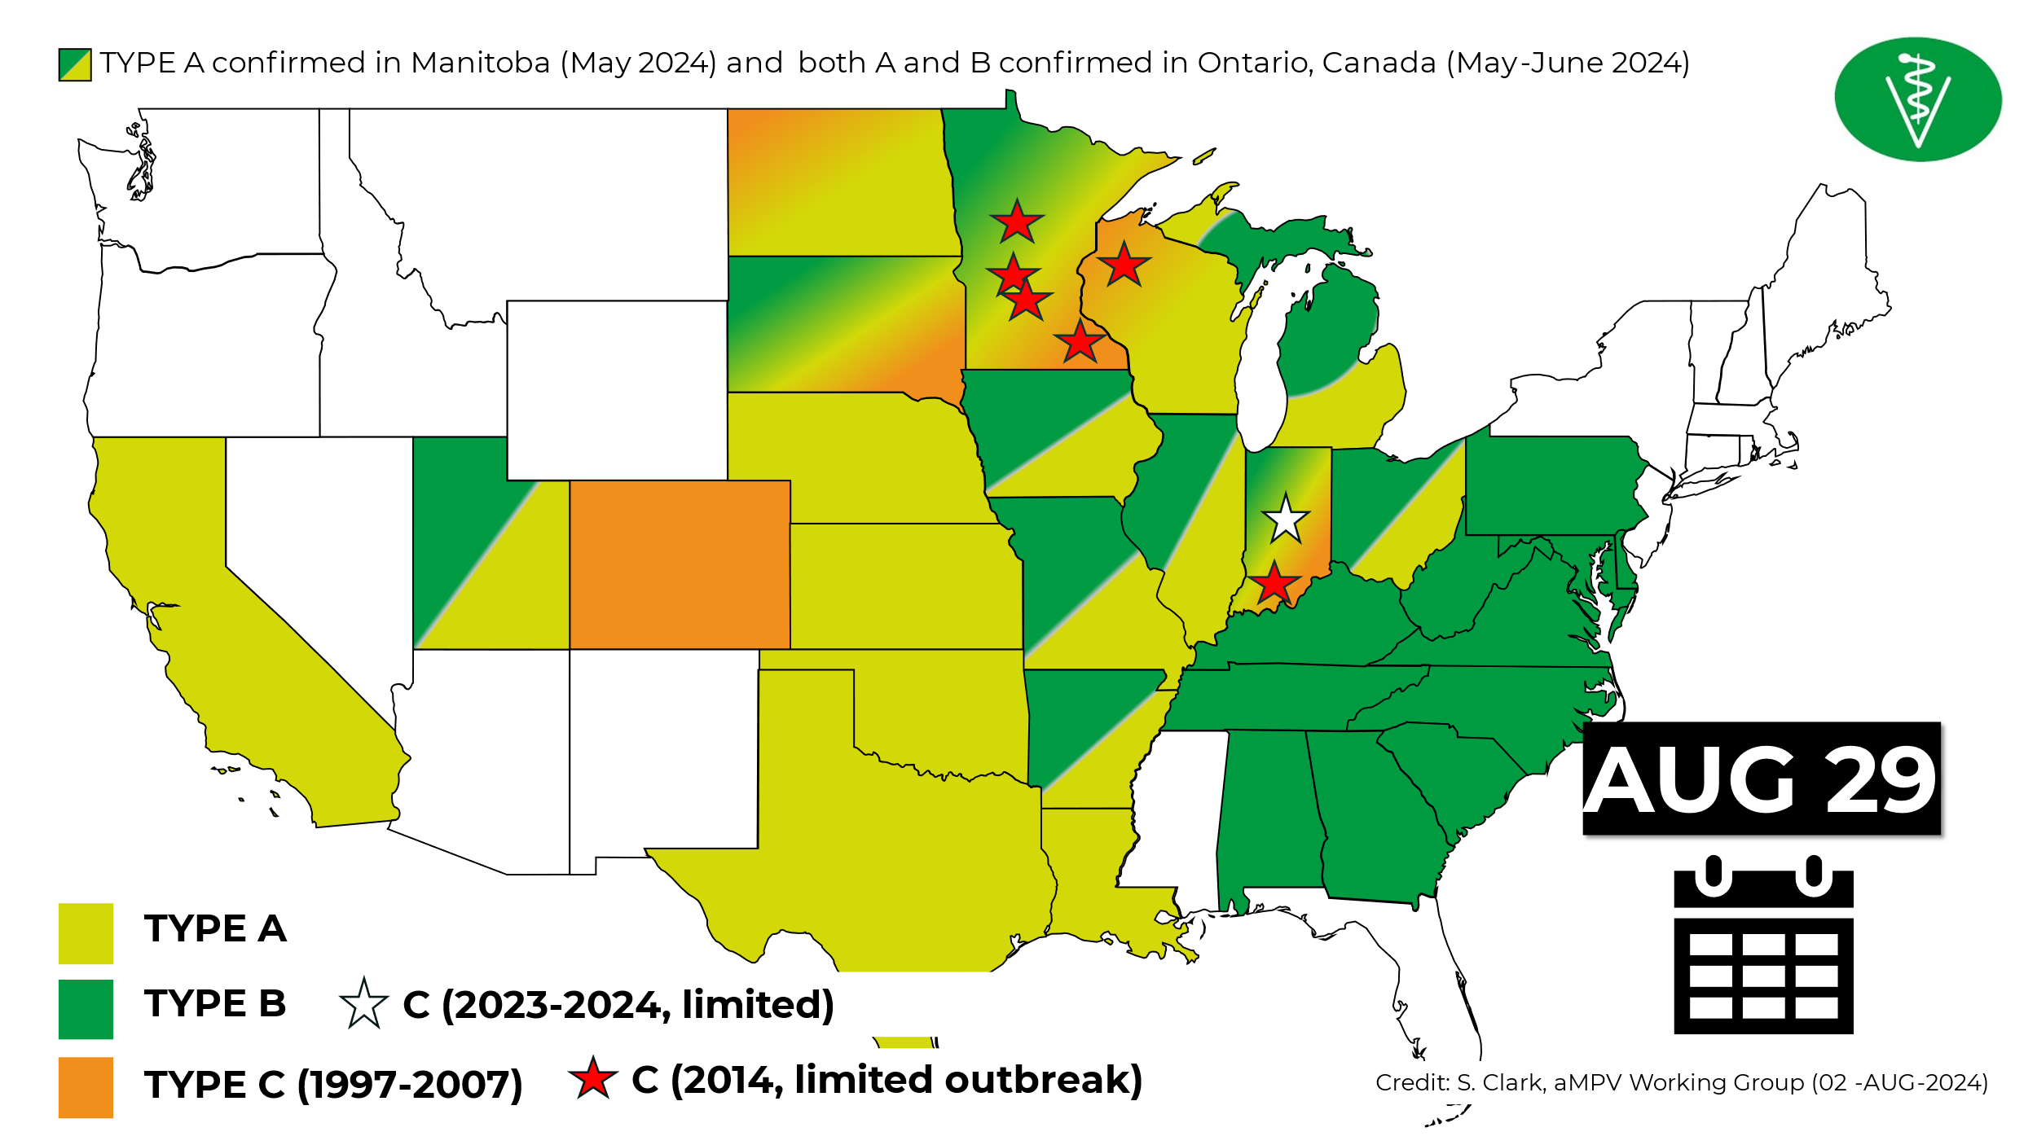

National Poultry Improvement Plan (NPIP) 2024 Annual Report
Drs. Elena Behnke and Katy Burden, USDA-APHIS-VS-ASEP, Conyers, GA.

NPIP overview:
- 51 Official Agencies
  - 50 States and 1 Territory
- 98 Authorized Laboratories
  - In 43 States
  - 42 Also Belong to the NAHLN
- Provisions in 4 Sections of Title 9 CFR and in the Program Standards
  - 145, 146, 147, 56
- General Conference Committee – 7 members
- Hatcheries
  - Egg/Meat Type Chickens – 277
  - Turkeys – 43
  - Waterfowl, Exhibition, Game Bird - 688

NPIP breeding flocks and birds:
- Egg-Type Chickens
  - 395 flocks representing 9,410,324 birds
- Meat-Type Chickens
  - 4,632 flocks representing 82,370,386 birds
- Turkeys
  - 225 flocks representing 2,248,846 birds
- Waterfowl, Exhibition Poultry, Game Birds
  - 6,544 flocks representing 14,537,833 birds
- Meat-Type Waterfowl
  - 127 flocks representing 409,780 birds

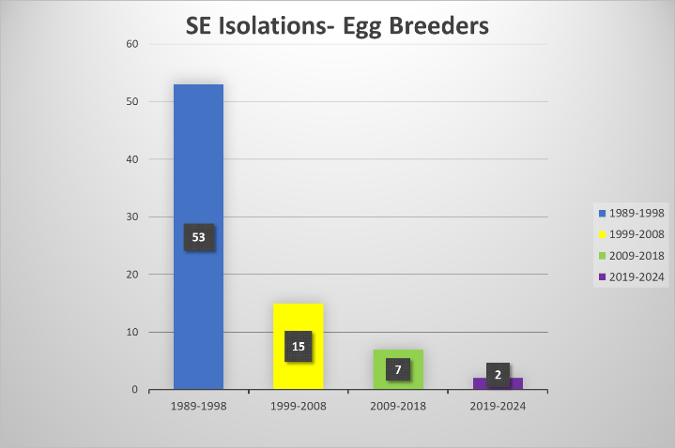

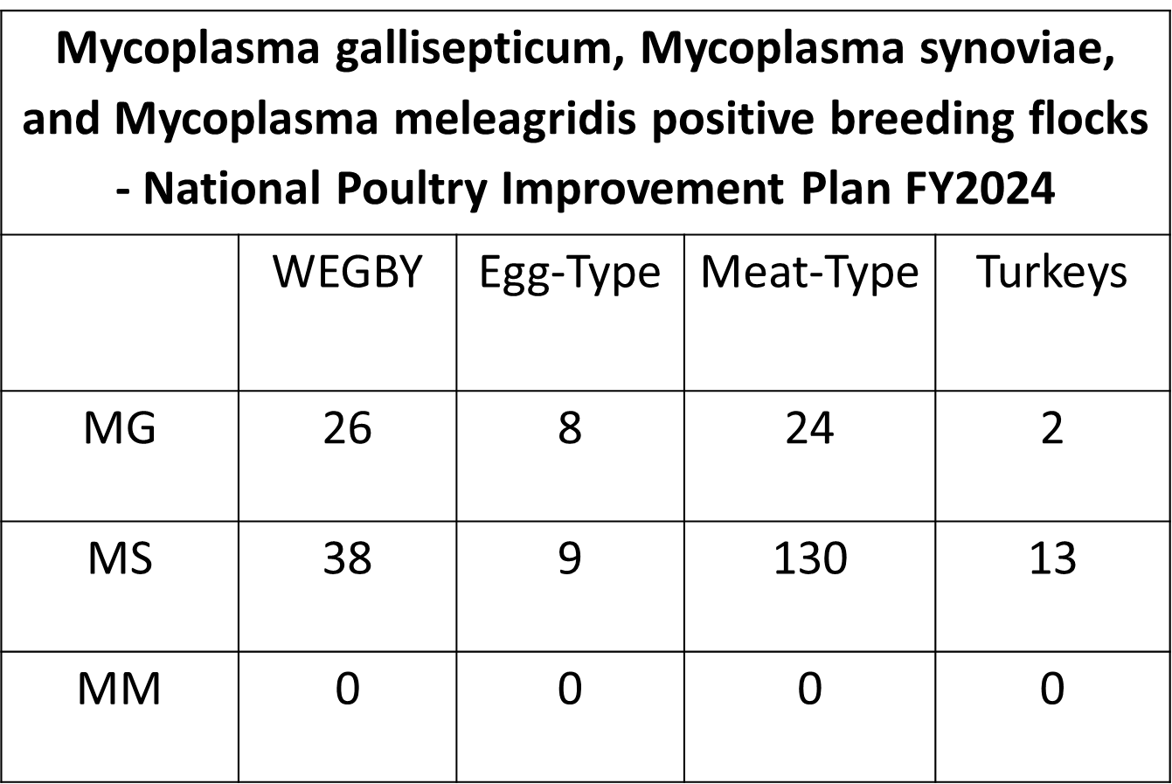

Avian influenza:
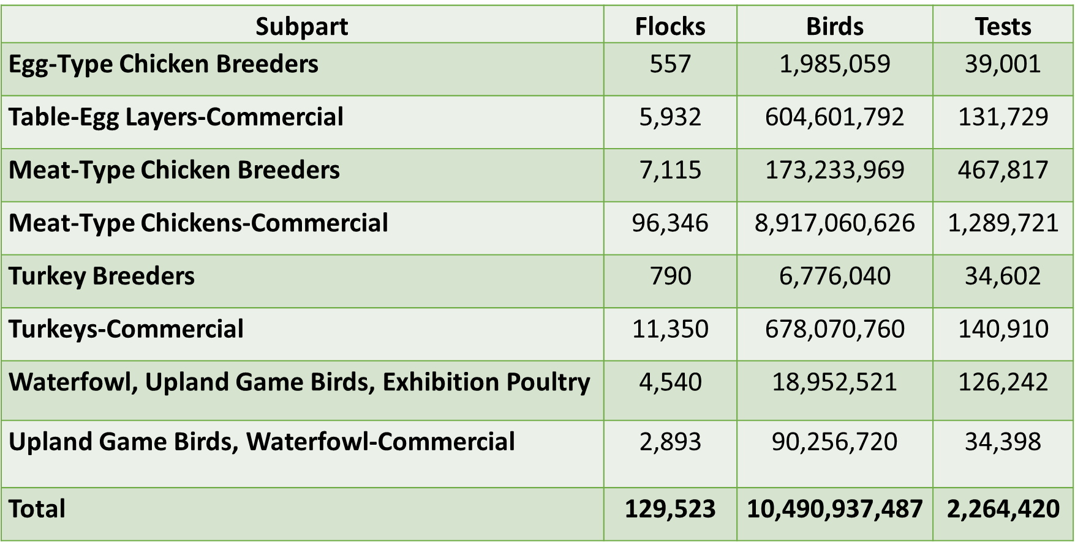

Live Bird Marketing System (LBMS) Avian Influenza Program FY2024 Working Group Report
Dr. Fidelis N. Hegngi, USDA-APHIS-VS, Riverdale, MD.

The United States domestic low pathogenicity avian influenza (LPAI) program provides surveillance for H5 and H7 LPAI prevention and control in the Live Bird Marketing System (LBMS). Beginning in 1994, LPAI H7N2 proved to be endemic in live bird markets (LBMs) in the northeastern United States. In 1999, the United States Department of Agriculture (USDA) established a LBMS working group to support States wanting to eliminate LPAI H7N2 that was persistent in the LBMs. On October 20, 2004, USDA, Animal and Plant Health Inspection Service (APHIS) Veterinary Services (VS) published uniform standards for H5 and H7 LPAI prevention and control in the LBMS to establish a more consistent approach by participating States in controlling LPAI in the LBMS. VS revised the LBMS uniform standards in 2008, 2012, 2016, 2020, and 2024.

In August 2024, VS published an updated edition of the uniform standards. The updates include revising the definition of a live bird market to: “Any facility (including botanica, poultry store, or poultry slaughter exempt) that procures live poultry to hold or display for more than 24 hours and sells such poultry for onsite slaughter or offsite ritual use”; and added a new and revised definition of “poultry” to reflect the changes to World Organization for Animal Health (WOAH – Founded as OIE) Chapter 10.4 on avian influenza. VS changed the verbiage throughout the document to reflect the program as a LPAI H5/H7 prevention and control program. The standards are currently being implemented.
State participation is voluntary; participating States will enact regulations necessary for compliance of their LBMs, including producers, and distributors. All LBMs, producers, and distributors that supply the markets must be registered or licensed with the State and must allow Federal and State inspectors access to their facilities, birds, and records. These facilities must also have written biosecurity protocols in place. VS coordinates and administers the program and provides personnel and resources to assist States with implementation and compliance with program requirements.

In FY 2024 the LBMS Working Group held its annual business meeting in Miami, Florida. The meeting was attended by approximately 78 program participants including 38 VS field, district, and headquarters staff; 3 LBMS/poultry industry stakeholders; 4 State animal health diagnostic laboratory representatives; 1 Centers for Disease Control and Prevention (CDC) representative; 3 university representatives; and 29 State Department of Agriculture participants representing 33 States. The meeting provides opportunities for continued program development, implementation, and advancement.

The working group also discussed:
(1) 2020 LBMS Uniform Standards –Suggested Proposed Changes and Additions to the 2024 Uniform Standards
(2) LBMS Status and FY2024 Budget Update.
(3) An update on Initial State Response and Containment Plan (ISRCP) Cooperative Agreements, Indemnity, and Compensation procedures.
(4) Current HPAI Situation & Response in the United States.
(5) States Response to H5N1 HPAI in New York’s LBM - Challenges and Lessons Learned (Florida, New Jersey, New York, Pennsylvania, and Virginia).
(6) New York, New Jersey, Virginia, and Pennsylvania LBMS H5N1 HPAI Epidemiology Summary and Lessons Learned.
(7) Structure of the Pennsylvania Poultry Industry and Unique Disease Challenges.
(8) CDC – Zoonotic Flu in Humans and an Overview of Live Bird Market Surveillance Conducted in Other Countries.
(9) HPAI – Role of Wild Birds & Update-Wild Bird AI Surveillance Projected for 2024 and Beyond.
(10) National Veterinary Services Laboratories - Update on Surveillance Testing - Current Nationwide Findings and Status of Current Diagnostics for AI and Newcastle Disease.
(11) Susceptibilities and Viral Shedding of Peri Domestic Mammals and Birds Infected with Clade 2.3.4.4b Highly Pathogenic Avian Influenza Viruses.
(12) Southeast Poultry Research Laboratory Update on HPAI Research and Vaccine.
(13) An Update on the National Poultry Improvement Plan (NPIP).
(14) An Update on the NPIP Authorized Laboratories System and Compartmentalization.
(15) Discussion on Outreach and Education Projects: Defend the Flock (DTF) – Combined Campaign Update: Bird Awareness Week; Flock Defender; Youth Outreach; and Calendar Replacement.
(16) Plans for 2024 LBMS Continuing Education Training Course at the School of Veterinary Medicine, University of California, Davis, CA.

In FY 2024, VS awarded a new contract to manage the Defend the Flock outreach and education campaign. With the new contractor in place, VS renewed its focus on communication efforts to small farms and backyard producers to disseminate biosecurity and disease prevention information.

VS continued to use Defend the Flock social media accounts to disseminate information on the HPAI outbreak and share the importance of biosecurity. VS also used a paid media campaign, referenced above, for social media and search engine marketing.

The 2025 Defend the Flock calendar will be available soon through online orders.

Additional Defend the Flock efforts focusing on the small farm and backyard audience included: Bird Health Awareness Week running February 18 – 24. As part of this week, VS increased its efforts to share information about biosecurity. APHIS shared information on the Defend the Flock social media channels via published and audio news releases.

The Annual Bird Health Webinar was held March 14. The webinar featured VS Veterinary Medical Officer Dr. Melissa Yates and a presentation on Biosecurity on a Budget aimed at delivering biosecurity information to small farms and bird owners. The webinar had 650 participants.

Radio Media Tour – Legislative and Public Affairs (LPA) worked with the Defend the Flock contractors to organize and host a radio media tour with Dr. Kathryn Burden on avian influenza and biosecurity for the spring migratory season. Dr. Burden interviewed with 16 radio stations across 15 States and 1 national outlet.

In FY 2024, surveillance in the LBMS remained a high priority. Approximately 68,483 tests have been conducted for LPAI surveillance in the LBMS, for the first three quarters. Tests included agar gel immunodiffusion (AGID), real-time reverse-transcriptase polymerase chain reaction (rRT-PCR), antigen capture immunoassay (ACIA), and virus isolation (VI). For VI and rRT-PCR, each sample may represent 5 or 11 individual swabs pooled for a composite single test.

Since VS and the States initiated the H5/H7 LPAI LBMS prevention and control program and surveillance and response efforts in 2004, the number of LBMS LPAI positive premises has decreased significantly. There was no detection of H5/H7 LPAI virus in U.S. LBMS in FY 2024. During the FY 2024 HPAI outbreak, only 8 LBMs and 1 dealer were found positive for H5N1 HPAI Clade 2.3.4.4b.

NVSL Bacteriology Diagnostics Report
Dr. Kim Lehman and Ms. Brenda Morningstar-Shaw, USDA-APHIS-VS-NVSL, Ames, IA.

Dr. Lehman presented the 2023 data on Salmonella, Mycoplasma, and Pasteurella in poultry species including number of tests run and prominent serotypes in clinical and non-clinical poultry samples. These data were compared to previous years and industry trends discussed.

Avian Influenza and Newcastle Disease Sub-Committee Report, SEPRL Report
Dr. David Suarez, USDA-ARS-SEPRL, Athens, GA.

The standing subcommittee reports provides a review of notable outbreaks of avian influenza and Newcastle disease that occurred outside the United States in the last year (October 2023 to September 2024). A variety of public sources were used to compile these results including the World Organization for Animal Health (WOAH), The United Nations Food and Agriculture Organization, the European Centre for Disease Prevention and Control, published manuscripts, news reports and personal observations. Despite the variety of sources, many outbreaks lack detail about the virus and the impact on poultry or wild bird populations.

Newcastle disease virus had only a limited number of outbreaks reported to WOAH despite the virus being endemic in South and Central America, Asia, and Africa. A notable outbreak occurred in Brazil in July 2024 with a single farm of over 14,000 chickens reporting high mortality. The genotype of the virus was not reported although the virus was reported to be closest sequence wise (95% similar) to a pigeon paramyxovirus. This was the first report in Brazil of NDV since 20026. A larger outbreak was reported in Sweden in May 2024 with high mortality on a single farm of 231,000 birds. The farm was depopulated and no spread was detected. Sweden is one of the few European countries that don’t vaccinate for NDV, and therefore the birds are fully susceptible to infection. The final NDV outbreak reported was in Taiwan on a single farm of 74,000 birds with high mortality. The outbreak response was to vaccinate the remaining birds that were eventually marketed.

Highly pathogenic avian influenza was reported on every continent in the last year and it continues to cause outbreaks in both poultry and wild birds. In the European Union, outbreaks of 2.3.4.4b H5N1 remains the predominant lineage and subtype, although both H5N5 and H5N8 were also reported. There was a downward trend in cases in the last year compared to the three previous years, but outbreaks were seen in both poultry and wild birds. For poultry outbreaks, chickens were most commonly observed species, but large numbers of outbreaks in turkeys, ducks and geese were also seen. In wild birds a distinct seasonality was observed with colony-breeding seabird species being heavily affected in the spring moths and waterfowl species were affected in fall and winter months. (European Food Safety et al., 2024)

The vaccination program in France continues in domestic ducks into the second year. The severity of outbreaks in 2021 and 2022 necessitated a different approach to control, and vaccination under government control and financial support was adopted. Initially a baculovurus subunit vaccine was the selected option, despite the antigenic differences with the field strain. In May 2024 a second mRNA vaccine was also approved for use. 35 million ducks received 2 doses of vaccine and 1.5 million ducks in high-risk areas received 3 doses of vaccine. A total of 10 vaccinated flocks were identified as being infected in the last year, but that number was considered a success as 1,374 outbreaks were detected in 2021-2022 and 396 outbreaks in 2022-2023. Few details on surveillance have been reported and there continues to be some trade ramifications of the vaccination program. (bioRxiv doi: https://doi.org/10.1101/2024.08.28.609837)
Outbreaks of both H5 and H7 HPAI were reported from Africa. South Africa and Mozambique had reported outbreaks of H7N6 HPAI that impacted the layer, broiler breeder and layer breeder sectors the most, but the outbreak was under control with the last reported outbreak in December 2023. Outbreaks of H5N1 HPAI were reported in Benin, Burkina Faso, Guinea, Nigeria and Niger. Other outbreaks of H5Nx were reported from South Africa in commercial ostrich, poultry and wildbirds including Jackass penguin and swift terns. HPAI remains endemic in Egypt with heavy vaccination use and is likely under reported in other African Countries.

H5N1 HPAI remains endemic in multiple countries in Asia with vaccination being commonly used. Notably H5N1 and H5N6 were reported in Japan. Wild bird detections are common. China continues to be the largest producer and user of vaccines for both H5 and H7 HPAI with the vaccine regularly updated and subsidized by the government. H9N2 also remains a major regional issue. In a published paper from China it was reported that H7N9 HPAI was still being isolated from 2020 to June 2023. Of the 16 isolates evaluated, 12 were closely antigenically related to the RE-4 vaccine, but 4 were antigenically different. The viruses evaluated appeared to have lost their high affinity for α 2,6 sialic acid which is believed to reduce their ability to infect humans. Animal studies support that the viruses were more attenuated in mice.(Liu et al., 2024)

Australia remains free of H5N1 HPAI, but they reported several H7 HPAI outbreaks in southern Australia. At least 16 affected farms with over 2 million birds were involved with H7N3, H7N8, and H7N9 being reported. Despite the three different viral HA and NA combinations, at least two of the viruses had highly similar hemagglutinin genes including a 3 amino acid insert at the cleavage site that suggest a common source. The outbreaks which started in May of 2024 remain ongoing.

In Mexico they continue to deal with both low and highly pathogenic avian influenza. After a report of resurgence of H7N3 HPAI in 2022 in northern Mexico, the outbreaks have continued with at least 8 additional farms being reported in 2024 with the spread of the virus into central Mexico. Vaccination continues to be used for control. Mexico continues to deal with H5N2 Mexican lineage virus. This virus can be traced back to the original outbreaks in 1994. The low pathogenic virus has been circulating in the country despite the use of widespread vaccination and continues to be an important disease pathogen. The virus has continued to evolve and two distinct sublineages with over 10% sequence difference between sublineages is observed. The hemagglutinin cleavage site of these viruses continues to have either 3 or 4 basic amino acids which leaves open the possibility that these viruses meeting the definition of highly pathogenic avian influenza viruses. The situation continued to worsen when it was reported that a fatal human case was identified with this viral lineage. There also appears to be sporadic cases of H5N1 HPAI in the country as well.

There remains only limited information from South America about HPAI. Some countries including Peru and Bolivia are using vaccination for control and outbreaks in wild birds and mammals appear to be ongoing.

The zoonotic threat of avian influenza continues with reports of human cases in multiple countries. The largest number of human cases is associated with the U.S. outbreak in dairy cows and poultry of H5N1, although these human cases are causing only mild disease. Two fatal cases of H5N6 were reported from China as well as the previously mentioned Mexican lineage H5N2 fatal case in Mexico. Human cases also occur with low pathogenic avian influenza, including 7 cases of H9N2 in China, India, and Vietnam, and a single case of H10N3 in China. The number of human cases is likely grossly under reported as mild cases are unlikely to be diagnosed.

European Food Safety, A., European Centre for Disease, P., Control, European Union Reference Laboratory for Avian, I., Alexakis, L., Fusaro, A., Kuiken, T., Mirinaviciute, G., Stahl, K., Staubach, C., Svartstrom, O., Terregino, C., Willgert, K., Delacourt, R., Goudjihounde, S. M., Grant, M., Tampach, S., & Kohnle, L. (2024). Avian influenza overview March-June 2024. EFSA J, 22(7), e8930. https://doi.org/10.2903/j.efsa.2024.8930
Liu, Y., Chen, Y., Yang, Z., Lin, Y., Fu, S., Chen, J., Xu, L., Liu, T., Niu, B., Huang, Q., Liu, H., Zheng, C., Liao, M., & Jia, W. (2024). Evolution and Antigenic Differentiation of Avian Influenza A(H7N9) Virus, China. Emerg Infect Dis, 30(6), 1218-1222. https://doi.org/10.3201/eid3006.230530

Poultry Depopulation AVMA Update
Dr. Cia Johnson, AVMA Animal Welfare Division, Schaumburg, IL.

The AVMA has built a reputation for developing veterinary guidance that is scientific, comprehensive, and inclusive of various perspectives. The current set of documents include the AVMA Guidelines for the Humane Slaughter of Animals (2024), AVMA Guidelines for the Depopulation of Animals (2019), and the AVMA Guidelines for the Euthanasia of Animals (2020). These Guidelines and associated decision-tree have been important tools for end-of-life decisions. The veterinary profession must continuously evaluate methods in use; support technology transfer and innovation; and appropriate training and ongoing support of personnel during end-of-life events. The process for how these Panels are convened and the review and revision of these important documents were covered during this presentation. As part of AVMA’s continuous improvement model, the Guidelines for the Humane Slaughter of Animals was published this year and the Guidelines for the Depopulation of Animals are currently under review, with an AVMA member comment period anticipated in the fourth quarter of 2024. Anticipated revisions to the Poultry chapters were emphasized.

Poultry Depopulation USDA Update
Dr. Koren Custer, USDA-APHIS-VS, Riverdale, MD.

Dr. Custer presented data on depopulation events in the commercial poultry industry since the start of the HPAI outbreak in 2022. A proposal from USDA to modify the requirements to use ventilation shutdown plus (VSD+) was discussed.

HPAI Response Federal Update
Dr. Julie Gauthier, USDA-APHIS-VS, Raleigh, NC.

Dr. Gauthier presented an overview of the federal response to HPAI in the commercial poultry industry as well as the recent dairy cattle outbreaks. A summary of current epidemiologic data was provided.

HPAI Response MI State Perspective
Dr. Nora Wineland MDARD, Lansing, MI.

An overview of B3.13 HPAI in Michigan was shared. The first case in Michigan was found in a herd which had recently imported cattle. Signs were seen in the Michigan herd 12 days after the importation. The timeline for dairy and poultry cases was reviewed including a depiction of geographic spread. Key epidemiologic findings identified multiple plausible sources of spread: animal movement, milk movement, deadstock haulers, visitor traffic, and shared workers. The B3.13 strain has not been found in migratory waterfowl in Michigan. Peridomestic animals and wildlife were found to harbor the virus. While affected flocks were in close proximity to affected dairies, there was no evidence that wildlife or peridomestic species were responsible for disease spread.

With the multitude of plausible causes of spread coming to light through the epidemiologic investigations, Michigan elected to issue a risk reduction response order under authorities in the animal industry act. The order requires implementation of on farm biosecurity measures patterned after the secure milk supply plan. Michigan elected not to quarantine affected dairies, opting instead to request producers alter their production and movement practices. Herds are being cleared from the affected herd list by achieving monitored unaffected status in the USDA Herd Status program.

HPAI Response CO State Perspective
Dr. Maggie Baldwin, CDA, Broomfield, CO.

Dr. Baldwin presented an overview of the Colorado state response to the HPAI events that have occurred in dairy cattle and poultry. The links between dairy farms and poultry farms were emphasized and biosecurity and surveillance plans discussed.

HPAI Epidemiology Report Update
Drs. Kammy Johnson and Col Vanicek, USDA-APHIS-VS CEAH, Riverdale, MD.

The 2022-2024 outbreak of highly pathogenic avian influenza (HPAI) H5N1 represents the most significant animal health event in U.S. history. Initial detection of the Eurasian H5 2.3.4.4b avian influenza virus occurred in February 2022, with subsequent detections spanning commercial and backyard poultry flocks, wild birds, and wild mammals across the United States. On March 25, 2024, the National Veterinary Services Laboratories confirmed the first incidence of H5N1 clade 2.3.4.4b, genotype B3.13, in a Texas dairy herd.

The Center for Epidemiology and Animal Health (CEAH) has continuously supported the HPAI outbreak response through epidemiologic analyses, data visualizations, and modeling efforts. An updated epidemiologic report, forthcoming on the APHIS avian influenza website, will provide additional insights into HPAI in poultry, including economic analyses, biosecurity implementation challenges, time of introduction analyses, phylogenetic analyses, and updates on wild bird and mammal surveillance.

CEAH, in collaboration with academic partners, is developing models to evaluate HPAI vaccination strategies and their impacts on surveillance design and future response outcomes. Additionally, efforts to forecast HPAI in poultry will leverage understanding of wild bird migration patterns and exposure risks. Furthermore, future endeavors at CEAH will involve spatial and epidemiologic analyses of H5N1 2.3.4.4b B3.13 genotype detections in poultry. Of the 69 detections in poultry since March 1, 2024, 73.8% were of the B3.13 genotype. Epidemiology questionnaires were completed for 38 of the infected premises. Among those completing the questionnaire, approximately half identified livestock links. Other risk factors included deadstock removal, bird movements, proximity to dairy farms, rodent pressure, and wildlife presence.

Following the first detection of H5N1 in dairy cattle in March 2024, the Animal and Plant Health Inspection Service (APHIS) acted swiftly to assess the prevalence of the virus in U.S. dairy herds and implement appropriate responses. Veterinary Services and State officials deployed standardized epidemiologic questionnaires to investigate H5N1 infections in dairy herds, identifying potential risk factors and transmission routes. The latest report, posted on September 24, 2024, summarizes questionnaire data from 64% of affected dairy farms. It highlights that state-to-state spread is likely due to both direct and indirect transmission routes. Biosecurity remains crucial in mitigating disease spread. The full report is available on the APHIS website.

Secure Poultry Supply Update
Dr. Rosemary Marusak, University of Minnesota, Chetek, WI.

Secure Poultry Supply Update: addressing the paradigm shift in HPAI outbreak response

Catherine Alexander, Peter Bonney, Carol Cardona, Cesar Corzo, Marie Culhane, Timothy Goldsmith, Dave Halvorson, Mickey Leonard, Sylvia Wanzala Martin, Rosemary Marusak, Amos Ssematimba, Kaitlyn St. Charles, Margret Tavai-Tuisalo’o, Emily Walz

College of Veterinary Medicine, University of Minnesota, Saint Paul, Minnesota, USA
https://securepoultrysupply.umn.edu/

The expanded geographic range and species diversity of the 2022-current H5N1 highly pathogenic avian influenza (HPAI) outbreak has resulted in a paradigm shift in the U.S. poultry industry. We may consider HPAI to be endemic in some reservoirs in the U.S. and consequently, new innovative biosecurity and biocontainment measures are needed to protect the poultry industry and reduce state/federal expenditures. In response, the University of Minnesota Secure Poultry Supply (SPS) team is embarking on several new projects (Table 1) to assess: 1) information on the consequences of early vs late virus detection in a flock; 2) updated virus characteristics and parameters to refine risk assessment; 3) data on new mammalian infection and transmission pathways; and 4) new scientific information, especially related to on-farm environmental contamination and disinfection efficacy, to understand likelihood of virus spread and risk mitigations.

Table 1. New Secure Poultry Supply Projects and their expected outcomes.
Project Goal | Project Title | Expected Outcomes
Addressing Industry Needs | Risk assessment for the movement of duck hatching eggs from a farm out of, into, or within an HPAI control area | New Secure Duck Supply; Risk Assessment & Permit Guidance
Addressing Industry Needs | Evaluating risk of moving organically-produced eggs from not known to be infected premises in a control area to a processing plant | Risk assessment & Permit Guidance
Addressing Industry Needs | Evaluating the risk of moving segregated processed eggs from infected premises to sites without susceptible species | Risk assessment
Science Database Update and Expansions | Secure Poultry Supply (SPS)  Risk Assessment Modernization | Revisions include incorporation of new virus science; disinfection science
Science Database Update and Expansions | Quantification of influenza virus transfer during different biosecurity protocols | Virus transfer data and an on-farm tool for quantitative biosecurity evaluation
Science Database Update and Expansions | Exploring the expanded HPAI host range | Feline seroprevalence data, introduction and exposure pathways definitions

The SPS risk assessment, “Evaluating the risk of moving segregated processed eggs from infected premises to sites without susceptible species” is presented as a means for discussing these new SPS activities. Important for this assessment is the determination of risk and confidence levels for movement from an infected premises. In 18 bi-weekly meetings, the egg layer risk assessment workgroup¹ identified these important criteria for both achieving acceptable risk and high move confidence:
- early virus detection in a flock;
- protection, i.e., segregation, of cooler eggs from recontamination; and
- scientific assessed egg truck disinfection protocols/practices for exiting an infected premises.

The pathways of virus introduction and spread to cooler eggs and egg transportation vehicles and their mitigations are critically discussed. Workgroup summaries also highlight a need for environmental surveillance of areas essential to egg storage and transport at regular intervals until the time of egg movement; a draft template for targeted data collection is proposed.²

- The risk assessment working group consisted of production and processing egg layer industry representatives, state, federal and academic stakeholders, and subject matter experts
- For more complete descriptions of Secure Poultry Supply activities and targeted data collection templates see https://docs.google.com/document/d/1A7TDnOVHirTC6xGkpvRJhcMW_TY2Ip4aZUNQosKb9vg/edit?usp=sharing

Overview of AMPV in the USA
Dr. Ben Wileman, Select Genetics, Willmar, MN.

Dr. Wileman presented an overview of the current avian metapneumovirus (aMPV) outbreak in the commercial poultry industry. Control strategies were discussed, including the need for live vaccines.

Nov 29, 2023 – Feb 26, 2024, average weekly company-wide flock mortality was 1.28%, and the prior 12-month company (No 2022 – Nov 2023) average was 0.60%, and week of Jan 1, 2024, peaked at 1.85%. Following the winter introduction, average weekly flock mortality is 0.99% (March – September 2024) compared to before the disease introduction in 2023.
USDA CVB has granted a Special Import Permit for the HIPRA vaccine against Avian Metapneumovirus: HIPRAVIAR® TRT on July 26th, 2024 (No. VB-283390). “… subtype B chicken origin strain, 1062, with proven cross-protection against subtype A, in injectable emulsion. In countries where the product is registered, it is indicated for use in both for chickens (breeders and layers) and turkeys.” (Laboratorios Hipra S. A. memo, US - HIPRA introduction, 2024).
Merck Animal Health launches experimental autogenous vaccine for avian metapneumovirus type B
Ceva producing aMPV experimental autogenous vaccine using US-origin isolate - Modern Poultry
Srinivas, Geetha B. HPAI and Avian Metapneumovirus. USDA CVB presentation to AHI on September 18-19, 2024.
Poultry Slaughter 2023 Summary (February 2024). USDA, National Agricultural Statistics Service. Pg 5. https://downloads.usda.library.cornell.edu/usda-esmis/files/pg15bd88s/q524m975v/zs25zx570/pslaan24.pdf
Poultry - Production and Value 2022 Summary (April 2023). USDA, National Agricultural Statistics Service. Pg 8-9. https://downloads.usda.library.cornell.edu/usda-esmis/files/m039k491c/b2775j31b/9k4213149/plva0424.pdf
Poultry Slaughter 2023 Summary (February 2024). USDA, National Agricultural Statistics Service. Pg 5.
USDA, ERS, Livestock & Meat Domestic Data, Turkey Sector: Background & Statistics: https://www.ers.usda.gov/newsroom/trending-topics/turkey-sector-background-statistics/#:~:text=U.S.%20turkey%20disappearance%20per%20capita%3A&text=2019%3A%2015.9%20pounds,WASDE%20at%20a%20Glance%20visualization

