Committee on Poultry and Other Avian Species
Chair: Kayla Niel, PA
Vice Chair: Andrew Smith, IA

The Committee met virtually on October 20, 2025, from 10:00 AM to 2:00 PM, Eastern Time, and at the Gaylord on November 3, 2025, from 1:00 PM to 5:06 PM, Mountain Time. There were members beyond quorum in-person, up to 90 members and guests virtually, and many guests present in-person. Chair Kayla Niel presided, assisted by Vice Chair Andrew Smith. Niel welcomed the Committee on Poultry and Other Avian Species (CPAS) members, summarized the 2024 meeting and provided final responses from USDA-APHIS-VS to the 2024 resolutions:

Resolution 11 – Avian metapneumovirus live vaccine for poultry

The United States Animal Health Association strongly urges the United States Department of Agriculture (USDA), Animal and Plant Health Inspection Services (APHIS), Veterinary Services (VS) Center for Veterinary Biologics (CVB) to expedite the approval of the importation of modified-live, commercially available vaccines for avian metapneumovirus subtypes A and B for chickens and turkeys which meet USDA-APHIS-VS-CVB’s requirements for purity.

USDA-APHIS-VS-CVB Response:

The United States Department of Agriculture (USDA), Animal and Plant Health Inspection Service (APHIS), Veterinary Services (VS) recognizes the concerns of the United States Animal Health Association (USAHA) and appreciates the opportunity to respond.

Due to the impacts of this outbreak, APHIS’ Center for Veterinary Biologics has conducted risk assessments of foreign-manufactured avian metapneumovirus modified live virus (MLV) and inactivated products for importation. In general, the importation of live products carries a greater risk of introducing contaminants or poultry diseases not in the United States. APHIS has conducted limited purity and safety testing for these foreign-manufactured aMPV MLV vaccine candidates for use in U.S. poultry as part of the risk assessment. APHIS has issued import permits for five internationally registered aMPV MLV products since December 2024 and all five are being shipped to the field as of July 2025. As of July 2025, APHIS is working with a manufacturer to have samples submitted to test a sixth aMPV MLV product.

In July 2025, following consultation with industry groups and the National Assembly of State Animal Health Officials, CVB provided guidance to manufacturers to decrease the regulatory burden of shipping product to the field. Manufacturers and producers are still required to collect and maintain the same information in case of an incident but will no longer have to provide information to the CVB proactively except for test reports of MLV products. This should streamline product availability for outbreak response efforts.

Resolution 12 – H5N1 influenza vaccine in cattle

The United States Animal Health Association strongly urges the United States Department of Agriculture, Animal and Plant Health Inspection Services to lead the coordination of all livestock sectors, state animal health officials, and public health officials to develop and implement a consistent and comprehensive strategy for H5 influenza management. The strategy should include these elements:

- Risk-based regional surveillance to efficiently generate the data needed to understand risks and to mitigate them with consistent control strategies.
- Adherence to science-based principles of disease control to reduce further spread of H5 influenza.
- Epidemiologic studies and tools to understand connections among susceptible populations.
- Resolution of concerns, such as trade, that impede the utilization of vaccine needed to control the spread of H5 influenza.
- Additional resource allocation to minimize the long-term impacts of H5 influenza on human health, food security, and economic sustainability.

USDA-APHIS-VS Response:

The United States Department of Agriculture (USDA), Animal and Plant Health Inspection Service (APHIS), Veterinary Services (VS) recognizes the concerns of the United States Animal Health Association (USAHA) and appreciates the opportunity to respond.

APHIS, state responders, and allied industry partners have documented additional “spillover” events of HPAI H5 clade 2.3.4.4b virus (heretofore HPAI) from wild birds into dairy cattle, which is not unexpected in the context of the ongoing global epizootic situation of the virus disseminated from wild birds to poultry and other mammals. APHIS continues coordinating poultry and dairy livestock responses with states and allied industries.

The United States continues to implement a “stamping out” response to poultry HPAI detections and movement restrictions in other impacted species, to limit disease spread and ultimately eliminate circulating virus in domestic species. National Animal Health Laboratory Network (NAHLN) laboratories and APHIS continue to offer testing for all species (including wild birds and mammals) to quickly detect the virus and better understand its transmission.

APHIS has published two Federal Orders to increase surveillance for HPAI virus in the national dairy herd and decrease interstate spread of the virus. The National Milk Testing Strategy (NMTS) implemented following the December Federal Order facilitates comprehensive surveillance of the nation’s milk supply and dairy herds to mitigate the spread of the virus without disruptions to the production, processing, and sale of pasteurized milk and milk products. Additionally, there is the voluntary Dairy Herd Status Program to help ease the burden of testing for herds that move interstate frequently. Financial support mechanisms for dairy producers are also available and information can be found here.

The NMTS includes a combination of dairy processing plant silo monitoring and state-specific surveillance, and ongoing testing for case investigation and response. Testing and surveillance activities are based on each state’s dairy industry and HPAI status. States use the NMTS to demonstrate Unaffected State status. The benefits of the NMTS is evident by the detection of two independent spillovers of the D1.1 genotype in dairy herds in New Mexico and Arizona and additional detections of the B3.13 genotype in Idaho. This also provides a justification to continue the NMTS at a monthly basis for unaffected states especially through the upcoming fall waterfowl migration. The NMTS state statuses can be found here.

In addition to conducting expert epidemiological and phylogenetic analysis to better understand the virus, and sharing that information globally, APHIS continually encourages and evaluates innovative disease response or prevention strategies that might bolster our work in protecting poultry and livestock health through science-based measures. This year, USDA APHIS invested $100 million d to explore prevention, therapeutics, research, and potential vaccine candidates to identify and foster innovative solutions to fight HPAI.

Resolution 14 – Audit of the United States Department of Agriculture, Animal and Plant Health Inspection Service, Veterinary Services Import and Export staffing

The United States Animal Health Association (USAHA) urges the Administrator of the United States Department of Agriculture, Animal and Plant Health Inspection Service, Veterinary Services to conduct an audit to determine the staffing needs for all import and export activities as well as needs for negotiating zoning, regionalization and compartments for all transboundary diseases. USAHA also requests that state animal health officials and industry representatives be included in the audit process and results are shared with USAHA in 2025.

USDA-APHIS-VS Response:
The United States Department of Agriculture (USDA), Animal and Plant Health Inspection Service (APHIS), Veterinary Services (VS) recognizes the concerns of the United States Animal Health Association (USAHA) and appreciates the opportunity to respond.

APHIS-adjusted user fee rates are collected to cover the costs of providing certain goods and services, including veterinary diagnostic goods and services and veterinary services for imports and exports of live animals and animal products. APHIS’ animal health import and export user fees cover significant activities across the country, including at border locations and quarantine facilities. These fees support personnel, facilities, and information technology systems. They also recover the costs of inspection and certification services for imports and exports of live animals, animal products, and animal byproducts and provide for veterinary diagnostic goods and services. In January 2025, APHIS updated its User Fee rates; the changes ensure the fees it charges align with the costs of providing these services. APHIS anticipates that these changes will allow the agency to improve customer service by hiring and training personnel and ensuring the availability of information technology needed to facilitate trade processes, such as issuing export health certificates.

The Live Animal Import/Export Unit underwent a Workforce Review from 2022-2023 and the review results are informing hiring decisions/priorities, onboarding approaches, training, and data management. APHIS appreciates USAHA's feedback and concerns surrounding staffing levels for the broader VS import and export activities and is supportive of the resolution pending resource availability.

2025 Presentations and Reports:

Virtual Meeting (10-20-2025):
AVBP Report Current Diseases of Concern was given by Dr. Andy Bishop, President of the Association of Veterinarians in Broiler Production. A summary of the report is included in these proceedings.

Table Egg Layer Industry Report was given by Dr. Linnea Tracy, President of the Association of Veterinarians in Egg Production. A summary of the report is included in these proceedings.

Turkey Industry Report was given by Dr. Carrie Cremers, President of the Association of Veterinarians in Turkey Production. A summary of the report is included in these proceedings.

LBMS AI Program FY 2024 Working Group Report was given by Dr. Fidelis Hegngi, USDA-APHIS-VS. A summary of the report is included in these proceedings.

NVSL Bacteriology Diagnostics was given by Dr. Kim Lehman, USDA-APHIS-VS-NVSL. A summary of the report is included in these proceedings.

National Poultry Improvement Plan (NPIP) Update was given by Drs. Savannah Busby and Katy Burden, USDA-APHIS-VS-ASEP-NPIP. The presentation given is included in these proceedings.

AI/NDV Disease Subcommittee Report was given by Dr. David Suarez, USDA-ARS-SEPRL. A summary of the report is included in these proceedings

SEPRL Updates was given by Dr. David Suarez, USDA-ARS-SEPRL. A recording of the presentation was provided to committee members.

NVSL HPAI Diagnostics was given by Dr. Mia Kim Torchetti, USDA-APHIS-VS-NVSL. A recording of the presentation was provided to committee members.

Wildlife Biosecurity Assessments was given by Dr. Amber Headen, USDA-APHIS-WS. The presentation given is included in these proceedings.

In-person Meeting (11-03-2025)

Federal HPAI Update was given by Dr. Oriana Beemer, USDA-APHIS-VS. A summary of the report is included in these proceedings.

California State HPAI Update was given by Dr. Alexi Haack, California Department of Food and Agriculture.

Industry Update (AAAP HPAI Task Force) was given virtually by Dr. Michelle Kromm, representative of the American Association of Avian Pathologists.

High Expansion Nitrogen Foam Projects was given by Dr. Alex Hamberg, Pennsylvania Department of Agriculture, and Mr. Dan Hougentogler, Agricultural Emergency Services Inc. The presentation given is included in these proceedings.

Salmonella Updates Post-Framework was given by Dr. Lindy Froebel, National Turkey Federation. A summary of the report is included in these proceedings.

Economic Impact of Avian Metapneumovirus was given virtually by Ms. Gretta Irwin, Iowa Turkey Federation. Links to previously published reports on this topic were shared with the committee members via email and are included in these proceedings.

Committee Business:

Subcommittee Report: The Avian Influenza/Newcastle Disease Subcommittee Report as presented by Dr. David Suarez was motioned to approve by Julie Helm, seconded by JC Essler, and approved by the CPAS Committee.

Old Committee Business:

2024 Resolutions:
The committee determined that the final responses from USDA-APHIS on the 2024 resolutions were sufficient and no additional action is required at this time.

New Committee Business:

Committee Resolutions:
There were four resolutions that were brought before the Committee, all of which were approved unanimously following discussion and minor amendments by the Committee:
Resolution 1 – National Poultry Improvement Plan (NPIP) Staffing

Resolution 2 – HPAI Vaccination

Resolution 3 – Innovation Grand Challenge Updates

Resolution 4 – Need for Epidemiological Data for Current H5 Epizootic

Committee chairs:
Dr. Niel has served as Vice Chair or Chair for a total of 4 years to date. Dr. Smith has served as Vice Chair for 2 years. The committee was asked to start thinking about the future leadership of the committee and nominate potential candidates for future years. Dr. Niel plans to rotate off after next year, with Dr. Smith taking over as Chair. A new Vice Chair will be needed for the 2027 meeting.

A motion to adjourn the meeting was initiated by Michael Martin and seconded by Alex Hamberg. There being no further business the Committee on Poultry and Other Avian Species adjourned at 5:06 PM.

AVBP Report Current Diseases of Concern
Dr. Andy Bishop, President of the Association of Veterinarians in Broiler Production

USAHA 2025
Broiler Industry Report
Association of Veterinarians in Broiler Production (AVBP)
Andrew Bishop, DVM, MAM, Diplomate ACPV

Broiler Production¹: The U.S. broiler industry placed 9.89 billion chicks in 2024, a 1.28% increase from 2023. As a result, the number of birds processed increased by 92.9 million head (+1.01%) to 9.33 billion total for 2024. Average broiler weight for 2024 was 6.55 pounds per bird, a 0.46% increase from 2023. This led to an overall increase of 846 million live pounds processed (+1.40%), to a total of 61.07 billion live pounds for 2024. Ready-to-cook (RTC) pounds increased by 607 million (+1.31%), to a total of 46.99 billion pounds of chicken meat in 2024.

Livability^{1, 2}: Average total broiler livability for 2024 decreased to 94.29%, a decrease of 0.25% from 2023.¹ Average first-week mortality for companies participating in Agristats increased by 0.13% to 1.80% for 2024². Since a large portion of the industry does not participate in Agristats, this may or may not be representative of the broiler industry as a whole. This continues a trend of worsening first-week mortality over the past several years. Broiler veterinarians report increasing challenges with undersized “non-starter” chicks, as well as increased incidence of septicemia among the causes of this worsening first-week mortality.

Condemnations³: Combined ante-mortem and post-mortem condemnations were relatively similar year-over-year. Combined pounds condemned totaled 0.65% of live weight in 2024, down slightly from 0.66% in 2023.

Issues of Concern Survey demographics: A survey of the Association of Veterinarians in Broiler Production (AVBP) membership was conducted in October, 2025. 16 responses were collected, representing veterinary oversight of 143 million birds per week (79.7% of total industry production). These individuals practice in 24 states: AL, AR, CA, DE, FL, GA, IA, IL, KY, MD, MS, NE, LA, MO, NC, OH, OK, PA, SC, TN, TX, VA, WA, WV.

Key Broiler Disease Issues:

Avian Metapneumovirus (aMPV) ranked first among diseases of concern, in only its second year of appearing on this survey. In the absence of a live vaccine, the winter of 2024/2025 saw widespread incidence of aMPV Types A and B in both broilers and broiler breeders. Live vaccines were made available by USDA under conditional approval in 2025, so veterinarians are hopeful that this issue will lessen in coming years.

Avian Influenza, including infections in Dairy Cattle, ranked second. Like other sectors of poultry, the broiler industry has seen Avian Influenza outbreaks continue to occur in a largely unpredictable pattern and incidence rate. Efforts are ongoing to improve biosecurity and wild-bird mitigation on farms.
Third highest in concern this year was Infectious Laryngotracheitis Virus (ILTV). ILTV has consistently ranked high in concern for the broiler industry. New vaccination techniques such as hatchery application of live vaccines are being utilized by some producers. Many producers are pursuing more frequent genotyping of field isolates to better understand the epidemiology of the disease.

Bacterial Osteomyelitis and “Kinky Back” (bacterial spondylitis) garnered much more responses than previous years and placed number four. Some respondents broadly described issues with Bacterial Chondronecrosis and Osteomyelitis (BCO), while others specifically mentioned spondylitis caused by Enterococcus cecorum (colloquially known as Kinky Back).

Number five was Gangrenous Dermatitis, falling from number three last year. Gangrenous Dermatitis has been another constant top concern for the industry.

For the first time in many years, Coccidiosis was not in the top five diseases listed. This likely reflects the current rise in prevalence and importance of other diseases, rather than decreased concern around Coccidiosis. Due to its ubiquitous nature and potential subclinical impacts, Coccidiosis requires constant preventative control measures in broiler and broiler breeder production.

Key Non-Disease Broiler Issues:

Hatchability / Fertility remained the number one non-disease issue in its second year appearing on this survey, holding its place from the previous year. While it varies based on time of year and egg supply, industry-wide hatchability has been significantly decreasing over the past 3-5 years. Most producers report that these hatchability losses are due to a decrease in egg fertility.

Salmonella / Food Safety Regulations also held its previous placement at number two. USDA FSIS has been working towards a new framework for Salmonella monitoring for the past few years, causing numerous concerns in the industry on the feasibility of the potential new framework, as well as how best to meet new requirements once they are implemented.

Issues with Staffing Well-Trained Personnel garnered a large increase in responses this year, coming in at number three. Some respondents mentioned high turnover. Others mentioned a shortage of motivated recruits. A shortage of training programs for poultry industry employees, leading to less well-trained new employees, was also mentioned.

Vaccine Availability / Supply Disruptions came in at number four. Some respondents mentioned supply disruptions or shortages of commonly-used vaccines, while others broadly referenced “vaccine availability.”

Pullet/Cockerel Livability and Quality (Non-Disease) round out the top five concerns. This category included several individual responses, many of which broadly described “pullet quality issues” or “cockerel livability and quality,” and a few specific answers such as piling.

References

- 0https://esmis.nal.usda.gov/sites/default/release-files/gm80hv35d/4b29d2852/8336jw37d/brls0125.pdf1/02/2025 (Accessed 15 Oct 2025)

- Agristats, Inc. 6.6c

- https://esmis.nal.usda.gov/sites/default/release-files/3197xm04j/5h73rr28c/q237kn68n/psla0125.pdf (Accessed 15 Oct 2025)
projected

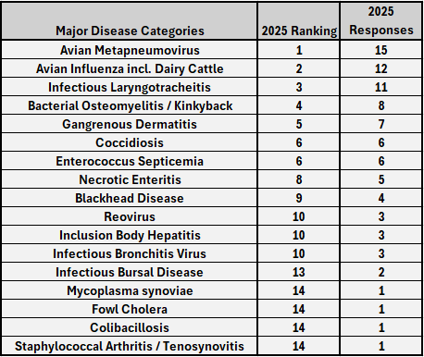

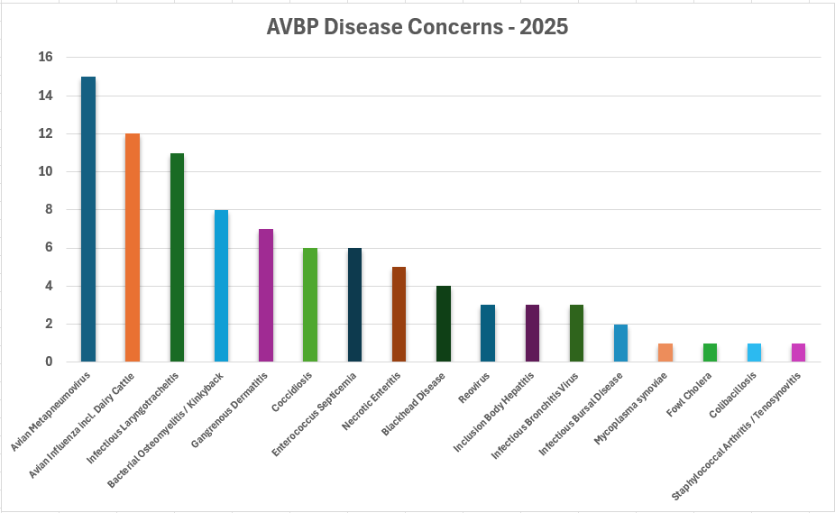

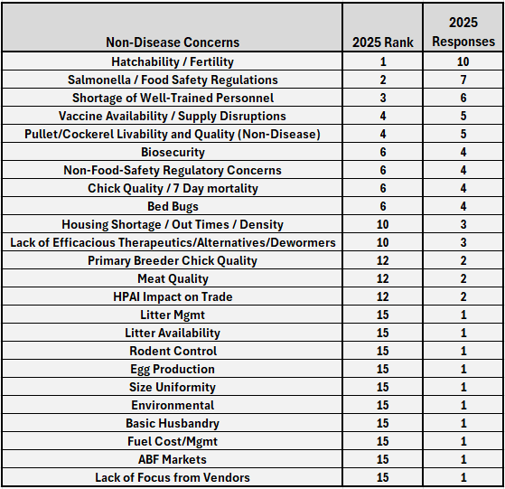

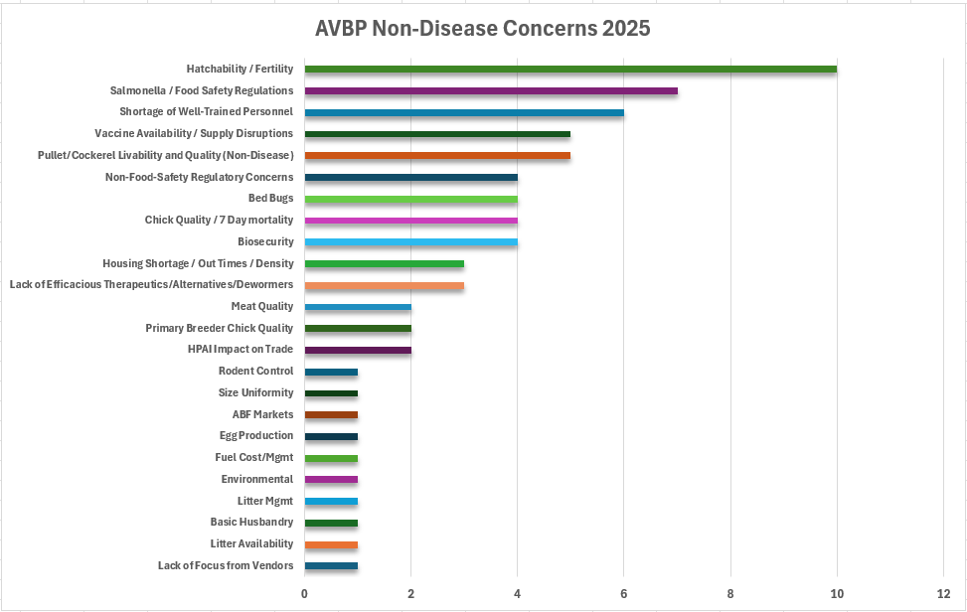
projected
Table Egg Layer Industry Report
Dr. Linnea Tracy, President of the Association of Veterinarians in Egg Production

A poll of members of the Association of Veterinarians in Egg Production (AVEP) based in the United States with a Veterinary-Client-Patient Relationship (VCPR) with layer pullet, breeder, and/or commercial layer flocks in the past calendar year was conducted in October 2025. Respondents answered questions applicable only to the types of birds under their supervision (pullet or mature layer) as well as the type of production systems those flocks were housed within (conventional, cage-free/aviary/floor, organic categories for pullets, and for layers the previously noted categories as well as free-range/pastured). For each type of flock and production style of said flock in their care, respondents were asked to list the top 5 clinical conditions of importance in that category and numerically rank each by importance from 1 (least important) to 5 (very important). This question was presented in an open-ended style to avoid biasing potential responses. Responses were sorted and conditions listed were ranked by first analyzing the number of responses then the weighted importance of each condition (sum of each numerical importance response divided by total number of responses listing that condition).

In addition to the ranked clinical condition questions, additional questions relevant to conditions of ongoing importance to the poultry industry were added to this year’s survey. These included a question about the impact and level of concern of Avian Metapneumovirus (AMPV) infection in supervised flocks, as well as an open-ended question to list the specific impacts and sequalae of concern, and which specific production styles have been most impacted in the respondents’ experience. Highly pathogenic avian influenza (HPAI) was addressed by asking “Which additional, if any, tools or information would you like to use in order to better prevent and control the spread of highly pathogenic avian influenza (HPAI)?” This question was asked as an open-ended short answer style. Finally, the last question asked “On a scale of 1 to 5 with 1 being least and 5 being most, how interested are you in vaccination as a tool for HPAI prevention and control?”

25/30 (83%) of polled veterinarians responded to the survey.
The results of the disease survey are shown below by category in ranked order of importance as described above. The top 5 conditions in each category are bolded. The weighted importance score as well as the number of respondents listing each condition is included in each table. Note: “Chick Quality Concerns” encompasses yolk infection, non-starter, and similar concerns. “Management Concerns” encompasses non-infectious management concerns such as pullet training, lighting programs, etc.

Conventional Pullets – 20 responding veterinarians
Rank | Condition | Weighted Importance | Responses
1 | Coccidiosis | 3.1 | 13
2 | Infectious Coryza | 4.5 | 10
3 | AMPV | 3.6 | 7
4 | E.coli | 3.3 | 7
5 | Chick Quality Concerns | 3 | 6
6 | Necrotic Enteritis | 3.2 | 5
7 | Body Condition Concerns | 3.75 | 4
8 | IBV | 2.7 | 3
9 (tie) | Cannibalism/Pecking | 2 | 3
9 (tie) | Bursal Disease | 2 | 3
10 | HPAI | 4.5 | 2
11 | Newcastle Disease | 3.5 | 2
12 | Salmonella | 3 | 2
13 | Management Concerns | 1.5 | 2
14 | Vaccine Reactions | 1 | 2
15 | False Layer Syndrome | 5 | 1
16 | Infectious laryngotracheitis | 3 | 1
17 | Histomoniasis | 2 | 1

Cage-free/Aviary/Floor Pullets – 24 responding veterinarians
Rank | Condition | Weighted Importance | Responses
1 | Coccidiosis | 2.8 | 19
2 | Piling | 3.1 | 11
3 | E.coli | 2.9 | 9
4 | AMPV | 2.8 | 9
5 | Body Condition Concerns | 3.33 | 6
6 | Infectious Coryza | 3.8 | 5
7 | Necrotic Enteritis | 3.6 | 5
8 | IBV | 1.4 | 5
9 | Cannibalism/pecking | 4.3 | 3
10 (tie) | Mechanical damage/trauma | 4 | 3
10 (tie) | Chick Quality Concerns | 4 | 3
11 | Management Concerns | 3 | 3
12 | Other bacterial diseases | 4 | 2
13 | Histomoniasis | 3 | 2
14 (tie) | Newcastle Disease | 2.5 | 2
14 (tie) | Vaccine Reactions | 2.5 | 2
15 | Beak Conditioning Concerns | 5 | 1
16 | HPAI | 4 | 1
17 (tie) | Fatty Liver Syndrome | 3 | 1
17 (tie) | Mycotoxins | 3 | 1
18 | Bursal Disease | 2 | 1

Organic Pullets – 12 responding veterinarians
Rank | Condition | Weighted Importance | Responses
1 | Coccidiosis | 3.1 | 9
2 | Histomoniasis | 3.4 | 5
3 | E.coli | 4 | 3
4 | Chick quality concerns | 3.3 | 3
5 | Piling | 3 | 3
6 | Necrotic Enteritis | 2.7 | 3
7 | AMPV | 3.5 | 2
8 | IBV | 1 | 2
9 | Infectious Coryza | 5 | 1
10 | Pecking | 5 | 1
11 | Other bacterial diseases | 4 | 1
12 (tie) | Management concerns | 3 | 1
12 (tie) | Infectious laryngotracheitis | 3 | 1
12 (tie) | Vaccination reaction | 3 | 1
13 | Mechanical damage/trauma | 2 | 1
14 (tie) | Ascarid infestation | 1 | 1
14 (tie) | Bursal disease | 1 | 1

All surveyed veterinarians had VCPR oversight of cage-free/aviary/floor pullets and the majority also had oversight of conventional pullets. Coccidiosis ranked as the top concern in all categories, with Necrotic Enteritis (whose causation is often associated with coccidiosis) ranking just behind the top 5 in all categories. E.coli appeared as a top 5 concern in all pullet categories, and AMPV in 2/3 of pullet categories.

Conventional Layers – 21 responding veterinarians
Rank | Condition | Weighted Importance | Responses
1 | E.coli | 3.5 | 11
2 | AMPV | 3.4 | 7
3 | IBV | 1.85 | 7
4 | Infectious coryza | 3.8 | 6
5 | Necrotic enteritis | 3.6 | 5
6 | HPAI | 4.5 | 4
7 | Cannibalism/pecking | 4 | 3
8 | Mycoplasmosis | 3.7 | 3
9 | Heat stress | 2 | 3
10 (tie) | Body Condition Concerns | 3.5 | 2
10 (tie) | Mycotoxins | 3.5 | 2
11 | Infectious laryngotracheitis | 2.5 | 2
12 (tie) | Cloacal prolapse | 4 | 1
12 (tie) | Erysipelas | 4 | 1
13 (tie) | False layer syndrome | 3 | 1
13 (tie) | Hepatitis E | 3 | 1
13 (tie) | Marek's Disease | 3 | 1
14 (tie) | Feather loss | 2 | 1
14 (tie) | Management concerns | 2 | 1
14 (tie) | Trauma | 2 | 1
14 (tie) | Gout | 2 | 1

Cage-free/Aviary/Floor Layers – 24 responding veterinarians
Rank | Condition | Weighted Importance | Responses
1 | E.coli | 3.7 | 15
2 | AMPV | 3.5 | 10
3 | Piling | 3.33 | 9
4 | Other bacterial diseases | 3.14 | 7
5 | Necrotic enteritis | 3.1 | 7
6 | Cannibalism/Pecking | 3.6 | 6
7 | Ascarid infestation | 2.2 | 6
8 | HPAI | 5 | 4
9 | Body Condition Concerns | 3.5 | 4
10 | Infectious coryza | 3.25 | 4
11 (tie) | Coccidiosis | 2 | 4
11 (tie) | IBV | 2 | 4
12 | Mycoplasmosis | 2.6 | 3
13 | Salmonella | 2 | 2
14 | Trauma | 5 | 1
15 (tie) | Cloacal Prolapse | 4 | 1
15 (tie) | Mycotoxins | 4 | 1
16 (tie) | Focal ulcerative dermatitis | 2 | 1
16 (tie) | Red Mites | 2 | 1

Organic Layers – 15 responding veterinarians
Rank | Condition | Weighted Importance | Responses
1 | E.coli | 3.85 | 7
2 | AMPV | 3.3 | 6
3 | Erysipelas | 2.75 | 4
4 | GI Parasitism | 2.5 | 4
5 (tie) | Cannibalism/ pecking | 4 | 3
5 (tie) | Pasteurellosis | 4 | 3
6 | Spotty Liver Disease | 2.7 | 3
7 | HPAI | 5 | 2
8 | Red mites | 4.5 | 2
9 | Egg Drop Syndrome | 4 | 2
10 | Ascarid infestation | 3 | 2
11 | Salmonella | 2 | 2
12 | Fatty Liver Syndrome | 5 | 1
13 (tie) | Body condition concerns | 3 | 1
13 (tie) | Necrotic enteritis | 3 | 1
13 (tie) | Focal Ulcerative Dermatitis | 3 | 1
14 (tie) | IBV | 1 | 1
14 (tie) | Mycoplasmosis | 1 | 1

Free-range/Pastured Layers – 11 responding veterinarians
Rank | Condition | Weighted Importance | Responses
1 | E.coli | 4 | 7
2 | Spotty Liver Disease | 3.8 | 6
3 | Pasteurellosis | 3.3 | 6
4 | AMPV | 3.8 | 5
5 | Cannibalism/ pecking | 3.3 | 3
6 | Red Mites | 4.5 | 2
7 (tie) | Predation | 3 | 2
7 (tie) | Erysipelas | 3 | 2
8 | Fatty Liver Syndrome | 5 | 1
9 (tie) | GI Parasitism | 3 | 1
9 (tie) | Focal Ulcerative Dermatitis | 3 | 1

All surveyed veterinarians had VCPR oversight of cage-free/aviary/floor layers and the majority also had VCPR oversight of conventional layers. E. coli appeared as the top concern in all categories, and AMPV appeared in the top 5 in all categories. Cannibalism/pecking behavior was a top concern in all non-conventional categories. Pasteurellosis, erysipelas, and other bacterial conditions ranked highly in all non-conventional categories, notably taking the top 3 slots in free-range/pastured layers. As in previous years, weighted importance scores in free-range/pastured flocks are higher, potentially reflecting higher clinical severity observations. Red mites are notable additions to organic and free-range/pastured categories, although Northern Fowl Mites were present on the top 10 list for cage-free (indoor only) layers in the 2024 survey.

The results of AMPV questions are shown below in graphical format indicating number of responses for each response category. Responding veterinarians indicated that most had a moderate to high level of concern for the impacts of AMPV in their flocks, with responses nearly normally distributed in a bell curve. Veterinarians are most concerned with decreased production (transient or recurring), secondary bacterial infections, and mortality in affected flocks. Respondents indicated that cage-free/aviary/floor flocks were most affected by AMPV, and cumulatively cage-free/aviary/floor, organic, and free-range/pastured flocks were most affected. These categories are disproportionately populated with brown layers, which respondents also indicated were highly impacted (32% response).

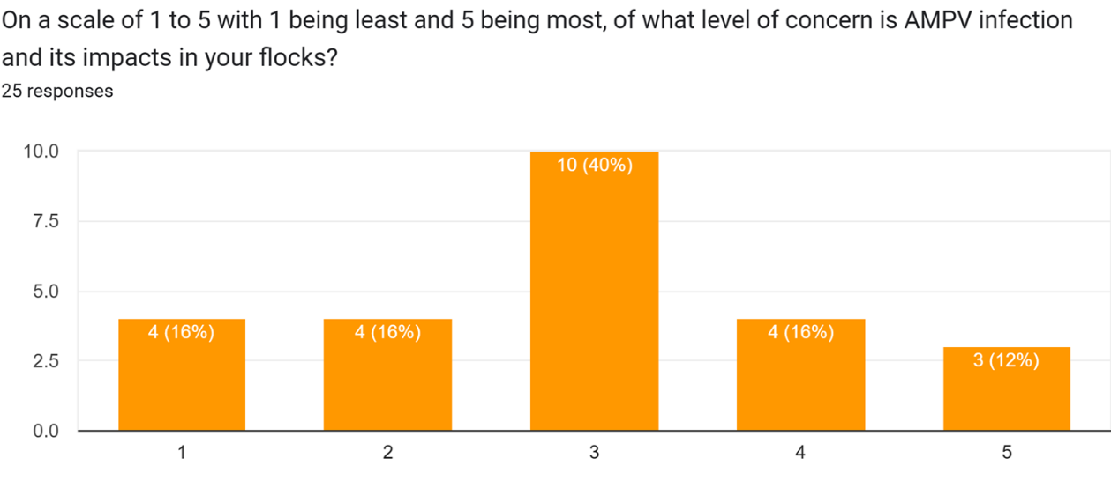

Specific complications or sequalae of most concern to responding veterinarians who have experienced AMPV in their flocks:
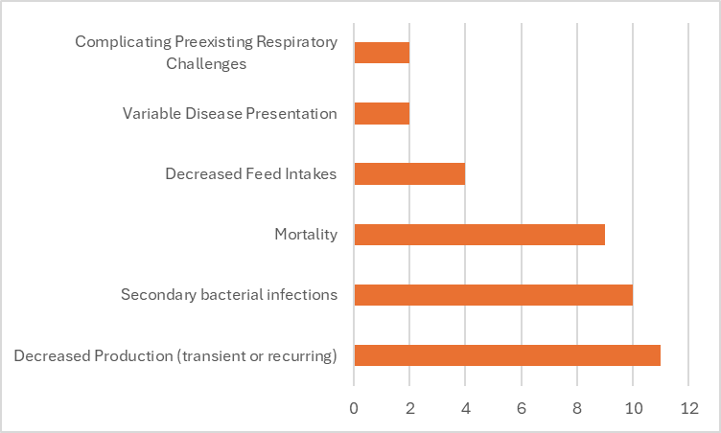

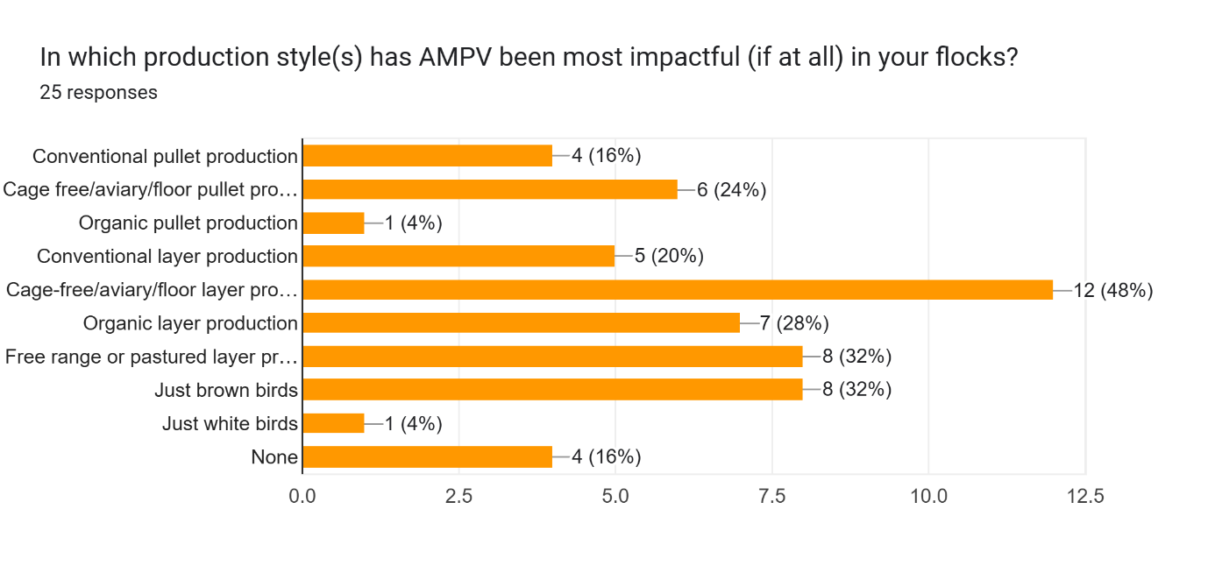

The results of HPAI questions are shown below in graphical format indicating number of responses for each response category. Questions were asked in the order they are presented in order to avoid biasing respondent answers. A majority of respondents (16/24) indicated they would like to have access to vaccination against HPAI. This response was more than doubly popular than any other answer provided when asked an open-ended question about tools or information to control HPAI spread. When then specifically queried as to their level of interest in vaccination against HPAI, 84% of respondents answered that they were very interested in using vaccination.

“Which additional, if any, tools or information would you like to use in order to better prevent and control the spread of HPAI?”

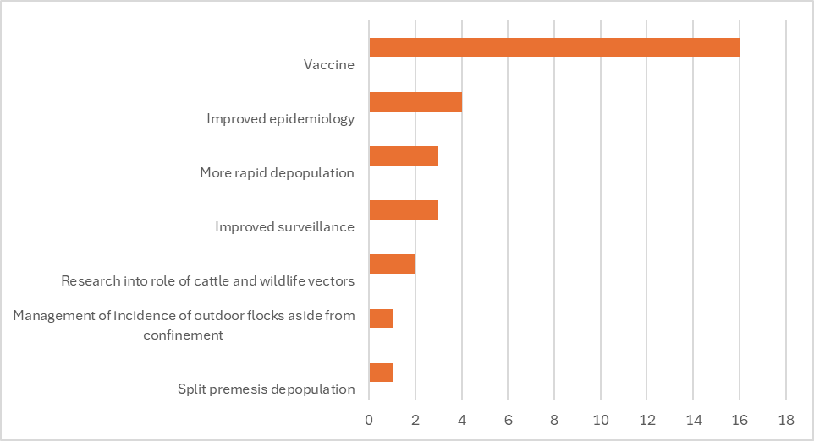
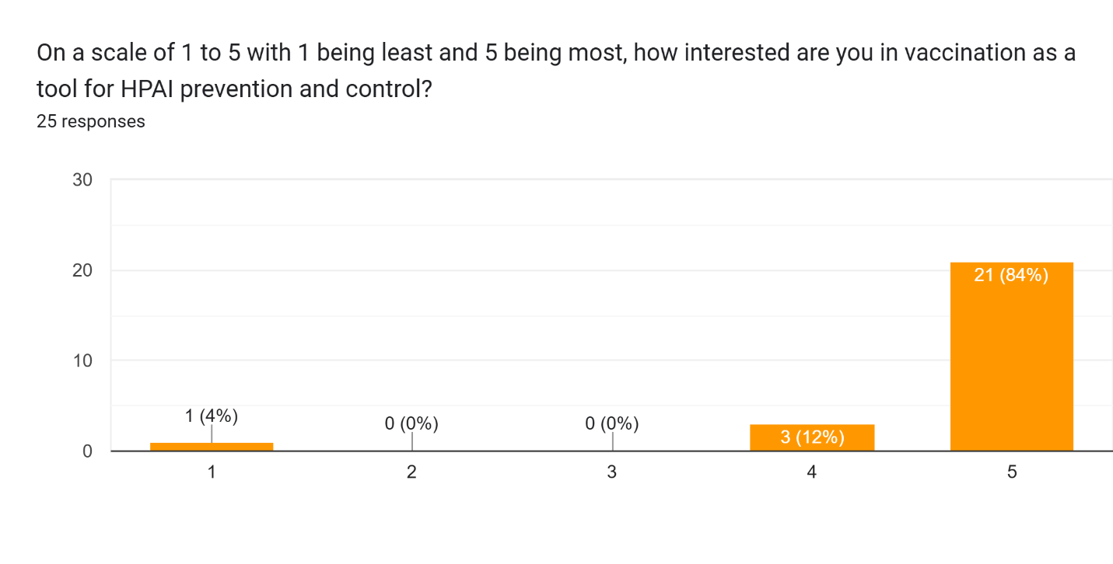

Turkey Industry Report
Dr. Carrie Cremers, President of the Association of Veterinarians in Turkey Production

2025 Turkey Industry Annual Report - Current Health Issues Facing the US Turkey Industry

Steven R. Clark, DVM^{1,2*}
Professional Veterinary Services Manager, Turkeys
Huvepharma, Inc.
Peachtree City, Georgia

Lindy Froebel, PhD
Sr. Vice President of Science and Policy
National Turkey Federation (NTF)
Washington, DC

Carrie Cremers, DVM, MAHM
Manager of Technical Service and Animal Welfare
President, Association of Veterinarians in Turkey Production (AVTP)
Jennie-O Turkey Store
Willmar, MN

¹Turkey Industry subcommittee chairman of the United States Animal Health Association Committee on Poultry and Other Avian Species.
²Clark, et.al. Turkey Industry Annual Report available since 2000 <www.usaha.org>
*Contact: steven.clark@huvepharma.us

For the 2025 annual report to the USAHA Committee on Poultry & Other Avian Species, a survey of U.S. turkey industry veterinarians and production professionals (n = 21) was conducted to assess the health status of turkeys produced from August 2024 through August 2025. Surveys were collected by a third party, blinded, and provided to the Subcommittee Chair, Dr. Clark, for analysis. The 2025 survey represented 201.4 million head—equivalent to 101% of the 200.0 million turkeys reported raised by USDA. Table 1 summarizes the leading disease and management issues identified (n=39 issues). The top three challenges remained unchanged from 2024, led by Avian Metapneumovirus (aMPV) (#1), lack of efficacious drugs (#2), and Highly Pathogenic Avian Influenza (HPAI) (#3). Clostridial Dermatitis (Cellulitis) and Colibacillosis exchanged positions at #4 and #5, respectively. Enteric diseases ranked in the lower half (16 and below; Figure 1A), while five respiratory diseases appeared among the top ten overall (Figure 2B).

Reovirus continues as a notable issue in the 2025 survey, TR-DFTR (Turkey Reovirus Digital Flexor Tendon Rupture) and THRV (Turkey Hepatitis Reovirus), ranked #9 and #11 respectively, from #6 and #10 the prior year. Reovirus infections may be associated with “Leg Problems” (#8) and “Bleeders” (aortic, hepatic ruptures), moved from #18 to #25. In addition, Ornithobacterium rhinotracheale (ORT) (7, stayed same) and Bordetella avium (11 to #15) and Blackhead (13 to #16) moved down in ranking. This year respiratory diseases make up five of the top 10 rankings, Table 1B. Mycoplasma synoviae (MS) jumped up to #10 (159 cases reported, Table 2) from #19 (161 cases).

Avian Metapneumovirus (aMPV) rose from years at the bottom (38 in 2023) of the ranking to #1 of the 2024 survey and reported 2,355 cases. The 2025 Survey again ranks aMPV #1 and reported 5,964 cases. aMPV is closely associated with secondary issues including, lack of drugs, colibacillosis, ORT and Bordetella. The introduction of Avian metapneumovirus (aMPV) into the United States was suspected in late 2023, with subtype A detected in California and subtype B in North Carolina. By January 2024, the rapid dissemination of aMPV was confirmed in both states, and within four months, it had spread to most poultry-producing regions nationwide (Figure 1).

aMPV is affecting all categories of poultry, including turkeys, broiler chickens, egg layers, and breeder poultry. Among these, turkeys are the most significantly impacted. Turkey breeders are experiencing egg production declines ranging from 20% to 100%, lasting 2 to 4 weeks. This decrease in egg production is leading to disruptions in the poult supply chain. In commercial turkey flocks, mortality rates can be severe, approaching 100%, with clinical disease persisting for up to three weeks. Secondary infections, including Escherichia coli, cholera (Pasteurella multocida), ORT (Ornithobacterium rhinotracheale), and MG (Mycoplasma gallisepticum), complicate the clinical disease in all poultry species.

On December 20, 2024, the USDA issued the first-ever permit for the importation of a modified live virus vaccine produced outside the United States, an Avian Metapneumovirus vaccine (Figure 2). Since the issue of the first importation of a modified live vaccine USDA’s Center for Veterinary Biologics (CVB) has issued import permits for five commercial modified-live aMPV vaccinations and two commercial killed aMPV vaccinations. This landmark decision by APHIS marks a pivotal step in controlling aMPV in the U.S. NTF has continued communication with CVB as aMPV vaccines became available in the field and has encouraged extensions of the one-year import permits to continue addressing the disease until USDA approved domestically produced vaccines become available.
In year four of the current Highly Pathogenic Avian Influenza (HPAI) outbreak in commercial poultry, NTF remains actively engaged in the response to the virus. Since the start of the outbreak more than 179.8 million birds have been lost, over 20.2 million of which have been commercial turkeys. As of October 17, there have been 110 commercial turkey cases in 2025 resulting in a loss of more than 2.9 million birds. HPAI continues to be a key focus of the full NTF team. Over the last year, there have been several key events, including USDA Secretary Brooke Rollins releasing her 5-point plan to address HPAI and lower egg prices. At NTF's direction, Senators Klobuchar (D-MN), Grassley (R-IA), Rounds (R-SD) and Slotkin (D-MI) sent a letter urging Secretary Rollins to broaden USDA’s strategy for managing HPAI to include measures for turkeys. USDA has since expanded the strategy to include all poultry species, and NTF has assisted members with the cost sharing opportunity for enhancing biosecurity measures identified through biosecurity audits.

Currently, biosecurity remains the only tool to prevent HPAI introductions into turkey flocks. At NTF’s Annual Convention in February, NTF’s Board of Directors passed the following policy statement related the HPAI vaccination.

The National Turkey Federation (NTF) supports research on finding an effective vaccine for Highly Pathogenic Avian Influenza (HPAI), improving vaccine and diagnostic technology while creating a vaccination plan for commercial poultry. As vaccine technology advances, there is growing interest in using a HPAI vaccine to prevent disease spread and reduce losses as part of a "stamping out" approach. As a parallel path, NTF strongly encourages USDA to renegotiate with key trading partners to minimize the implication of vaccine deployment.

NTF continues to prioritize efforts that align with the Federation’s policy resolution on vaccination and remains engaged with policy makers at the White House, USDA and on Capitol Hill. NTF is a member of the USDA HPAI Poultry Response Strategies Working Group that provided feedback as USDA developed a HPAI vaccination strategy to be presented to Secretary Rollins. NTF continues to engage on the HPAI vaccination, and looks forward to reviewing a potential strategy.

The lack of approved, efficacious drugs ranks for the second year in a row at #2 and is likely a contributor to all turkey health challenges and disease issues that follow it on the ranking list. In 2024 to present, veterinarians have prescribed antibiotics to manage secondary bacterial infections associated with the widespread aMPV outbreak. NTF’s Turkey Health Task Force continues to engage with industry and regulatory agencies to advance efforts to bring new animal health products to market for the turkey industry. NTF participated in a poultry health roundtable to discuss animal health and welfare challenges and additional solutions needed by the industry to further highlight the need for new animal health products for the turkey industry in 2024. Following, The Reagan-Udall Foundation for FDA published the report Transforming Animal Health in the U.S. for the 21st Century in June with recommendations for reforming FDA’s regulatory framework to be reflective of current technology and more appropriately address industry needs.

In April 2025 the U.S. Department of Commerce launched the Section 232 investigation into pharmaceuticals to assess whether pharmaceuticals and pharmaceutical ingredients and their derivative products, “are being imported into the United States in such quantities or under such circumstances as to threaten to impair the national security.” NTF joined comments prepared by the Animal Health Institute (AHI) to discuss the importance of animal health products that could potentially fall under Section 232. NTF will continue to engage with others in the industry and voice the importance of importing necessary pharmaceuticals and pharmaceutical ingredients for animal health ingredients.

Reported cases of Mycoplasma synoviae (MS) and M. gallisepticum (MG) was 159 and 75 respectively, from 161 and 43 prior year. Cases of Turkey Reovirus Digital Flexor Tendon Rupture ranked #9 in 2025 reported 273 cases (#6 and 368 prior year). THRV (Turkey Hepatitis Reovirus) ranked #11 (#9 prior year). Added to the survey as an emerging disease in 2021, Streptococcus gallolyticus (aka, S. bovis) dropped to #29 from #23.

Turkey Arthritis Reovirus (TARV) also called, Turkey Reovirus Digital Flexor Tendon Rupture (TR-DFTR), was recognized as a newly emerging disease in 2011. A unique reovirus has been isolated and identified as the cause of tenosynovitis and digital flexor tendon rupture in commercial turkeys. Clinical signs in young flocks are reportedly mild to nonexistent but can develop into lameness and/or abnormal gait in older flocks, starting at about 12 weeks of age. Affected flocks may also report an increased incidence of aortic ruptures and poor flock performance (weight gain, uniformity). Research continues into pathogenesis, virus characterization, diagnostics and epidemiology. Research indicates that the turkey arthritis reovirus is distinct from the recently identified novel reovirus causing arthritis in chickens, and most like the turkey enteric reovirus. A 2019 NTF industry survey documented the severity of impact on the industry could be as high as $33.7 million with highly pathogenic strains of TARV.

Industry lacks commercial diagnostic and vaccine options for Turkey Reovirus. In 2024, the NTF Foundation publicly announced a Reovirus Project that has the purpose to provide a reward for the development and successful marketing of diagnostic tool and/or vaccine that aids in reducing the impact of reovirus on the turkey industry. The project details can be found on NTF’s website eatturkey.org. In 2025, NTF hosted a virtual reovirus symposium for NTF members and researchers to discuss ongoing reovirus research, industry challenges and opportunities to address the disease challenge moving forward.

THRV (Turkey Hepatitis Reovirus) is a disease issue added to this survey in 2020. THRV affected flocks ranged in age ranged from 7 to 46 days with a median age of 15.5 days. Mortality peaks and subsides in a week and the cumulative mortality is 3-8%. Dr. M. Lighty (2019, personal communication) describes THRV as “… increased incidence of viral hepatitis in poults caused by reovirus. This appears to be an emerging disease caused by a previously recognized pathogen. Gross lesions range from subtle mottling to multifocal white/gray/tan foci in the livers; mild hepatomegaly has also been noted in some cases. Histopathology on these livers shows severe multifocal hepatocellular necrosis with infiltration by macrophages, lymphocytes, plasma cells, and/or heterophils. Necrotic hepatocytes may fuse to form multinucleated syncytial cells and there is often marked fibrin accumulation in necrotic areas. Morbidity and mortality due to reoviral hepatitis can be highly variable. Risk factors for development of the disease and the economic significance of this disease on the turkey industry are not fully understood at this time.” There are indications from the field that flocks developing hepatitis as poults can go on to develop turkey reoviral arthritis during grow out.

ORT (Ornithobacterium rhinotracheale) which remained unchanged at #7 and scored 3.0 in 2025, compared to #7 (3.7) prior year, is a highly contagious respiratory disease in poultry caused by a gram-negative pleomorphic rod-shaped bacterium. It has been isolated from chickens, ducks, partridges, and guinea fowl. It was originally recognized in Europe and South Africa. ORT was first confirmed in the US turkeys in 1993. Horizontal transmission (such as, bird-to-bird, contaminated people and equipment) by direct and in-direct contact is the primary route of spread. However, vertical transmission is suspected (Hafez, 2000). In the fall of 1995, it was a major cause of respiratory disease in midwestern states and since it has become endemic across most of the USA. Management systems, such as brood-and-move have increased the exposure of ORT-naive birds to ORT in the finisher barns, resulting in respiratory disease and mortality in some operations. Biosecurity procedures must be taken. Proper water sanitation can minimize severity and spread. Vaccination is limited and results are varied (toxoids, bacterins). Bacterins are used in breeders. No commercial vaccine is approved. Limited application of controlled exposure efforts on individual flocks have shown value. ORT in turkeys is an identified critical research need.

Bordetella avium continues as a significant respiratory disease challenge; bordetellosis ranked #15 (scored 2.2) from prior year at #11 (scored 2.5). Bordetellosis, otherwise known as Turkey Coryza, is a highly infectious, acute upper respiratory tract disease of turkeys characterized by high morbidity and usually low mortality. Bordetella avium (BA) is a small, Gram-negative, non-fermentative, motile, strictly aerobic bacillus. Other birds and older turkeys can be carriers but may not show clinical signs. Commercial vaccines are available. Water sanitation and biosecurity are emphasized to control Bordetella.

Turkey Coronavirus (TCV) ranked #27 from #31 (prior year), as cases remained low to 54 from 31 cases in 2024 and 411 in 2023, as the TCV outbreak in one geographic area ended. TCV is also known as Coronaviral Enteritis of Turkeys, Bluecomb, Mud Fever, or Transmissible Enteritis.

Coccidiosis dropped scoring 1.8 (2.2) and its rank moved from #24 to #13. Concerns with coccidiosis control are likely reflecting the industry’s Raised Without Antibiotics (RWA), Antibiotic Free (ABF) and No Antibiotics Ever (NAE) market. RWA and NAE programs do not permit the use of ionophore anticoccidials and some programs prohibit FDA approved chemical anticoccidials, limiting anticoccidial programs to vaccination. An effective coccidiosis control program in turkeys involves the use of anticoccidial medications, and/or phytonutrients, and/or live vaccines and the subsequent development of immunity. Table 4 summarizes the US turkey production coccidia control programs. New in 2024, USDA granted conditional approval to a three-strain commercial turkey coccidiosis live vaccine (Huvepharma, Inc.) in addition to the previously licensed two strain product (Ceva). Nutritional dietary supplementation with phytonutrients is either via in-feed application or drinking water administration. Phytonutrients include organic acids, yeast, phytonutrients from plant extracts (saponin, yucca, etc.) and essential oils (oregano, carvacrol, thymol, cinnamaldehyde, capsicum oleoresin, turmeric oleoresin). Essential oils may be natural extracts or synthetic nature-identical compounds.

The industry was surveyed (only 20 of 21 reported) to classify their antibiotic programs (Table 3) defined by how anticoccidials and antimicrobials are allowed; ranking allowed mostly unchanged. Twenty percent (20%) of the industry turkeys in 2025 were reared NAE/ABF category, not significantly different from 19% prior year, similarly Conventional Use programs moved to 60% from 56% (2024). Conventional/Full Use program permits the proper use of any FDA approved antibiotics, administered in the feed or drinking water, including ionophores, bacitracin, bambermycins, and /or those deemed medically important to humans by FDA. The third category titled “No Growth Promotants, CRAU/CRAU-like” (Certified Responsible Antibiotic Use), only permits the therapeutic uses under the prescription and supervision of a veterinarian. Thirty percent (30%) of those turkeys reported were CRAU programs. No Antibiotics Ever (NAE) /Antibiotic Free (ABF, RWA), does not permit either in-feed or in-water antibiotics. FDA has stated that ionophore anticoccidials are antibiotics. New to the survey in 2025, tally the percentage of turkeys raised with “no hatchery injection of antibiotics” totaling 18%.

Salmonella ranked #6 this year. In April, the USDA Food Safety and Inspection Service (FSIS) announced the withdrawal of the proposed Salmonella Framework for Raw Poultry Products to further evaluate its approach based on public feedback. Although this specific proposed rule is not moving forward — a positive outcome given the significant concerns raised — FSIS has made it clear this action was not purely a deregulatory effort and that it plans to move forward with a change to continue addressing Salmonella in poultry products. NTF remains committed to working closely with the NTF membership to ensure any future policy is grounded in science, practical in application and aligned with current technologies and risk-based approaches and has advocated for the agency to update its Salmonella policy based on advances in technology and a better understanding of Salmonella.

USDA’s Center for Veterinary Biologics published Notice No. 24-15, Salmonella Vaccines and USDA Food Safety and Inspection Service’s Framework to Reduce Salmonella Illnesses Attributable to Poultry, to inform veterinary biologics manufacturers of FSIS’ interest in Salmonella vaccines for poultry. FSIS had indicated interest in learning about and engaging in discussions with veterinary biologics manufacturers on vaccination technologies, especially modified-live vaccines targeting FSIS’ proposed serotypes of public health concern or their associated serogroups. NTF views this as a promising opportunity to highlight the need for additional tools for the industry.

In July, congress passed the budget reconciliation package, The One Big Beautiful Bill Act, which included several Farm Bill provisions related to animal health, nutrition and commodity payments. A top priority for NTF was the inclusion of the “three-legged stool” that provides additional funding for the National Animal Disease Preparedness and Response Program (NADPRP), the National Animal Health Laboratory Network and the National Animal Vaccine and Veterinary Countermeasures Bank (NAVVCB). The House and Senate Agriculture Committees have turned their attention to drafting a Farm Bill that addresses the remaining sections not included in the July package. While committee leadership was optimistic that work could be done early in the fall, it is more likely a Farm Bill will not be completed this year. NTF will continue to advocate for the inclusion of provisions that are important to the turkey industry.

In 2024, turkey production decreased from 6,845,984 in 2023 to 6,442,185 1,000-pounds (live weight) and decreased to 200,000,000 turkeys raised (218,000,000 prior year) with an average live weight of 32.54 pounds (31.70 prior year). Per capita consumption for turkey products decreased to 13.8 pounds in 2024 from 14.7 pounds in 2023.

Table 1. Turkey health survey (August 2024 - 2025) of professionals in US turkey production (n = 21, head reporting = >201.4 million) ranking current disease issues (1= no issue to 5 = severe problem). Data on file.

Issue |  | Score Average (1-5)
Avian Metapneumovirus (AMPV) |  | 4.7
Lack of approved, efficacious drugs | 4.4
Avian Influenza, High Path (HPAI) | 4.1
Clostridial Dermatitis (Cellulitis) | 3.5
Colibacillosis | 3.4
Salmonella | 3.2
Ornithobacterium rhinotracheale (ORT) | 3.0
Leg Problems | 2.8
TR-DFTR (Turkey Reovirus Digital Flexor Tendon Rupture) | 2.8
Mycoplasma synoviae (MS) | 2.6
THRV (Turkey Hepatitis Reovirus) | 2.6
Heat Stress/Mortality | 2.5
Late Mortality | 2.4
Cholera | 2.3
Bordetella avium | 2.2
Blackhead (Histomoniasis) | 2.2
Tibial Dyschondroplasia (TDC, Osteochondrosis) | 2.2
Protozoal Enteritis (Flagellated) | 2.2
Mycoplasma gallisepticum (MG) | 2.1
Poult Enteritis of unknown etiologies | 2.1
Cannibalism | 2.1
Round Worms (Ascaridia dissimilis) | 1.9
Breast Blisters and Breast Buttons | 1.9
Coccidiosis | 1.8
Bleeders (aortic, hepatic ruptures) | 1.8
Osteomyelitis (OM) | 1.8
Turkey Coronavirus | 1.8
Avian Influenza, Low Path (LPAI) | 1.7
Streptococcus gallolyticus (aka, S. bovis) | 1.6
Newcastle Disease Virus (NDV) | 1.5
PEMS (Poult Enteritis Mortality Syndrome) | 1.5
H3N2 (H1N1) Swine Influenza | 1.5
Shaky Leg Syndrome | 1.5
Necrotic enteritis | 1.4
Erysipelas | 1.3
Fractures | 1.3
Mycoplasma meleagridis (MM) | 1.0
Mycoplasma iowae (MI) | 1.0
Spondylolisthesis (Kinky-Back) | 1.0

Table 1A. Turkey health survey (August 2024 - 2025) of professionals in US turkey production (n = 21, head reporting >201.4 million): Enteric Diseases Ranking for 2025.

Issue | Score Average (1-5) | Overall Rank (1-39)
Blackhead (Histomoniasis) | 2.2 | 16
Protozoal Enteritis (Flagellated) | 2.2 | 18
Poult Enteritis of unknown etiologies | 2.1 | 20
Round Worms (Ascaridia dissimilis) | 1.9 | 22
Coccidiosis | 1.8 | 24
Turkey Coronavirus | 1.8 | 27
PEMS (Poult Enteritis Mortality Syndrome) | 1.5 | 31
Necrotic enteritis | 1.4 | 34

Table 1B. Turkey health survey (August 2024 - 2025) of professionals in US turkey production (n = 21, head reporting >201.4 million): Respiratory Diseases Ranking for 2025.

Issue | Score Average (1-5) | Overall Rank (1-39)
Avian Metapneumovirus (AMPV) | 4.7 | 1
Avian Influenza, High Path (HPAI) | 4.1 | 3
Colibacillosis | 3.4 | 5
Ornithobacterium rhinotracheale (ORT) | 3.0 | 7
Mycoplasma synoviae (MS) | 2.6 | 10
Cholera | 2.3 | 14
Bordetella avium | 2.2 | 15
Mycoplasma gallisepticum (MG) | 2.1 | 19
Avian Influenza, Low Path (LPAI) | 1.7 | 28
Newcastle Disease Virus (NDV) | 1.5 | 30
H3N2 (H1N1) Swine Influenza | 1.5 | 32

Table 2. Turkey health survey (August 2024 - 2025) of professionals in US turkey production (n = 20, head reporting = 201.4 million): reporting cases of diseases. Data on file.

Cases (##) of | 2025 | 2024 | 2023 | 2022 | 2021 | 2020
Blackhead (Histomoniasis) | 60 | 51 | 61 | 103 | 130 | 82
Mycoplasma synoviae (MS) | 159 | 161 | 20 | 14 | 34 | 21
Turkey Coronavirus (TCV) | 54 | 31 | 411 | 459 | 117 | 27
Turkey Reovirus Digital Flexor Tendon Rupture | 273 | 368 | 487 | 170 | 239 | 548
Mycoplasma gallisepticum (MG) | 75 | 43 | 12 | 8 | 78 | 31
Avian Metapneumovirus (AMPV) | 5,964 | 2,355 | - | - | - | -

Table 3. Turkey health survey (August 2024 - 2025) of professionals in US turkey production (n = 20, head reporting = 201.4 million) by antibiotic program. Data on file.

 | 2025 | 2024
Conventional/Full Use¹ | 60% | 56%
No Growth Promotants, CRAU/CRAU-like² | 30% | 25%
NAE /ABF, RWA³ | 20% | 19%
No Hatchery Injection of Antibiotics⁴ | 18% | -

¹Conventional/Full Use (any antibiotics, including ionophores, bacitracin, bambermycins, and /or those deemed medically important to humans by FDA), allows in-feed and in-water administration of antibiotics.
²No Growth Promotants, CRAU/CRAU-like (Certified Responsible Antibiotic Use), permits only therapeutic uses.
³No Antibiotics Ever (NAE) /Antibiotic Free (ABF), Raised Without Antibiotics (RWA), does not use neither in-feed nor in-water antibiotics. No hatchery injection of antibiotics.
⁴No Hatchery Injection of Antibiotics means that antibiotics were not administered to the turkeys in the egg (in ovo) or as day-old hatchling poults.

Table 4. Turkey survey (August 2024 - 2025) of professionals in US turkey production (n = 20, head reporting = 201.4 million) coccidia control programs. Does not total 100%. Alternatives (phytonutrients) and vaccines may be used to supplement the current ionophore or chemical anticoccidial program, or as the sole program for coccidia control. Data on file. In 2025, due to the blinded nature of this study, it was not possible to verify the unique identity of each respondent. The reported coccidia control programs should therefore be interpreted with the understanding that some duplication of responses may be present.

Program | 2025 | 2024
Ionophore | 29% | 56%
Chemical | 27% | 41%
Alternative (Phytonutrients) | 20% | 11%
Vaccine | 34% | 26%

Figure 1: Map of aMPV cases in poultry. (Clark, aMPV Working Group)
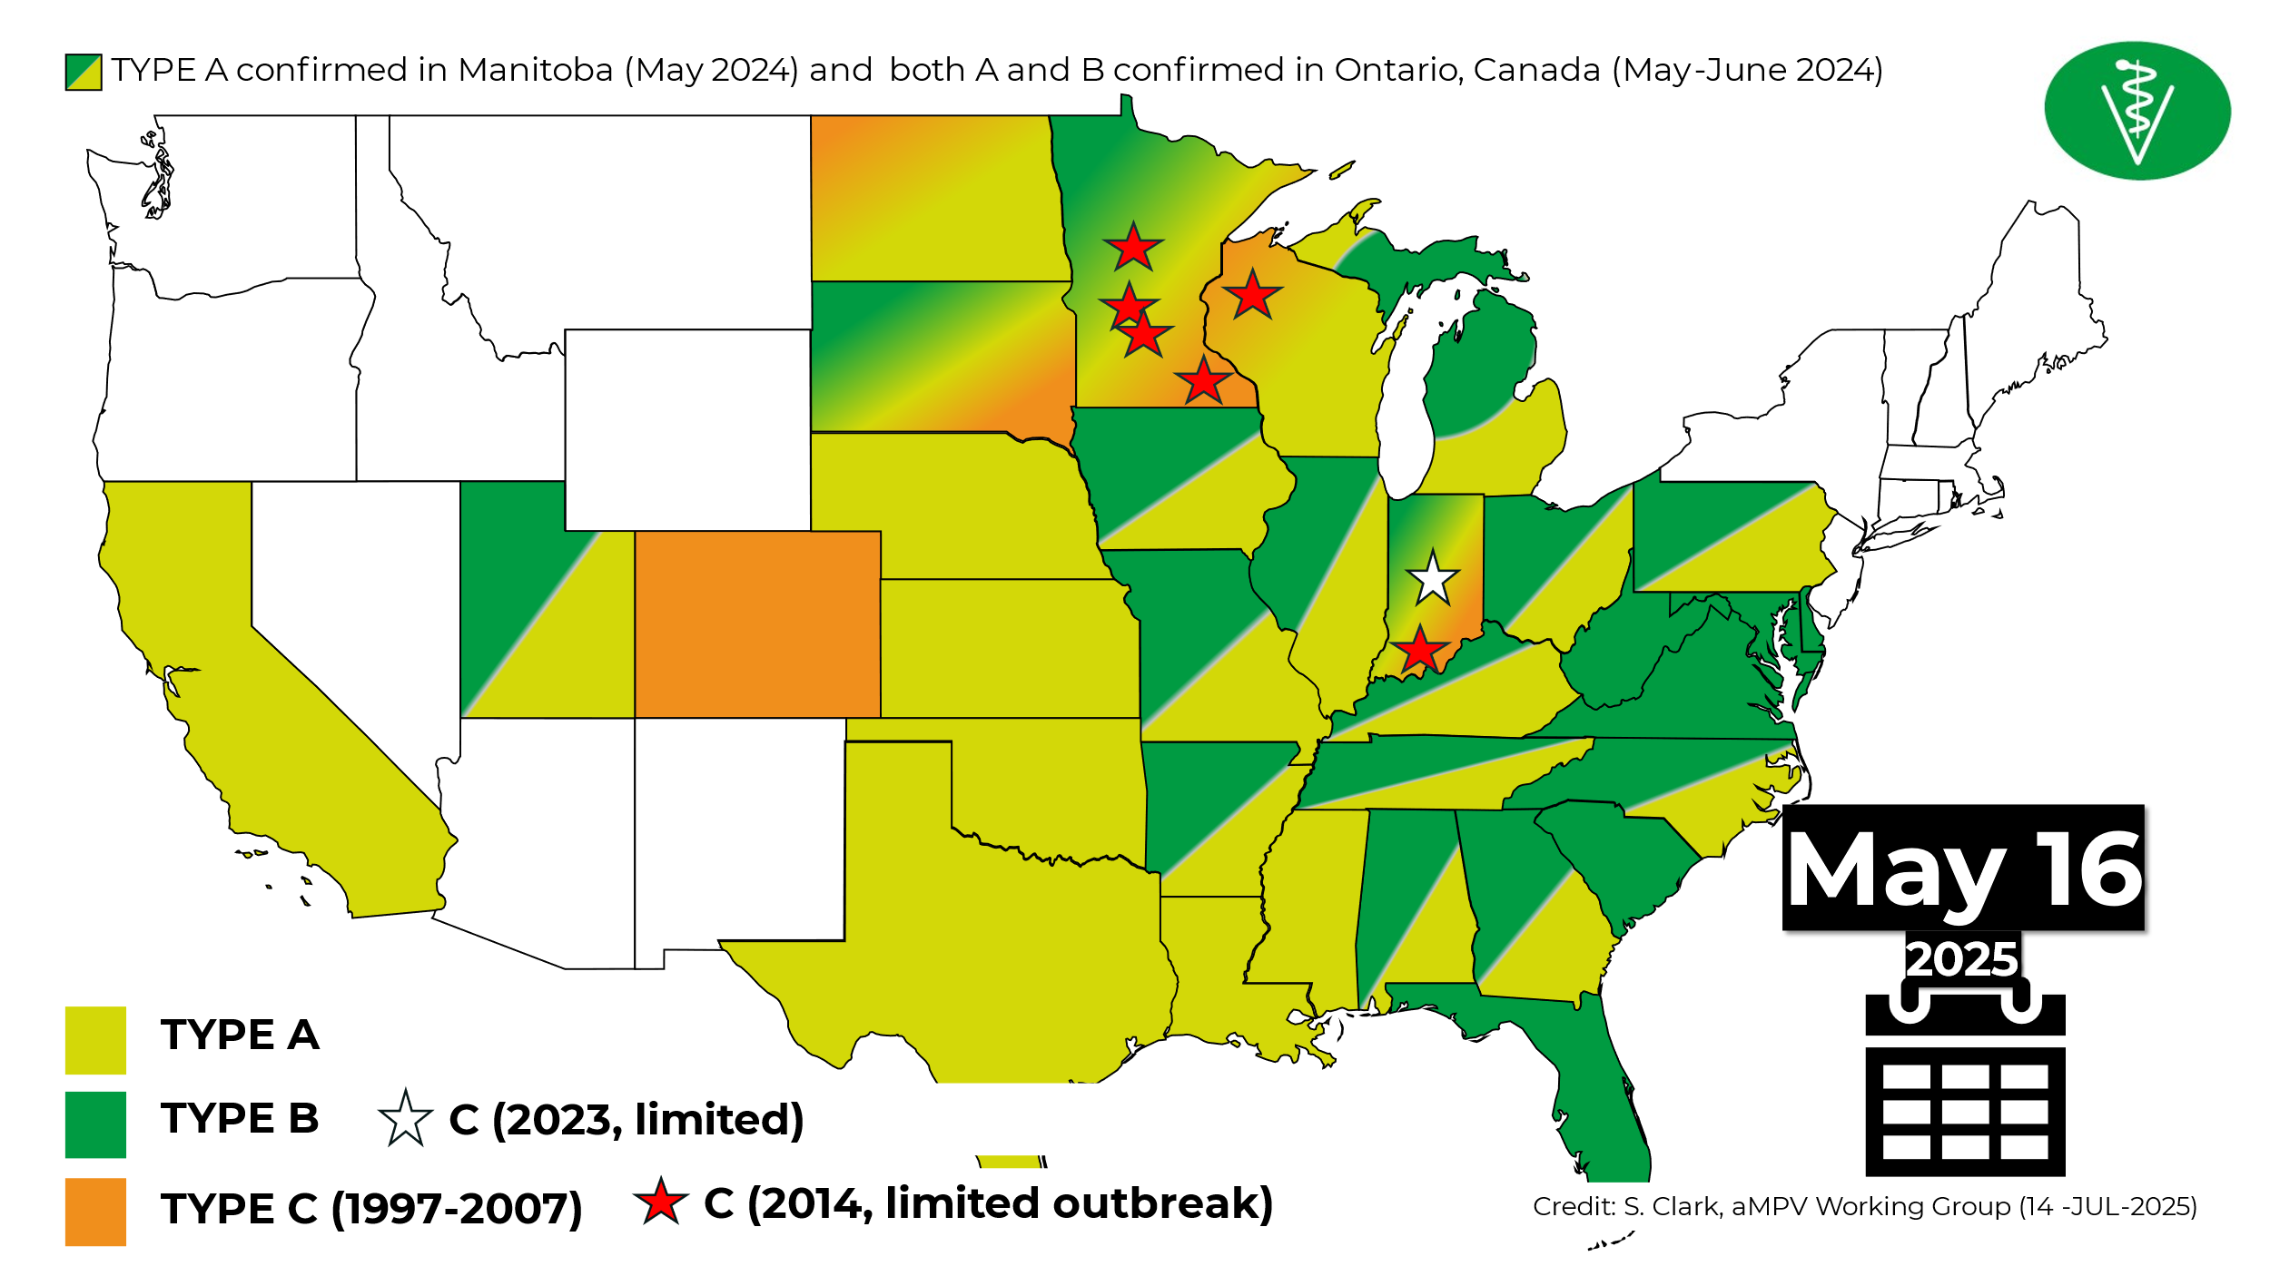

Figure 2. Vaccines Approved by USDA.

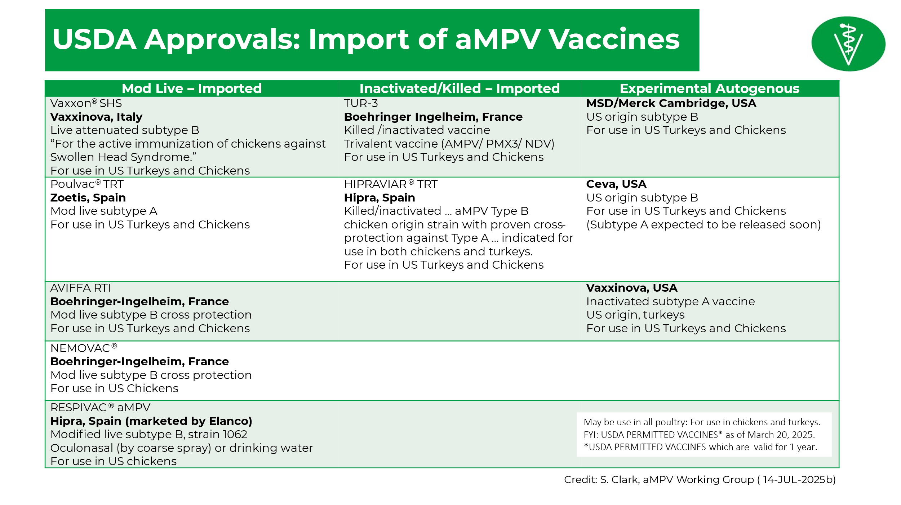

HVP.PO.102025.3

LBMS AI Program FY 2024 Working Group Report
Dr. Fidelis Hegngi, USDA-APHIS-VS

Live Bird Marketing System (LBMS) Avian Influenza (AI) Program
Fiscal Year (FY) 2025 Working Group Report

Dr. Fidelis N. Hegngi
U.S. Department of Agriculture
Animal and Plant Health Inspection Service (APHIS)
Veterinary Services (VS), Strategy and Policy (S&P)
Beltsville, MD.

The United States domestic low pathogenicity avian influenza (LPAI) program provides surveillance for H5 and H7 LPAI prevention and control in the Live Bird Marketing System (LBMS). Beginning in 1994, LPAI H7N2 proved to be endemic in live bird markets (LBMs) in the northeastern United States. In 1999, the United States Department of Agriculture (USDA) established a LBMS working group to support States wanting to eliminate LPAI H7N2 that was persistent in the LBMs. On October 20, 2004, USDA, Animal and Plant Health Inspection Service (APHIS) Veterinary Services (VS) published uniform standards for H5 and H7 LPAI prevention and control in the LBMS to establish a more consistent approach by participating States in controlling LPAI in the LBMS. USDA Veterinary Services (VS) revised the LBMS uniform standards in 2008, 2012, 2016, 2020, and 2024.

State participation is voluntary; participating States will enact regulations necessary for compliance with their LBMs, including producers, and distributors. All LBMs, producers, and distributors that supply the markets must be registered or licensed with the State and must allow Federal and State inspectors access to their facilities, birds, and records. These facilities must also have written biosecurity protocols in place. VS coordinates and administers the program and provides personnel and resources to assist States with implementation and compliance with program requirements.

In FY 2025 the LBMS Working Group held its annual business meeting in San Antonio, Texas. The meeting was attended by approximately 81 program participants including 28 VS field, district, and headquarters staff; 1 LBMS/poultry industry stakeholder; 5 State animal health diagnostic laboratory representatives; 5 university representatives; and 42 State Department of Agriculture participants representing 25 States. The meeting provides opportunities for continued program development, implementation, and advancement.

The working group also discussed:
(1) 2024 LBMS Uniform Standards –Changes and Additions to the 2024 Uniform Standards
(2) LBMS Status and FY2025 Budget Update.
(3) An update on Initial State Response and Containment Plan (ISRCP).
(4) An update on Cooperative Agreements, Indemnity, and Compensation procedures.
(5) Current HPAI Situation & Response in the United States.
(6) Texas LBMS.
(7) States Response to H5N1 HPAI in their LBMS - Challenges and Lessons Learned (California, Florida, New Jersey, New York, and Pennsylvania).
(8). Investigation of Illegally Imported Hatching Eggs into Texas.
(9) California HPAI H5N1 in Livestock and Poultry Challenges and Lessons Learned.
(10) HPAI Biosecurity Compliance Audit Program (BCAP).
(11) Response to Non-Poultry Animal Species on Positive HPAI Premises.
(12) Rural Live Bird Market Discussion and Regulation.
(13) HPAI – Role of Wild Birds & Update-Wild Bird AI Surveillance Projected for 2025 and Beyond.
(14) National Veterinary Services Laboratories - Update on Surveillance Testing - Current Nationwide Findings and Status of Current Diagnostics for AI and Newcastle Disease.
((15) Southeast Poultry Research Laboratory Update on HPAI Research and Vaccine.
(16) An Update on the National Poultry Improvement Plan (NPIP).
(17) An Update on the NPIP Authorized Laboratories System and Compartmentalization.
(18) Discussion on Outreach and Education Projects: Defend the Flock (DTF) – Combined Campaign Update: Bird Awareness Week; Flock Defender; Youth Outreach; and Calendar Replacement.
(19) 2024 LBMS Continuing Education Training Course at the School of Veterinary Medicine, University of California, Davis, CA.

In FY2025 USDA leveraged the Defend the Flock social channels and USDA APHIS LinkedIn account to share timely updates on the HPAI outbreak and reinforce the importance of biosecurity. A paid media campaign was deployed across Facebook, X, and LinkedIn channels, along with Search Engine Marketing and Google Display Network ads, alerting commercial and backyard bird owners to the threat of HPAI. Additional Defend the Flock paid media and outreach efforts targeting the small farm and backyard audiences included: Print and online ads distributed in partnership with Backyard Poultry Magazine; Paid programmatic audio placements disseminated campaign messaging relevant to all target audiences; and YouTube advertising ran to further connect with the young future farmer audience.

During Bird Health Awareness Week, February 16-22, 2025, APHIS distributed an audio news release (ANR) featuring Dr. Katy Burden on the importance of multi-species biosecurity, it aired across 360 stations in 108 markets. APHIS shared an awareness post on the Defend the Flock Facebook channel.

APHIS held the annual Defend the Flock webinar on April 17, 2025. Dr. Melissa Yates from Veterinary Services shared critical information about protecting poultry on a multi-species farm. 877 people attended.

APHIS conducted a radio media tour (RMT) on August 27, 2025, with Dr. Chrislyn Wood-Nicholson to spread Defend the Flock campaign messages and educate listeners on biosecurity best practices. Dr. Wood interviewed 18 radio stations across 14 states and four national outlets.

APHIS distributed a custom matte article titled, “What You Need to Know About Avian Influenza,” to media outlets nationwide from March through July 2025. The article ran 1,086 times.

APHIS shared the Fall 2024 and Spring 2025 Biosecurity News Bulletins on the Defend the Flock website. We ran paid ads across the Defend the Flock social channels alerting audiences of the new resources. We also sent GovDelivery eblasts to alert USDA stakeholders. The Fall 2025 Biosecurity Bulletin will be available soon on the Defend the Flock website.
The 2026 Defend the Flock calendar, refreshed to align with current campaign branding and utilizing engaging imagery, will be available this fall.

APHIS refreshed the “Healthy Harry” video series to align with current video standards and campaign branding. The updated videos will be uploaded to YouTube this fall and promoted to key audiences to encourage views.

In FY 2025, avian influenza surveillance in the LBMS remained a high priority. Approximately 65,871 tests have been conducted for LPAI surveillance in the LBMS, for the first three quarters. Tests included agar gel immunodiffusion (AGID), real-time reverse-transcriptase polymerase chain reaction (rRT-PCR), antigen capture immunoassay (ACIA), and virus isolation (VI). For VI and rRT-PCR, each sample may represent 5 or 11 individual swabs pooled for a composite single test. There were 4 backyard producers (WOAH- Poultry) H5N2 LPAI detections in Pennsylvania {Berks County-2, Mifflin County-1, and Lebanon County-1); 1 Auction Market / Live Bird Sales (non-slaughter) H5N2 LPAI detections in Lancaster County, Pennsylvania; 1 Backyard (WOAH- Poultry) H5N2 LPAI detection in Orleans County, New York; and 9 LBMs with H6N2 LPAI detection (NY-3, NJ-3, PA-1, and TX-2. During the FY 2025 HPAI outbreak, 32 LBMs, 2 LBMS production flocks and 2 Live Bird Sales (non-slaughter were found positive for H5N1 HPAI Clade 2.3.4.4b.

NVSL Bacteriology Diagnostics
Dr. Kim Lehman, USDA-APHIS-VS-NVSL

Poultry Salmonella, Mycoplasma, and Pasteurella Diagnostics at the NVSL
January 1-December 31, 2024

T. Mackie, K. LeCount, A. Haluch, K. Toot

Diagnostic Bacteriology and Pathology Laboratory, National Veterinary Services Laboratories, USDA
Ames, IA 50010

Salmonella serotyping

The Bacterial Identification section within the Diagnostic Bacteriology and Pathology Laboratory of the National Veterinary Services Laboratories (NVSL) routinely performs serotyping of Salmonella isolates submitted by private, state, and federal laboratories as well as veterinarians, researchers, and other animal health officials. This report summarizes Salmonella serotyping submissions to the NVSL from January 1 through December 31, 2024, originating from poultry.

Salmonella isolates are identified as clinical (clinical signs of salmonellosis from primary or secondary infection) or non-clinical (flock monitoring programs, environmental sources, feed). Serotyping data from isolates submitted for research purposes are not included in the summary.

From January 1 to December 31, 2024, the NVSL received 8,630 isolates for Salmonella serotyping. Of those, 3,947 isolates were from chicken sources, and 139 isolates were from turkey sources. The most isolated serotypes from chicken and turkey are listed in Tables 1 and 2, respectively.

Salmonella Enteritidis

From January 1 to December 31, 2024, 3,947 Salmonella isolates were received from chickens and their environment for identification of serotype. This was a 5% increase in chicken submissions from 2023. Salmonella Enteritidis was isolated in 7% of these isolates and remains in the top five serotypes observed in both clinical and non-clinical submissions.

Salmonella Pullorum and Gallinarum

The NVSL received 225 samples for Salmonella Pullorum and Gallinarum serological testing in 2024, a slight increase from 2023. No isolates of Salmonella Pullorum or Gallinarum were identified or confirmed at the laboratory in 2024. The NVSL provided 3,315 mL of S. Pullorum tube antigen; 1,650 mL of S. Pullorum stained microtiter antigen; and 454 mL of control antisera to testing laboratories between January 1 and December 31, 2024.

Pasteurella

The NVSL received 198 isolates for Pasteurella multocida Gel-Diffusion Precipitin testing. Thirty-seven isolates were identified as type 3 in 2024. Summary of somatic types of Pasteurella multocida is listed in Table 3. Additionally, 82 isolates were received for P. multocida DNA fingerprinting. The NVSL supplied 5 mL of P. multocida typing sera and 4 cultures to testing laboratories.

Mycoplasma

The NVSL received 46 samples for avian Mycoplasma hemagglutination inhibition testing in 2024. In addition, 324 mL of Mycoplasma control antisera and 106 mL of Mycoplasma hemagglutination antigen were supplied to testing laboratories. Information on Mycoplasma reagents provided is shown in Table 4.

Table 1: Most common serotypes in 2024: Chicken
Clinical Cases | Non-Clinical Cases
Serotype | Serotype
Enteritidis | Kentucky
Kentucky | Senftenberg
Typhimurium | Worthington
Hadar | Enteritidis
Schwarzengrund | Typhimurium

Table 2: Most common serotypes in 2024: Turkeys
Clinical Cases | Non-Clinical Cases
Serotype | Serotype
Agona | Typhimurium
Schwarzengrund | Senftenberg
Infantis | Alachua
Senftenberg | Liverpool
Hadar

Table 3: Somatic types of Pasteurella multocida observed at the NVSL
 | 2024
Type 1 | 66
Type 3 | 37
Type 3,4 | 15
All other | 80
TOTAL | 198

Table 4: Mycoplasma antisera (mL) and antigen (mL) provided by NVSL
Mycoplasma | Antisera | Antigen
M. gallisepticum | 114 | 44
M. meleagridis | 27 | 9
M. synoviae | 100 | 53
Negative | 83
Total | 324 | 106

Ewing, WH. 1986. Edward and Ewing’s Identification of Enterobacteriaceae. 4th edition. Elsevier Science Publishing Co., Inc., New York, U.S.
Grimont, PAD, Weill, FX. 2007. Antigenic Formulae of the Salmonella Serovars. 9th edition. WHO Collaborating Centre for Reference and Research on Salmonella. Paris, France.

National Poultry Improvement Plan (NPIP) Update
Drs. Savannah Busby and Katy Burden, USDA-APHIS-VS-ASEP-NPIP

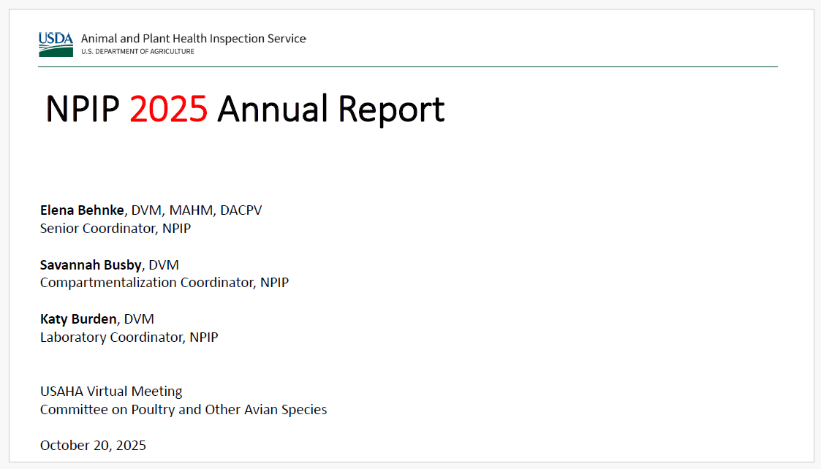

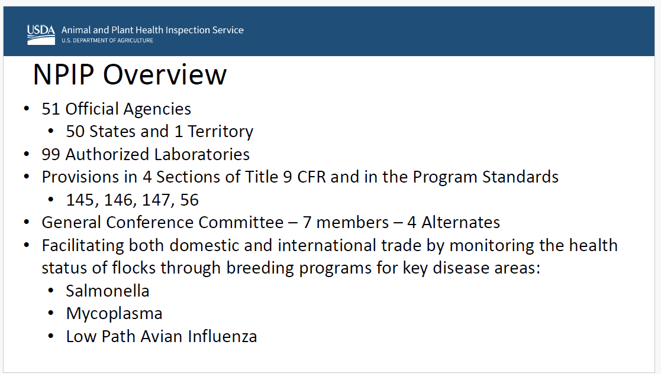

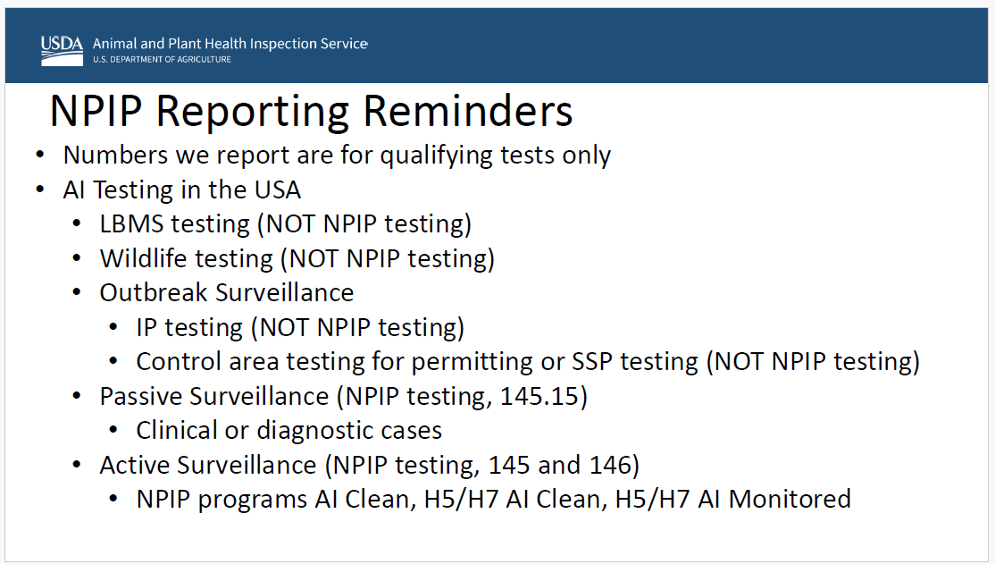

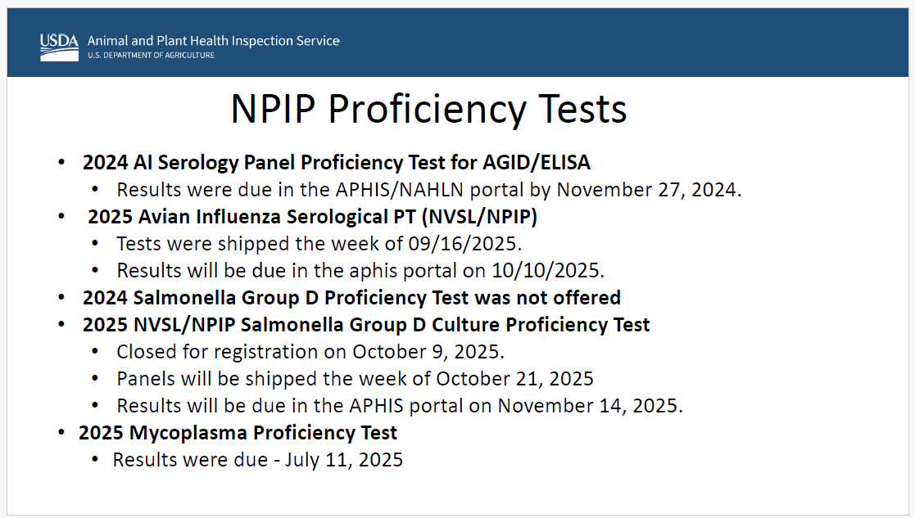

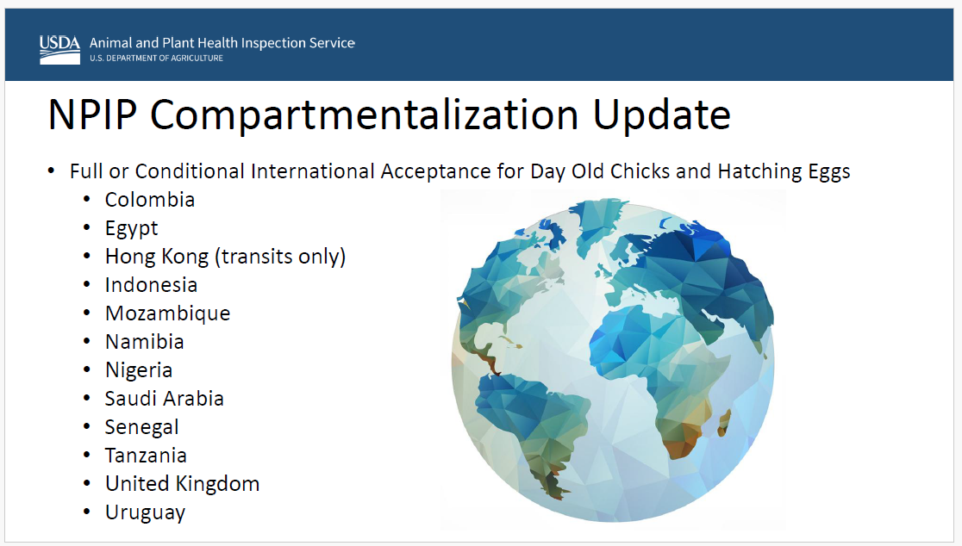

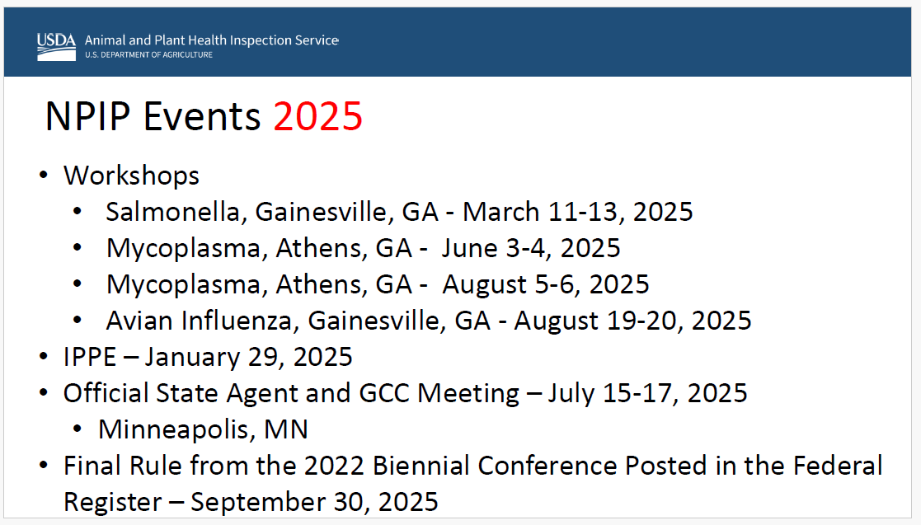

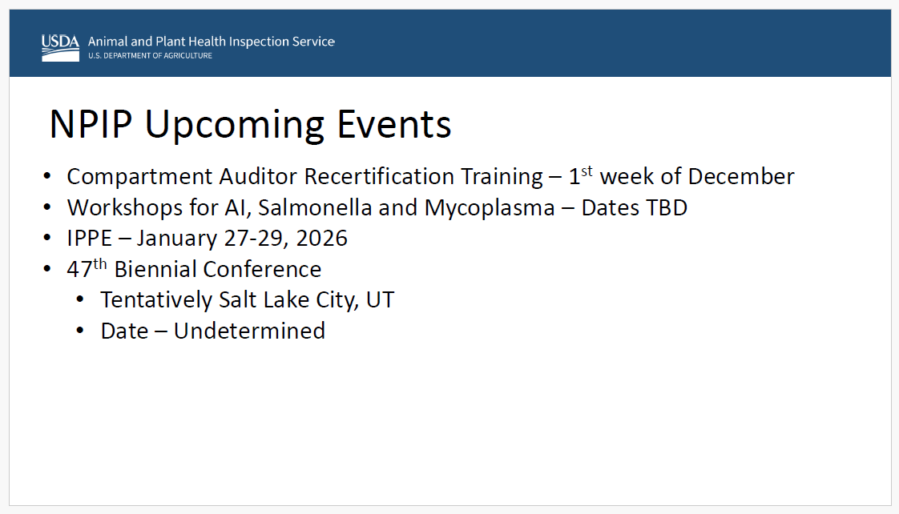

AI/NDV Disease Subcommittee Report
Dr. David Suarez, USDA-ARS-SEPRL

The standing subcommittee reports provides a review of notable outbreaks of avian influenza and Newcastle disease that occurred outside the United States in the last year (October 2024 to September 2025). A variety of public sources were used to compile these results including the World Organization for Animal Health (WOAH), The United Nations Food and Agriculture Organization, the European Centre for Disease Prevention and Control, published manuscripts, news reports and personal observations. Despite the variety of sources, many outbreaks lack detail about the virus and the impact on poultry or wild bird populations.

Newcastle Disease Virus

Newcastle disease virus had several notable outbreaks in Canada and Europe. In May of 2025, Canada reported an outbreak of virulent Newcastle disease on 2 commercial squab farms in the Fraser Valley affecting over 22,000 pigeons. Because the squab farms were related to meat production, the outbreaks were reportable as poultry to the World Organisation of Animal Health (WOAH). Sequence analysis showed the viruses to be class II genotype V 1. This lineage is more commonly referred to as pigeon paramyxovirus lineage, because it is primarily found in pigeons. This lineage is found worldwide and causes disease outbreaks in wild pigeons and farm raised pigeons on squab farms. The Canadian farms were not vaccinated, although killed vaccines are available and are used in the U.S to protect birds from clinical disease. This lineage of virus is virulent to chickens in the intracerebral pathogenicity index (ICPI) test, but this lineage of virus appears to be highly pigeon adapted and does not cause disease in chickens when given by a natural route of inoculation.¹

In the European Union, outbreaks in 6 different countries were reported to WOAH, but with one major exception were contained to just 1 or 2 farms in each country including Malta, North Macedonia, Sweden, Bulgaria, and Slovenia. A large and continuing outbreak is occurring in Poland. The outbreak appears to be continuing from outbreaks from 2023 and has affected over 5 million birds since Sept. 2024. Sequence supports the virus as a Class II genotype VII 1.1 lineage. This lineage is widely found in Europe, Asia, and Africa. The outbreaks are occurring in both backyard and commercial poultry spread throughout the country. Vaccination is being used to try and control the outbreak, but with limited success. It should be remembered that although Newcastle diseases virus is considered a single serotype, numerous studies support that the matching of the vaccine to the field strain can improve protection.² Unfortunately, the primary vaccines commercially available are the genotype I and II, which provide limited protection.

Avian Influenza

North America
The situation continues to be chaotic with both low pathogenic avian influenza (LPAI) and highly pathogenic avian influenza (HPAI) being found worldwide. In North America, the H5N1 goose/Guangdong lineage of HPAI continues to be the major threat because of the endemic nature of the virus in wild birds. Following the characteristic seasonality of the virus that appears tied to migratory bird movements, outbreaks seem to increase in the fall and early winter and then drop to low levels in the summer months with decreased wild bird and poultry detections. In Canada a total of 94 outbreaks in commercial flocks and 11 back yard flocks were reported from October 2024 to mid-September 2025. No outbreaks were detected in poultry from June-August 2025, but new outbreaks were reported in Alberta in September 2025. In Mexico no outbreaks of LPAI or HPAI H5 were reported to WOAH, but a lack of transparency on reporting is likely. In April of 2025 a fatal case in humans was reported in a 3-year-old child with clinical signs consistent with infection. The child had no known contact with poultry but the virus was sequenced and was clade 2.3.4.4b genotype D1.1, which is a genotype commonly found in wild birds and poultry.³ Continued outbreaks of highly pathogenic H7N3 avian influenza occurred in Mexico with 16 farms being reported with infected birds. The outbreaks were in Neuvo Leon state, which borders Texas, and involved over 2 million birds. Vaccines for H7N3 are available, but it was not reported on whether vaccines were used in this region and the sequence of the outbreak viruses are not currently publicly available. Mexico also remains likely endemic for H5N2 LPAIV despite widespread vaccination.

South America
Several noteworthy outbreaks of goose/Guangdong 2.3.4.4b lineage H5N1 HPAI were reported in South America. The first reported outbreak of H5N1 HPAI in commercial poultry in Brazil was reported in May 2025 in Rio Grande do Sul, and was preceded by detections in backyard poultry two weeks earlier. The outbreaks were reported as controlled. A similar situation in Argentina was reported with commercial outbreaks in August 2025 with previous detections in wildlife. Additional reports of wild bird detections were reported from Panama and Peru. Limited information is available about use of vaccination and wild bird detections because of limited surveillance, but outbreaks in the region continue.

Europe
Europe continues to have ongoing outbreaks of goose/Guangdong 2.3.4.4b lineage outbreaks in commercial poultry and wild birds. The European Food Safety Authority publishes comprehensive quarterly reports on outbreaks in poultry, wild birds, and other species including zoonotic infections in humans. ^{3,4} A summary of these reports include that there are a large number of detections, but they are lower levels than earlier peaks from 2021-2023. Seasonality is observed with few detections in the summer months. The epidemiologic curves show considerable overlap between the wild bird and poultry detections, which is strong supporting evidence of wild birds being the source of virus to poultry. A high percentage of virus detections are the H5N1 subtype, but about 3% of viruses are identified as H5N5 viruses, which are primarily coming from gull samples. In domestic poultry in the last 2 years, domestic ducks lead in the number of detections with 254 detections (28%), chickens 22%, turkeys at 16%, and geese at 11%. In wild birds, waterfowl lead detections with 1150 detections (56%), colony-breeding seabirds at 18%, and raptors at 12%.

France continues their vaccination program in ducks with a government supported program that vaccinates only duck flocks of 250 birds or larger. The government’s financial support is supposed to be reduced each year with the duck industry picking up the costs for vaccination and enhanced surveillance. Two different vaccines, including a baculovirus protein vaccine and a mRNA vaccine were selected for use in France. In the last year 5 vaccinated flocks were identified as being infected. Clinical disease was not observed in the flocks and the virus was identified by active surveillance. Additional poultry outbreaks with clinical disease were identified in chickens, guinea fowl, and turkeys in the country. A study on the likely benefit of the vaccination was published that showed the value of vaccination.⁵ There is increased acceptance of foreign governments for the vaccination and surveillance program instituted in France. In January of 2025 both the United States and Canada loosened import restrictions on unvaccinated poultry products, but vaccinated duck or eggs from vaccinated ducks are still prohibited. The United Kingdom in May 2025 has moved further and will allow the importation of vaccinated duck meat into the country. This international acceptance, although only partial is a major advancement for the acceptance of vaccination in poultry without ending all trade.

Africa
Outbreaks reported to WOAH are primarily in West African countries and South Africa with goose/Guangdong lineage virus. Other countries that are endemic for the virus, like Egypt, did not report to WOAH. The Food and Agriculture Organization has updates on outbreaks in sub-Saharan Africa (https://www.fao.org/animal-health/situation-updates/sub-saharan-africa-hpai/en) that can be accessed. The outbreak of H7N6 HPAI that had a major impact on the South African poultry industry was contained. This outbreak resulted in outbreaks on 116 farms with over 12 million birds affected, primarily layers and broiler breeders. ⁶ A study in Egypt that conducted surveillance in wild birds and poultry in live bird markets was conducted that showed a high prevalence of avian influenza in both groups of birds with 42% of poultry and 34% of wild birds with detections. The H9N2 subtype was the primary subtype detected but H5N1 and H5N8 HPAI were also detected. The study conducted over two years in 2021 and 2023 did not show a seasonal pattern of detection, and highlights the high viral pressure in Egypt despite the use of vaccination.⁷

Asia
Several lineages of goose/Guangdong H5 are endemic in many countries in both poultry and wild birds. One notable change in the region is the approval of a baculovirus H5 vaccine for use in the Philippines. Several published studies from China compared live poultry markets and fresh frozen poultry in Poyang Lake area (mid-Eastern China) that showed a high prevalence of virus by RT-PCR with 59% and 45% positive rate respectively. Further subtyping showed H9N2 was the predominant virus detected, but H5 influenza, presumably HPAI, was also routinely detected.⁸ In a separate study in Huzhou, China (coastal China) in live poultry markets, a similar high prevalence of detection was found in studies from 2019-2023 with some seasonality in detection. This study also found that H9N2 was most common with more than half of the detections. The H5 subtype, presumably HPAI, and H3 and H6 were also commonly found and only a low level of detection of H7N9 were observed.⁹ China still vaccinates for H5 and H7 using vaccine updated and supplied by the government. Vaccines for H9N2 are available, but farmers pay the full cost. Based on available data it is unclear if either H7N9 LPAI or HPAI is continuing to circulate in China. The two recent studies mentioned had an extremely low or negative detection rate for H7.

Australia
Australia and New Zealand are one of the few countries that have not detected the goose/Guangdong lineage of virus despite detections of virus in Asia and now Antarctica. However, Australia has continued to have sporadic outbreaks of H7 HPAI in the country. A new outbreak of H7N8 HPAI was reported in the state of Victoria in 4 commercial egg layer farms in February of 2025. This is on the heals of 3 unique H7 HPAI outbreaks in 2024. It appears that a lineage of H7 LPAI is circulating in wild birds that easily mutates to HPAI after introduction into poultry. This classic pattern of introduction of HPAI continues to be problematic in Australia, although the outbreaks are controlled quickly.

Antarctica
A brief summary of H5 HPAI in Antarctica is being added because of the impact the virus is having on wild birds and marine mammals in the continent. Despite the relatively small amount of surveillance that is being conducted in the region, wild bird and mammal outbreaks are being detected of the goose/Guangdong lineage 2.3.4.4b of virus. The outbreaks are often causing high mortality and because of the concentration and relatively small numbers of some of the species, the virus may be contributing to the extinction of some species. A more detailed report is provided by the Scientific Committee on Antarctic Research (https://scar.org/~documents/route%3A/download/6304).

Zoonotic Avian Influenza
Sporadic cases of zoonotic avian influenza continue to occur in many different countries world-wide. Fortunately, little evidence of human-to-human transmission is occurring. The H5N1 HPAI dairy/poultry outbreaks in the United States was the source for many human cases, but in most of these detections the patients have only mild disease. Sporadic H5N1 outbreaks were also reported in Vietnam, Mexico, and Australia (imported case). Other avian influenza subtypes with human cases include H3N8, H5N6, H10N5, H10N3, H5N2, and H9N2. The H9N2 subtype continues to be a commonly reported subtype of human infection, but fortunately it is primarily associated with mild clinical disease. However, serologic evidence in humans suggest infection is occurring much more commonly.¹⁰ The H9N2 subtype comprises multiple distinct poultry adapted lineages, and for some countries, like China and Egypt is widespread in the poultry industry.¹¹

Conclusions
The H5N1 2.3.4.4b goose/Guangdong lineage of virus remains the largest threat to both poultry, wild birds, and marine mammals of all the avian influenza viruses, but many other threats remain including other goose/Guangdong lineage viruses. The H5N2 LPAI is still endemic in Mexico and likely other countries, H9N2 is widespread in Asia, the Middle East, and Africa, and classical outbreaks of H5 and H7 HPAI that recently mutated from LPAI will continue to occur. There is an increasing interest in the use of vaccination for control of the disease, but negative trade implications remain the major impediment to wider use. International organizations like WOAH (https://www.woah.org/app/uploads/2025/02/web-gf-tads-hpai-strategy-woah.pdf), FAO, and International Association on Biological Standardization (IABS) (https://events.iabs.org/hpai-conference-2024) continue to provide forums for the consideration of vaccination as an alternative control tool.

References

1 Ferreira, H. L. et al. Virulent Newcastle disease viruses from chicken origin are more pathogenic and transmissible to chickens than viruses normally maintained in wild birds. Vet Microbiol 235, 25-34 (2019). https://doi.org/10.1016/j.vetmic.2019.06.004
2 Miller, P. J., Estevez, C., Yu, Q., Suarez, D. L. & King, D. J. Comparison of viral shedding following vaccination with inactivated and live Newcastle disease vaccines formulated with wild-type and recombinant viruses. Avian Diseases 53, 39-49 (2009).
3 European Food Safety, A. et al. Avian influenza overview March-June 2025. EFSA J 23, e9520 (2025). https://doi.org/10.2903/j.efsa.2025.9520
4 European Food Safety, A. et al. Avian influenza overview December 2024-March 2025. EFSA J 23, e9352 (2025). https://doi.org/10.2903/j.efsa.2025.9352
5 Guinat, C. et al. Promising Effects of Duck Vaccination against Highly Pathogenic Avian Influenza, France, 2023-2024. Emerg Infect Dis 31, 1468-1471 (2025). https://doi.org/10.3201/eid3107.241445
6 Abolnik, C. et al. Molecular and In Vivo Characterization of the High Pathogenicity H7N6 Avian Influenza Virus That Emerged in South African Poultry in 2023. Transbound Emerg Dis 2024, 8878789 (2024). https://doi.org/10.1155/2024/8878789
7 Mahmoud, S. H. et al. Transmission dynamics of avian influenza viruses in Egyptian poultry markets. Npj Viruses 2, 25 (2024). https://doi.org/10.1038/s44298-024-00035-3
8 Song, W. et al. Active surveillance of avian influenza in the southwestern Poyang Lake area, China: Analyzing changes in wholesale and frozen fresh retail markets post-policy implementation. Poult Sci 104, 104486 (2025). https://doi.org/10.1016/j.psj.2024.104486
9 Bo, H. et al. Characterization of the avian influenza viruses distribution in the environment of live poultry market in China, 2019-2023. Infect Dis Poverty 14, 36 (2025). https://doi.org/10.1186/s40249-025-01304-w
10 Pusch, E. A. & Suarez, D. L. The Multifaceted Zoonotic Risk of H9N2 Avian Influenza. Vet Sci 5 (2018). https://doi.org/10.3390/vetsci5040082
11 Fusaro, A. et al. Proposal for a Global Classification and Nomenclature System for A/H9 Influenza Viruses. Emerg Infect Dis 30, 1-13 (2024). https://doi.org/10.3201/eid3008.231176
SEPRL Updates
Dr. David Suarez, USDA-ARS-SEPRL

Dr. Suarez presented on current and ongoing projects at the Southeast Poultry Research Laboratory and recent changes to facilities and staffing. A recording was provided to committee members.

NVSL HPAI Diagnostics
Dr. Mia Kim Torchetti, USDA-APHIS-VS-NVSL

Dr. Torchetti presented updates on highly pathogenic avian influenza (HPAI) diagnostics and recent developments in circulating virus genotypes. A recording was provided to committee members.

Wildlife Biosecurity Assessments
Dr. Amber Headen, USDA-APHIS-WS

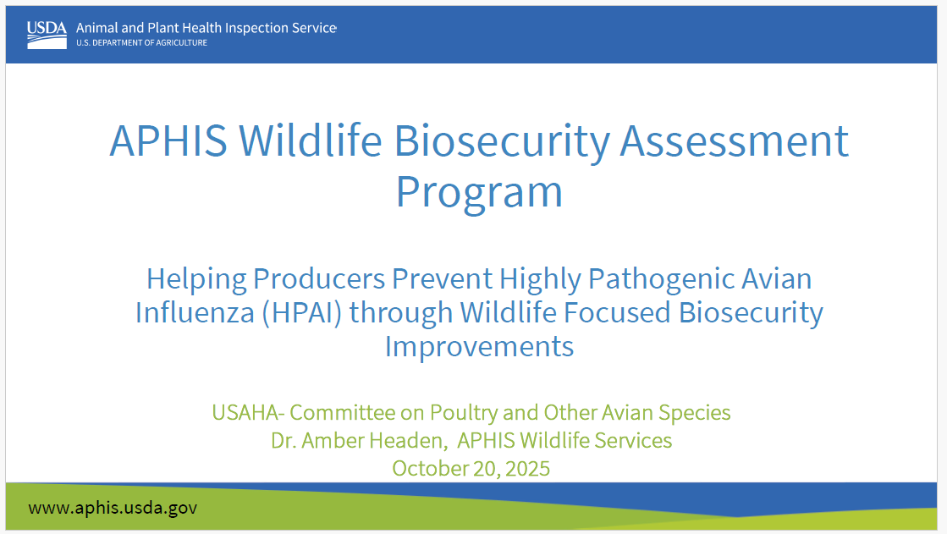

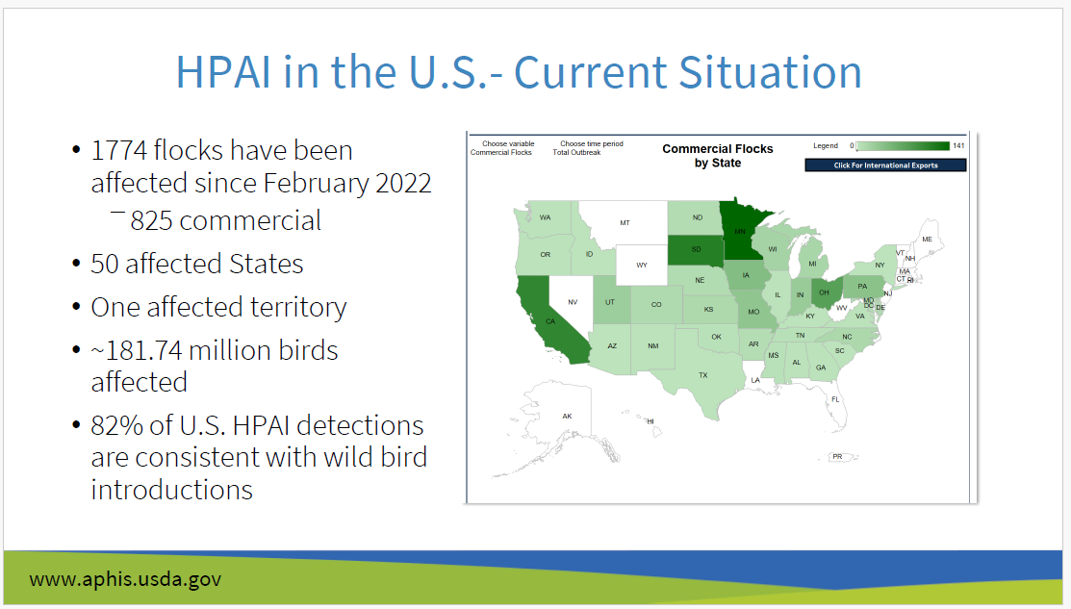

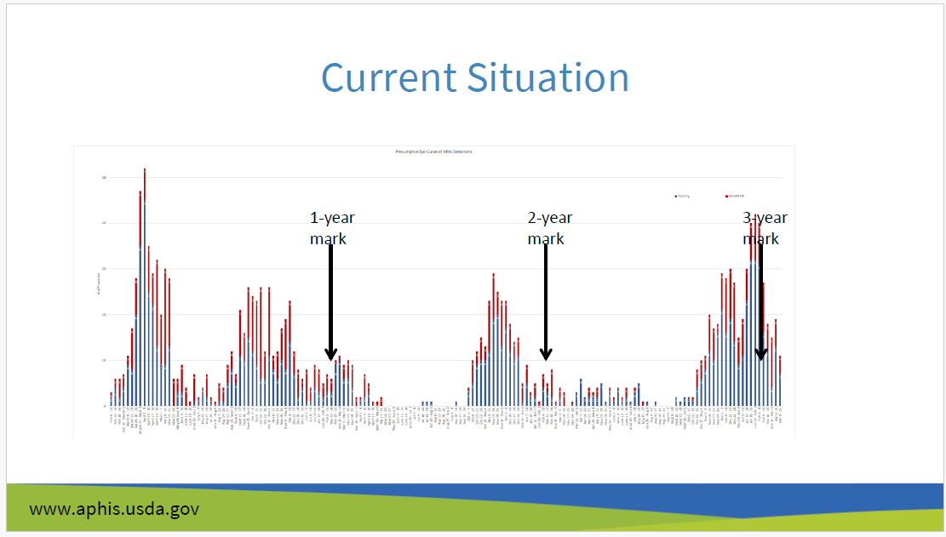

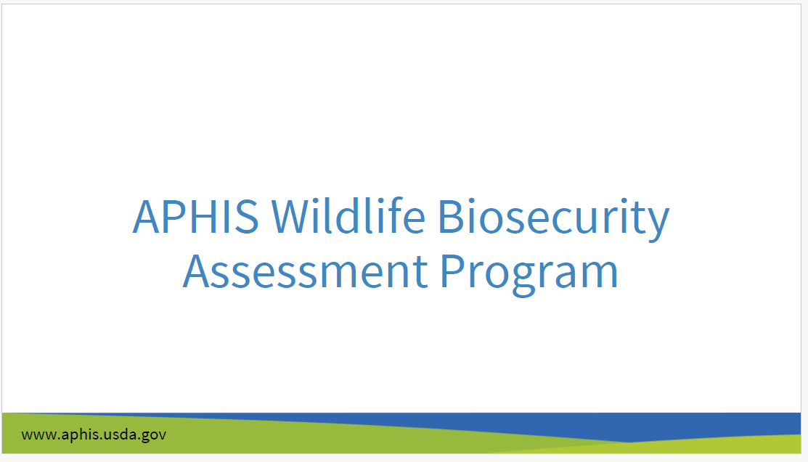

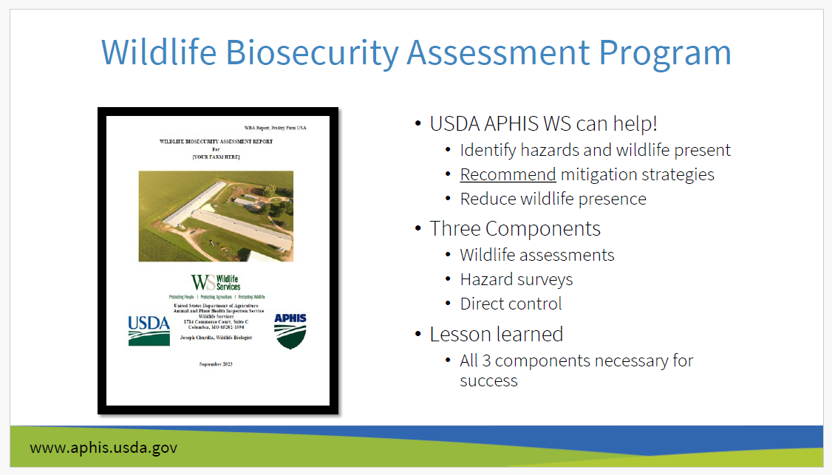

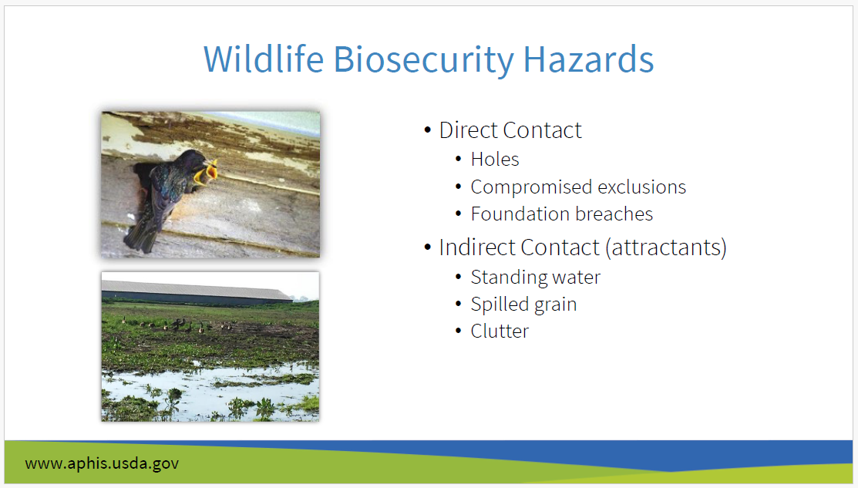

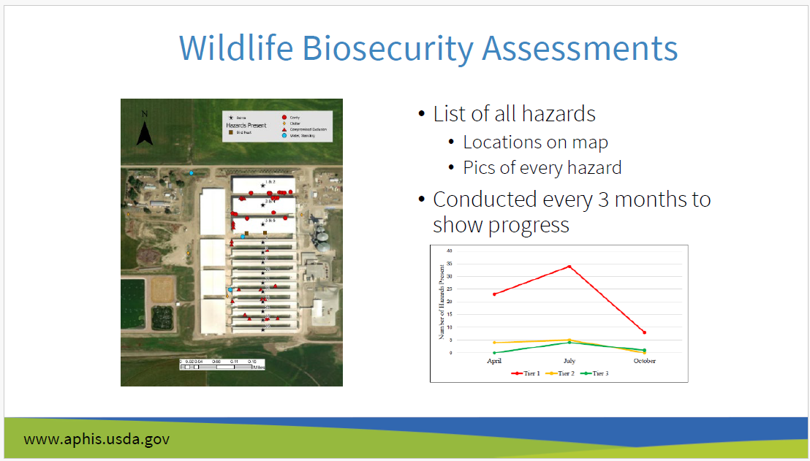

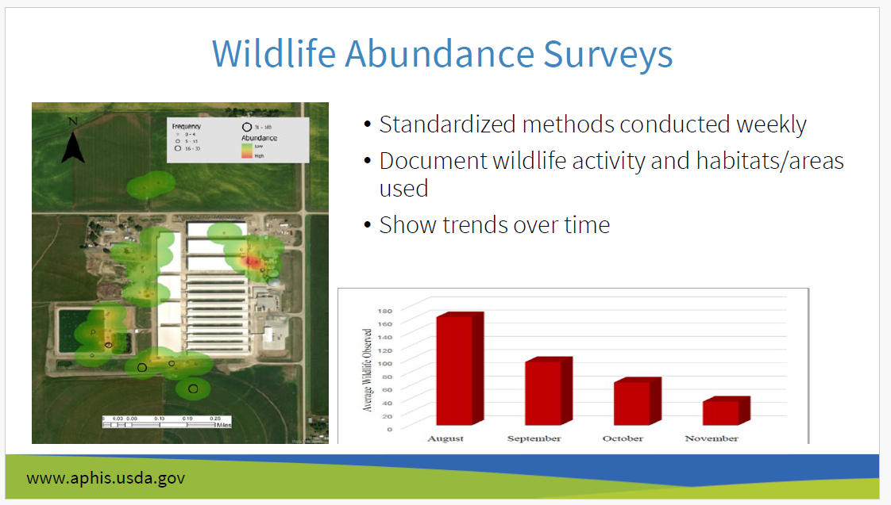

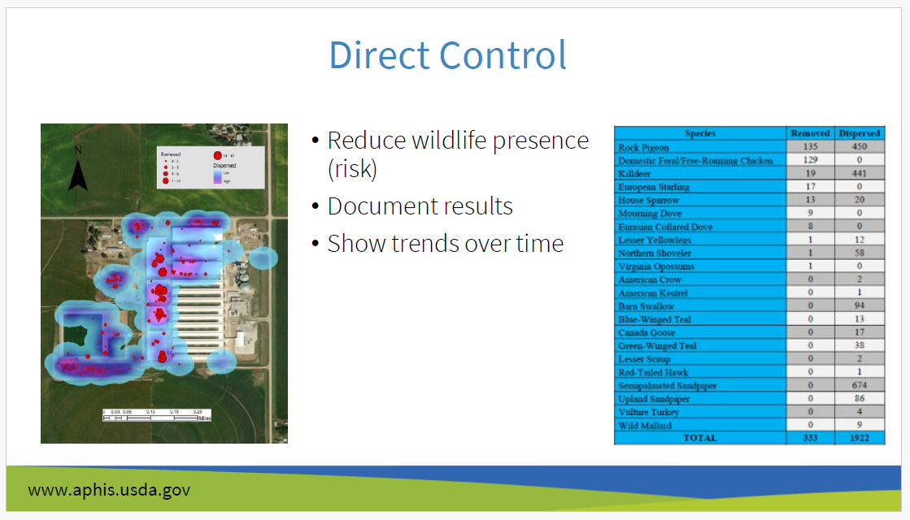

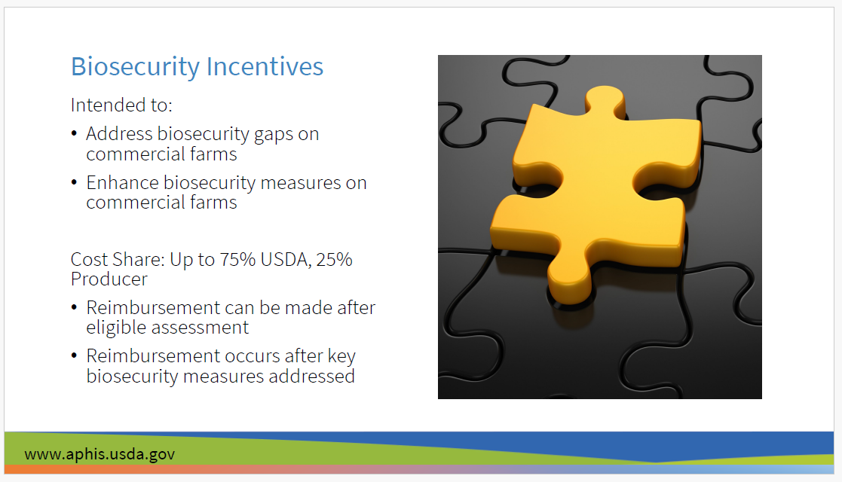

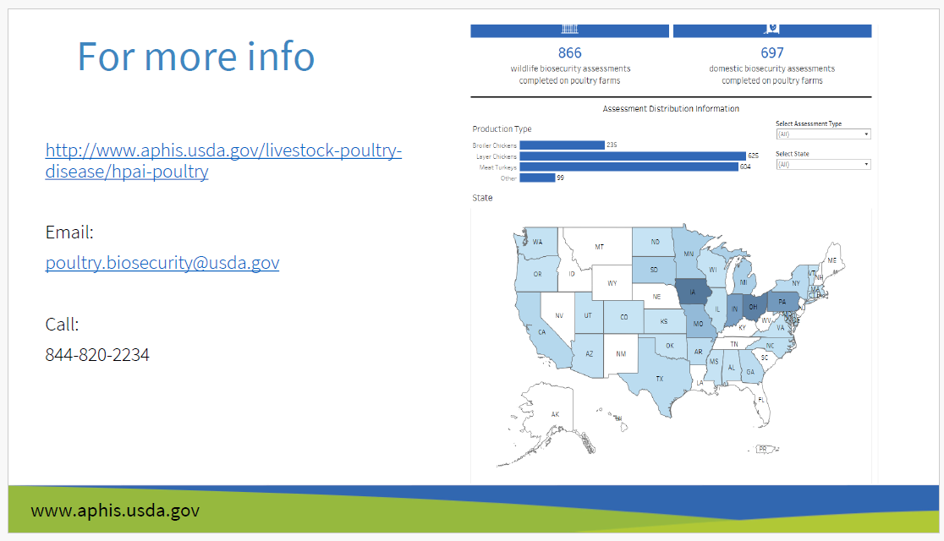

Federal HPAI Update
Dr. Oriana Beemer, USDA-APHIS-VS.

APHIS provided an update on the current highly pathogenic avian influenza situation in the United States, including the livestock and poultry disease situations. Main topics covered included situational updates on outbreak status, the importance of biosecurity as a key to mitigate the risk of disease spread and ways USDA is promoting best practices, the importance of surveillance testing to quickly respond and eliminate circulating virus from the nation’s livestock and poultry, and the additional work addressing the ongoing outbreak.

California State HPAI Update
Dr. Alexi Haack, California Department of Food and Agriculture

Dr. Haack summarized the ongoing HPAI outbreak in CA poultry flocks and dairy herds and the various challenges they have faced. She also addressed possible future directions and control strategies.

Industry Update (AAAP HPAI Task Force)
Dr. Michelle Kromm, representative of the American Association of Avian Pathologists

Dr. Kromm summarized the AAAP position statements on H5 influenza and vaccination for H5N1 2.3.4.4b as can be found on the AAAP website. She also discussed barriers to HPAI vaccination in the US as the poultry industry sees them and possible next steps.

High Expansion Nitrogen Foam Projects
Dr. Alex Hamberg, Pennsylvania Department of Agriculture, and Mr. Dan Hougentogler, Hougentougler Enterprises, LLC/Agricultural Emergency Services Inc.

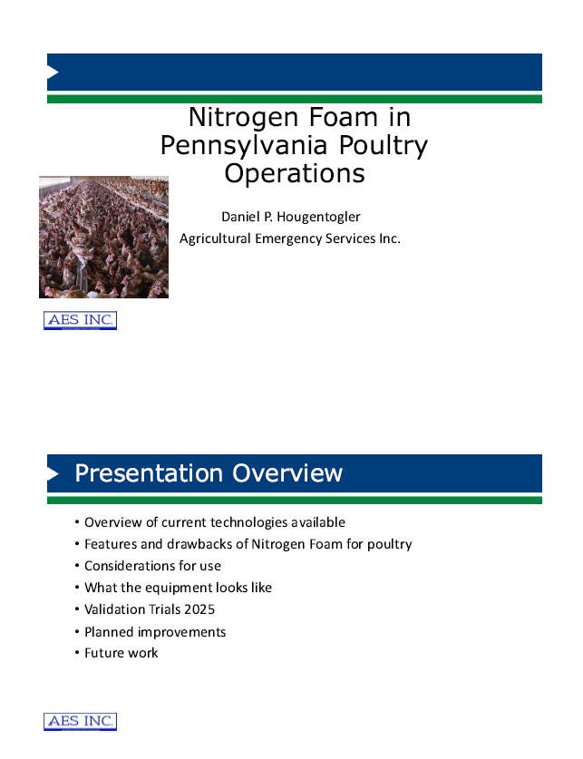
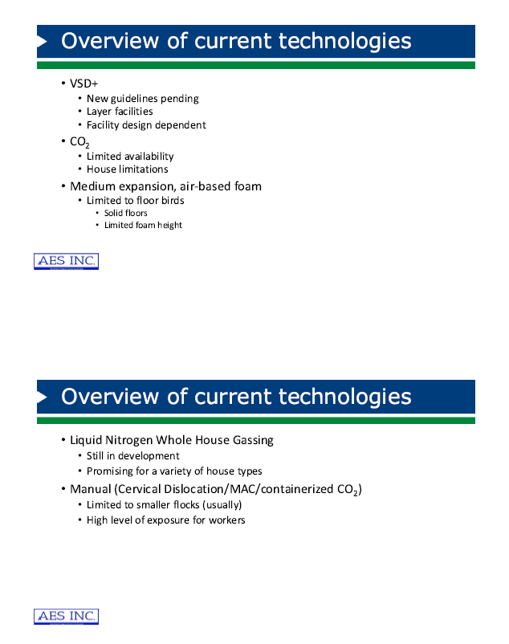
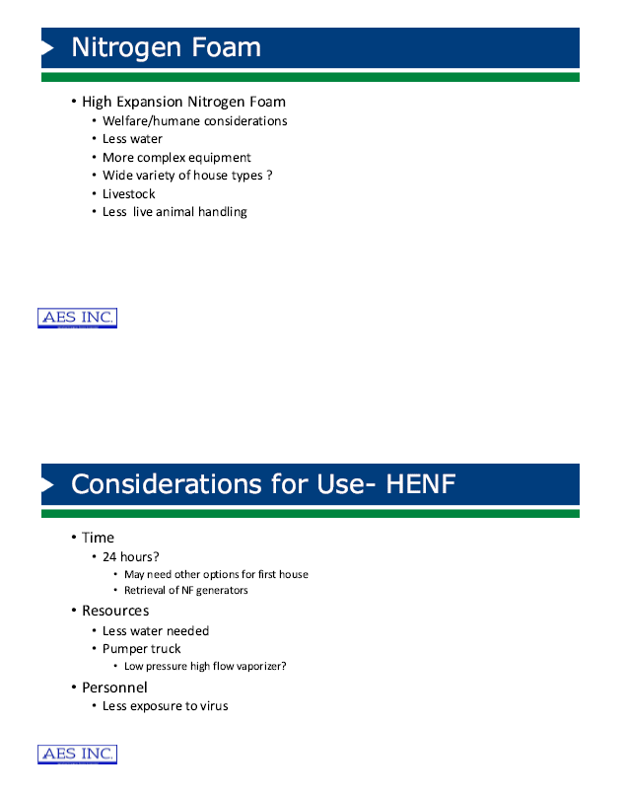
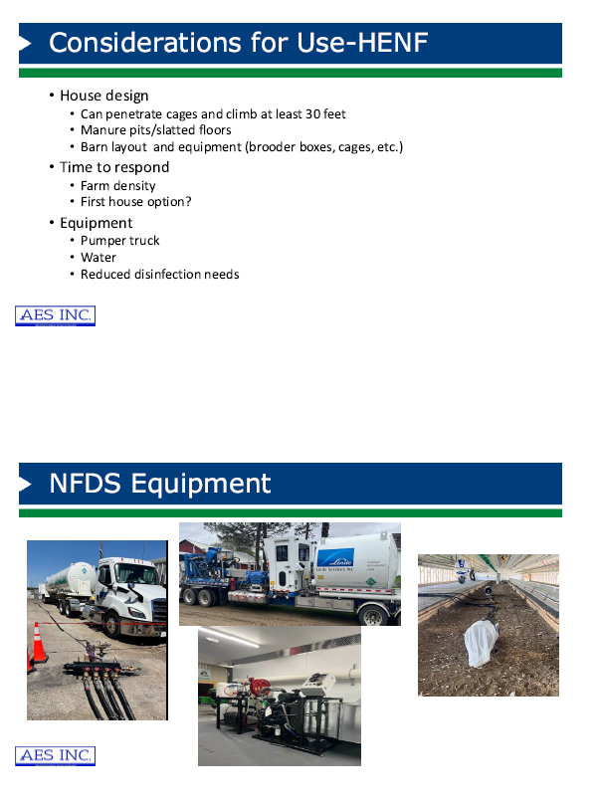
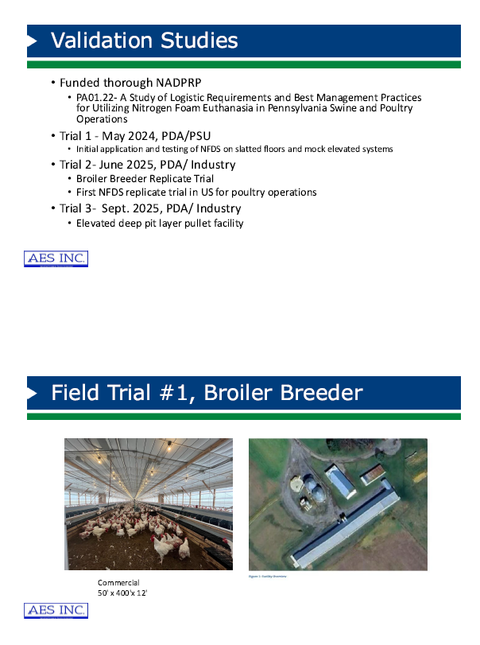
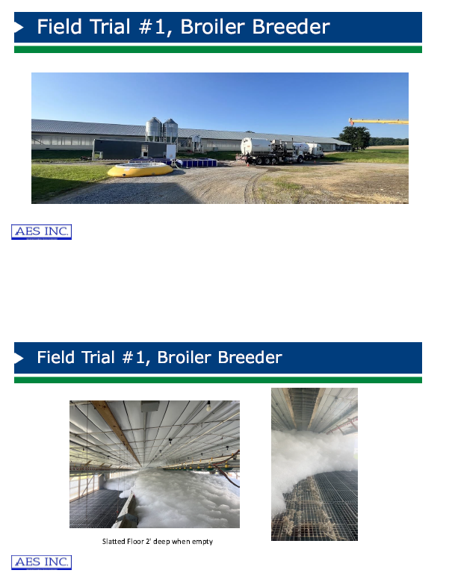
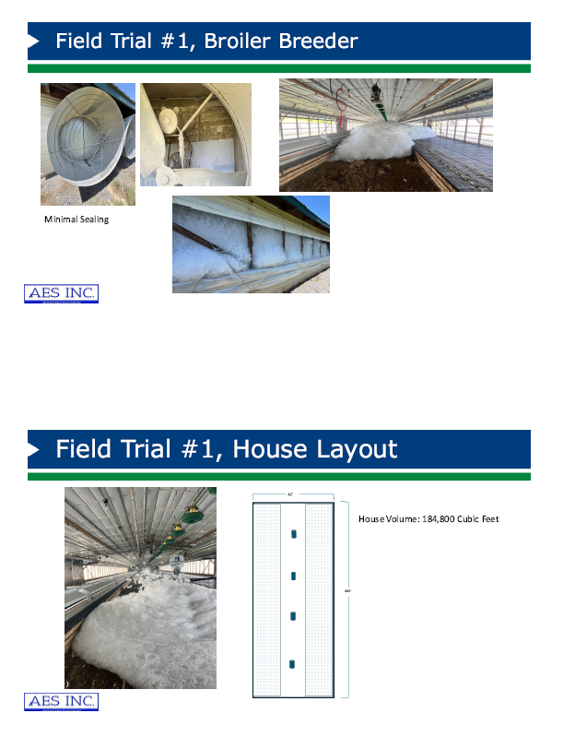
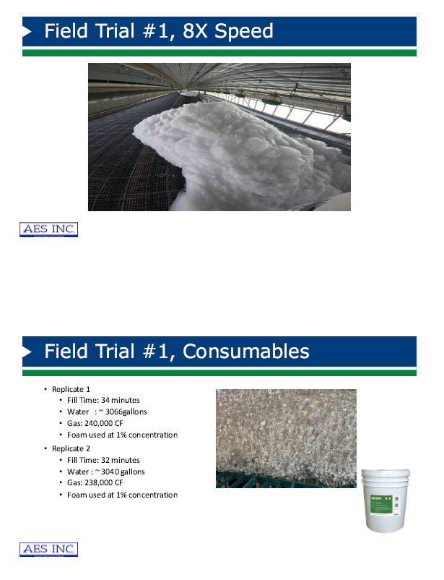
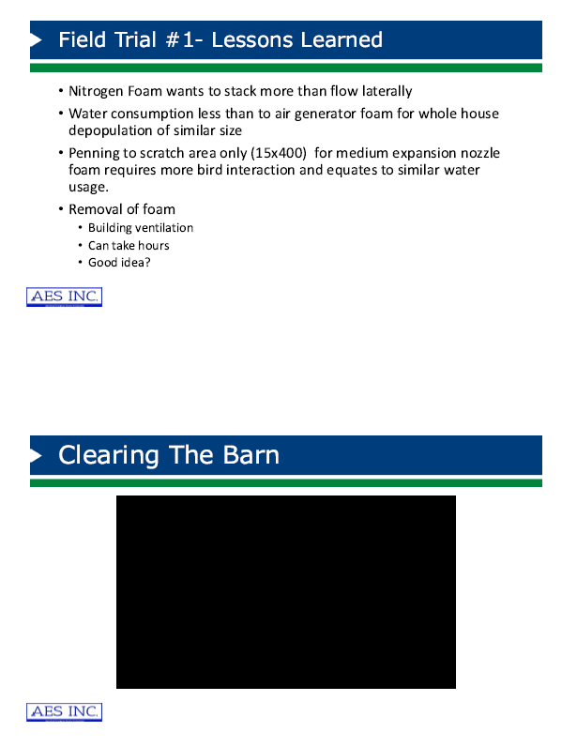
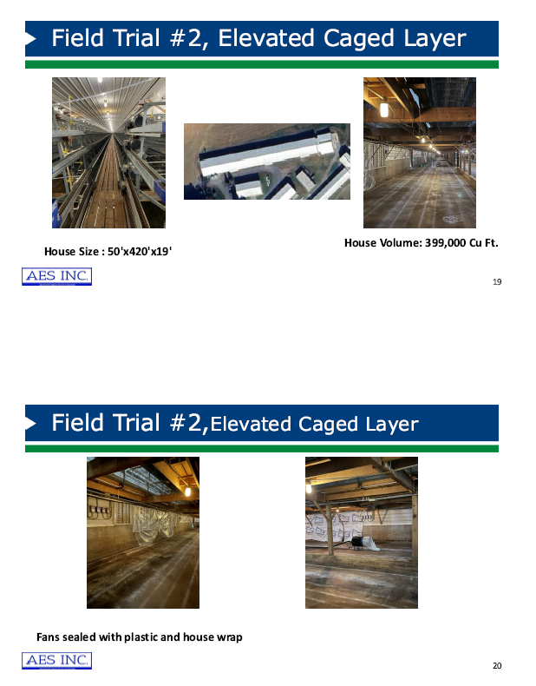
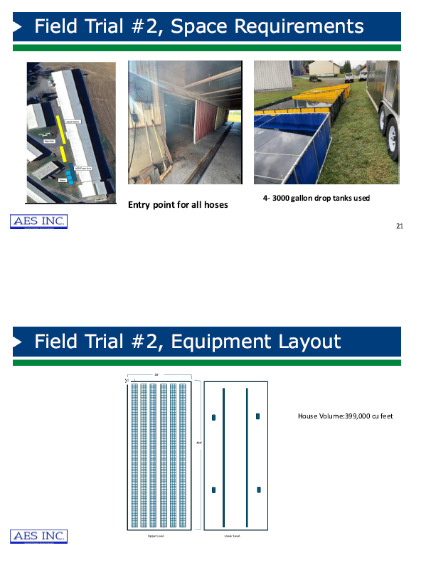
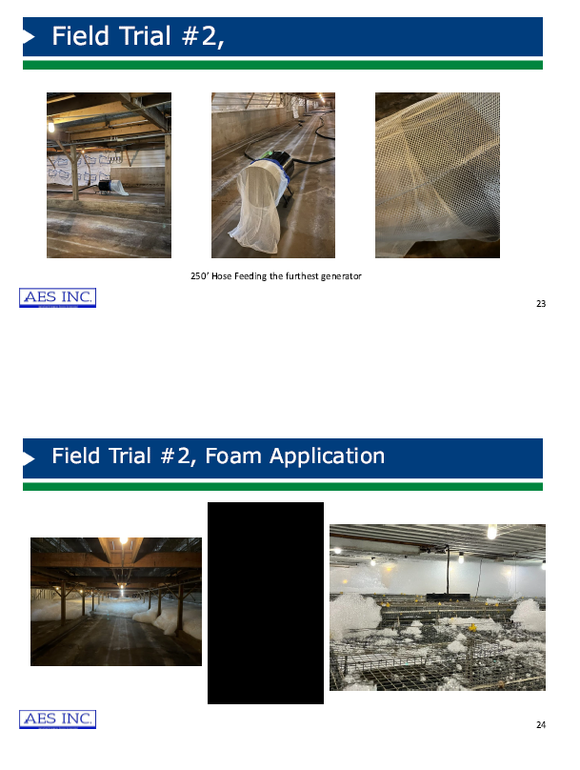
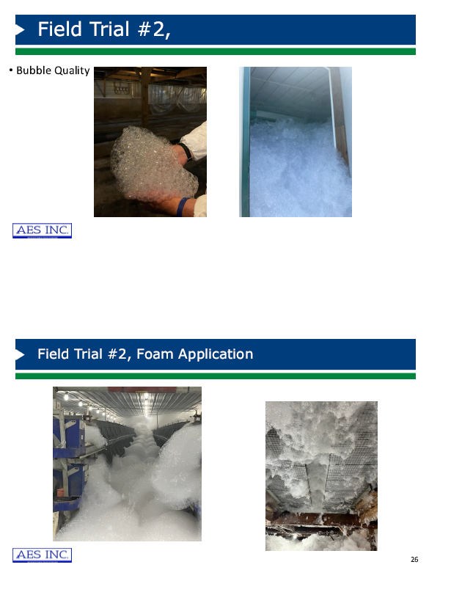
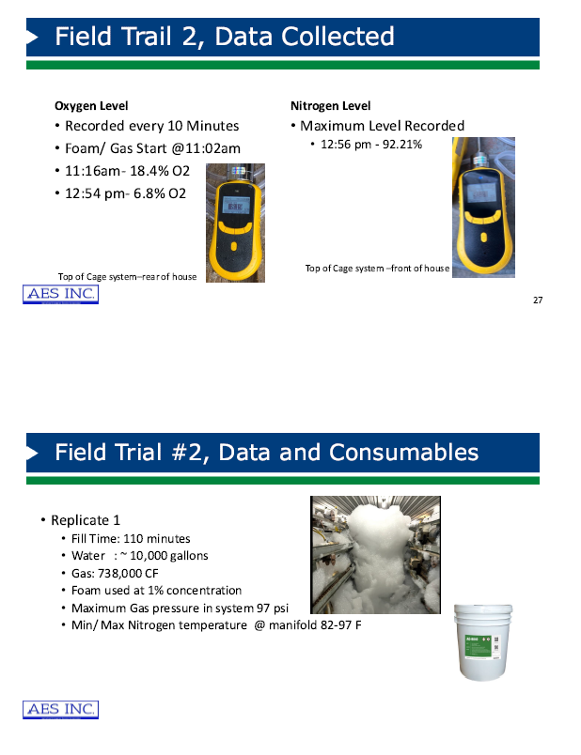
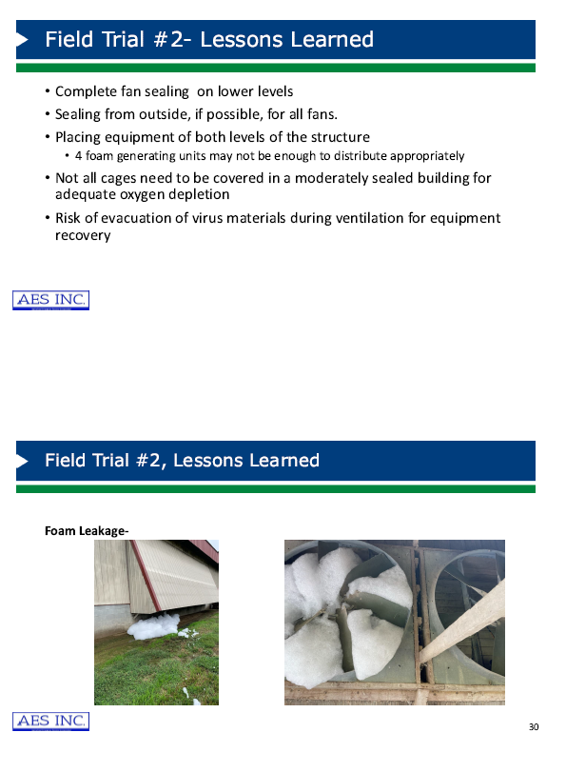
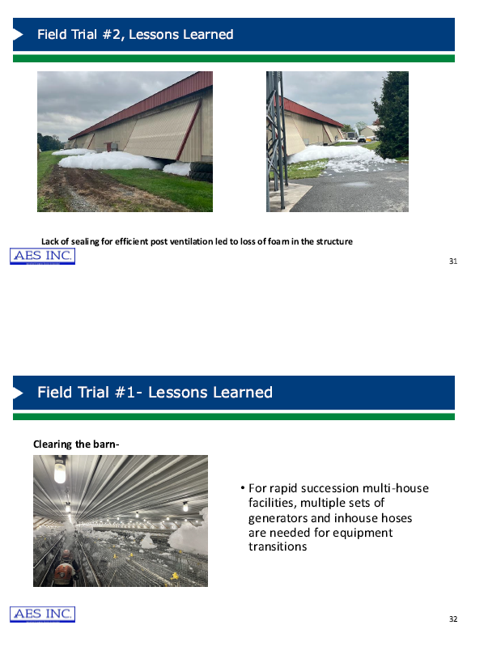
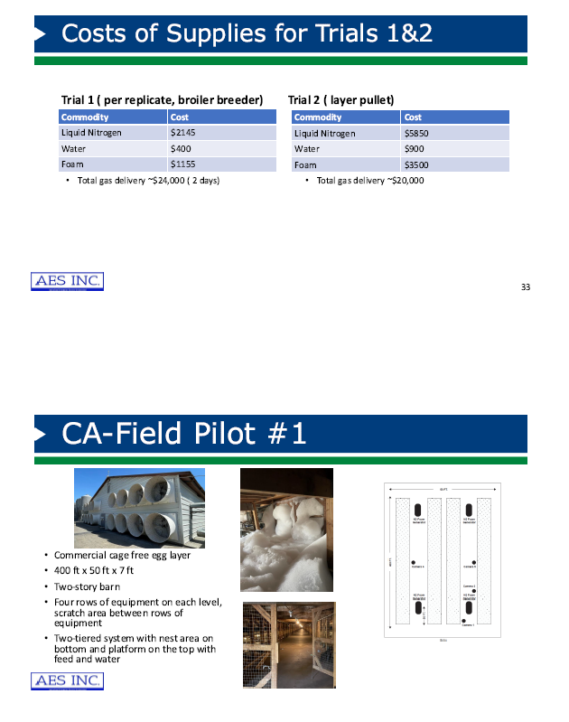
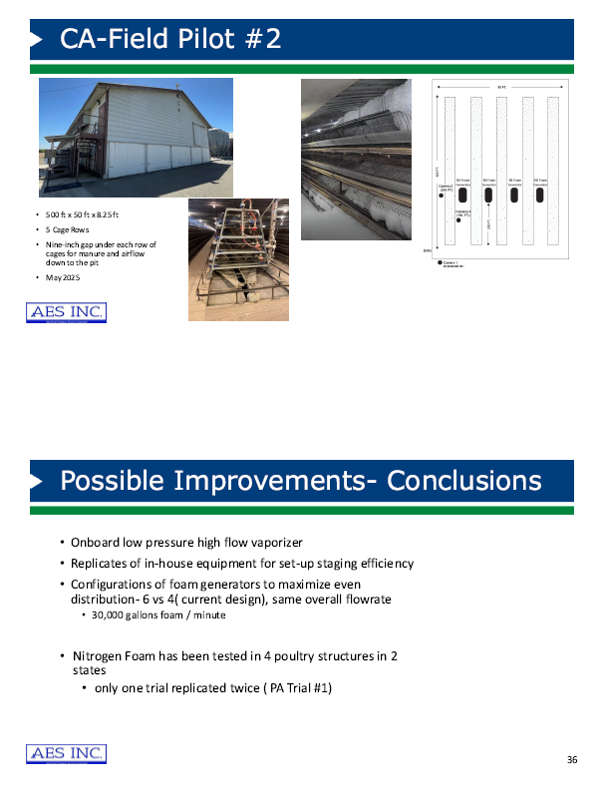
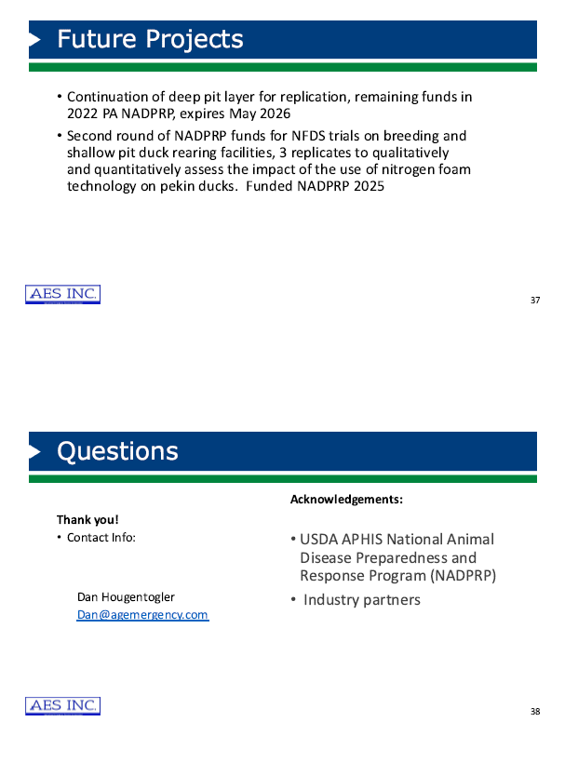

Salmonella Updates Post-Framework
Dr. Lindy Froebel, National Turkey Federation

Dr. Froebel presented a Salmonella policy update. Following USDA-FSIS announcing a proposed regulatory framework to reduce Salmonella illnesses attributable to poultry in October 2022, the Agency published a proposed rule and proposed determination in the Federal Register titled ‘‘Salmonella Framework for Raw Poultry Products’ in August of 2024. In April 2025, USDA announced the withdrawal of the proposed rule and proposed determination, noting while FSIS continues to support the goal of reducing Salmonella illnesses associated with poultry products, the Agency believes that the comments have raised several important issues that warrant further consideration.

An overview of the "5 prong food safety plan" from USDA Secretary Brooke Rollins was provided. Dr. Froebel also expanded on the National Turkey Federation (NTF) position that a new Salmonella regulatory framework should be explored, but noted any new policy must be founded in science and all regulatory decisions be data-driven.

Economic Impact of Avian Metapneumovirus
Ms. Gretta Irwin, Iowa Turkey Federation

Ms. Irwin provided the following links to previously published reports on the economic impact of avian metapneumovirus.

The Economic Impact of aMPV on the Minnesota Turkey Industry
Possible Economic Impacts from aMPV and HPAI in the Iowa Turkey Industry

Due to the blinded nature of this study, it was not possible to verify the unique identity of each respondent. The reported headcount should therefore be interpreted with the understanding that some duplication of responses may be present.
USDA, ERS, Livestock & Meat Domestic Data, Turkey Sector: Background & Statistics: https://www.ers.usda.gov/newsroom/trending-topics/turkey-sector-background-statistics
Due to the blinded nature of this study, it was not possible to verify the unique identity of each respondent. The reported coccidia control programs should therefore be interpreted with the understanding that some duplication of responses may be present.
Due to the blinded nature of this study, it was not possible to verify the unique identity of each respondent. The reported antibiotic programs should therefore be interpreted with the understanding that some duplication of responses may be present.
Poultry Slaughter 2024 Summary (February 2025). USDA, National Agricultural Statistics Service. Pg 5. www.nass.usda.gov/Publications/Todays_Reports/reports/pslaan25.pdf
Poultry - Production and Value 2024 Summary (April 2025). USDA, National Agricultural Statistics Service. Pg 8-9. https://esmis.nal.usda.gov/sites/default/release-files/m039k491c/ws85cd48j/q524mm00n/plva0425.pdf
Poultry Slaughter 2024 Summary (February 2025). USDA, National Agricultural Statistics Service. Pg 5.
USDA, ERS, Livestock & Meat Domestic Data, Turkey Sector: Background & Statistics: https://www.ers.usda.gov/newsroom/trending-topics/turkey-sector-background-statistics

