COMMITTEE ON animal emergency management
Chair: Sara McReynolds
Vice Chair: Todd Tedrow

[USAHA Staff will enter your committee roster]

The Committee met during the 2023 Annual Meeting in National Harbor, MD on October 16. There were 144 total in attendance with over 62 members present.

There were three presentations during the Annual Meeting. Summaries are below.

Title: USDA Swine Hemorrhagic Fevers Integrated Surveillance Plan Overview
Presenter: Nicki Humphrey, DVM

Affiliation: Swine Health Team; Aquaculture, Swine, Equine and Poultry Health Center; Strategy and Policy; Veterinary Services; Animal and Plant Health Inspection Service; United States Department of Agriculture

African swine fever (ASF) continues to spread across the globe, most recently to the island of Hispaniola, and classical swine fever (CSF) remains present in the Caribbean and South America. Veterinary Service (VS) — a program within the United States Department of Agriculture’s (USDA) Animal and Plant Health Inspection Service (APHIS) — has an integrated surveillance plan designed to accomplish three primary objectives: 1) strengthen detection capabilities by providing timely and consistent surveillance to establish a baseline of disease absence, 2) enhancing outbreak preparedness by testing the capability for high-volume sample collection, and of laboratory capacity and data management systems prior to an outbreak, and 3) supporting claims of disease freedom¹. The plan targets three subpopulations of swine (commercial swine, high-risk swine including waste feeders and outdoor raised swine with potential feral swine exposure, and feral swine) across the US through active and passive surveillance. There are currently 12 National Animal Health Laboratories conducting sampling for the active surveillance and 39 National Animal Health Laboratories that are approved to conduct testing for foreign animal disease investigations and that could support surge capacity testing in the event of an outbreak. Approved sample types for ASF/CSF testing include spleen or spleen swab, tonsil, whole blood or whole blood swab and lymph nodes. As of June 30, 2023 VS has tested 67,870 specimens for ASF and CSF. Of the specimens tested 24,637 have been from Diagnostic Sick Pig submissions direct from farm.
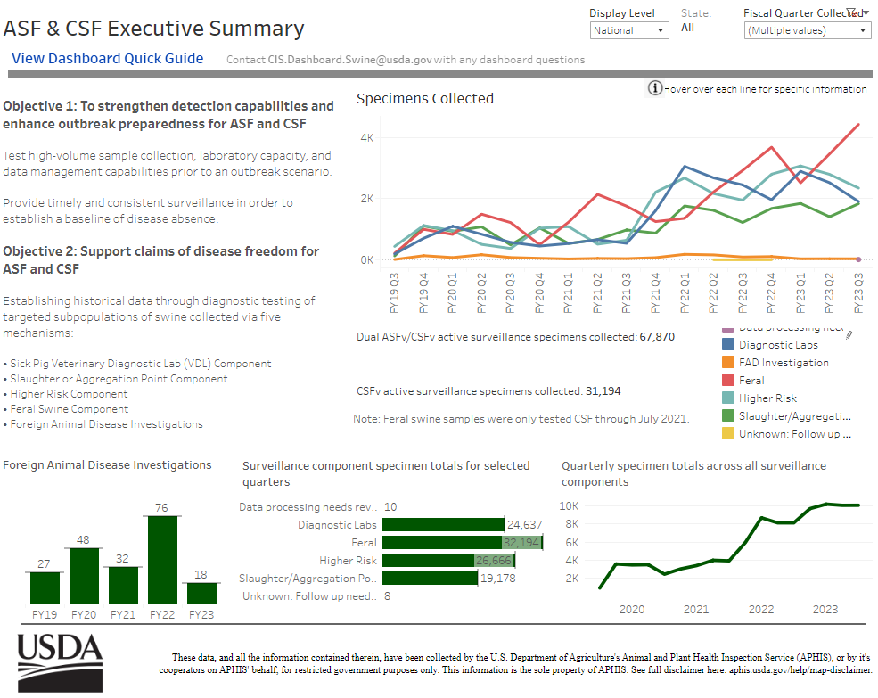
Figure 1: USDA ASF and CSF State Animal Health Official Dashboard displaying all surveillance components through 3rd Quarter of Fiscal Year 2023.
- USDA-APHIS (United States Department of Agriculture – Animal and Plant Health Inspection Service). Swine Hemorrhagic Fevers Integrated Surveillance Plan. 2022. Available at https://www.aphis.usda.gov/animal_health/downloads/animal_diseases/swine/hemorrhagic-fevers-integrated-surveillance-plan.pdf

Title: Regional Ruckus Report Out and Workgroup Next Steps
Presenter: Dr. Kathryn MacDonald, Director of Emergency Preparedness, Livestock Poultry Health, Clemson University:

An overview of the Regional Ruckus 2023 meeting. MSPSA, SAADRA, and NESAASA are multi-state regional groups with membership consisting of agricultural/animal emergency managers and responders. Each regional group leverages each membership state’s experience, projects, support, innovation, and collaboration to provide more consistent and advanced agricultural emergency response and field operation activities. The Regional Ruckus 2023 was an event which allowed the three groups to meet together to share information, experiences, expertise, and resources across the regions. During the three-day meeting, the regional groups conducted a gap analysis of emergency preparedness and response for the food and agriculture sector within each region and across the regions. Gaps and challenges identified by all three groups were considered national gaps. Solutions were discussed for these national state-identified issues resulting in about ten work groups consisting of members from each of the three regional groups.

Title: Virginia’s NAHLN Laboratory Liaison Lessons Learned from HPAI
Presenter: Dr. Jessica Walters, Program Manager, Office of Laboratory Services, Virginia Department of Agriculture and Consumer Services

An overview was given of the Virginia Department of Agriculture and Consumer Services Office of Laboratory Servies Table Top Exercise in 2022. The purpose of the exercise was to provide participants an opportunity to evaluate current response concepts, plans, and capabilities for a NAHLN laboratory response in the State of Virginia. The exercise focused on the laboratory personnel and their roles in an outbreak situation. The exercise emphasized the interaction between laboratory personnel in response to an AI outbreak. The findings of the exercise were presented and then shortly after the exercise HPAI impacted Virigina. The lessons learned from the exercise were critical in their response. The surprises during the response was how sampling processing was a big time sink and handling accessioning as the samples came in surges.

Committee Business:
The Committee was requested to review the response the 2022 Resolution on subject matter of Strengthening the U.S. Animal Disease and Traceability and Disease Prevention RFID Infrastructure. An email with a survey to vote on response was emailed to the Committee on October 6.

Seven (7) resolutions were submitted by committee members and were adopted/approved through motions made, seconded and passed by hand vote:

- FMD National Movement Standstill Exemptions: Bovine Germplasm
- Movements of in vivo-derived Bovine Embryos in an FMD Outbreak
- FMD Diagnostics – Serology Assay Deployment to NAHLN Laboratories
- FMD Diagnostics – Oral Swab Deviation for a New Population of Animals
- Emergency Management Assistance Compacts for Agriculture
- FMD Vaccine Distribution – National Veterinary Stockpile Partnership with an Independent Vaccine Distribution Company
- Policy Regarding Allowable ASF Sample Collectors

The Committee adjourned at 5:15 pm.

