COMMITTEE ON Global Animal Health and Trade
Chair: Elizabeth Parker DVM
Vice Chair: Herbert M “Tim” Richards III DVM

[USAHA Staff will enter your committee roster]

The Committee met during the 2026 Annual Meeting in Madison, WI on October 20th. There were ?? members and ??] guests with well over 130 people in attendance. Brief introductions were made with housekeeping of signing in to the session and agendas being available on back tables.

Presentations & Reports are attached in the GAHT Thumb drive

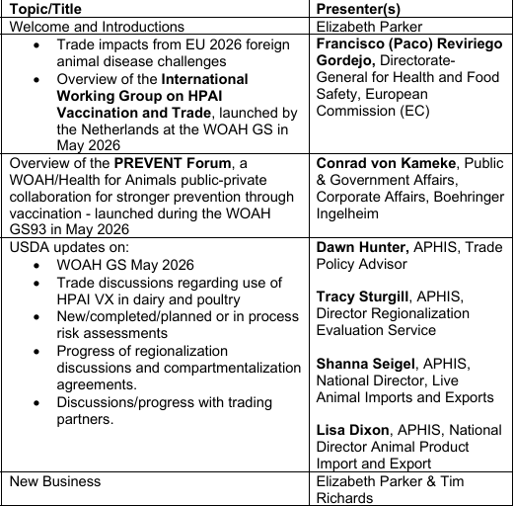

Committee Business:
There was no formal business before the Committee.

The meeting was closed with statements of gratitude to the speakers and participants.

The Committee was also thanked for their help and support over the years and that Dr Elizabeth Parker and
Dr Tim Richards had reached the end of their tenure as the Chair and Vice Chair and are stepping down.

