Committee on Poultry and Other Avian Species
Chair: Kayla Niel, PA
Vice Chair: Andrew Smith, IA

The Committee met virtually on October 12, 2026, from 9:00 AM to 12:23 PM, Central Daylight Time, and at the Monona Terrace Convention Center on October 19, 2026, from 1:00 PM to 4:47 PM, Central Daylight Time. There were members beyond quorum in-person, up to 85 members and guests virtually, and many guests present in-person. Chair Kayla Niel presided, assisted by Vice Chair Andrew Smith. Niel welcomed the Committee on Poultry and Other Avian Species (CPAS) members, summarized the 2025 meeting and provided final responses from USDA-APHIS-VS to the 2025 resolutions:

Resolution 10 – Need for Epidemiological Data for Current H5 Influenza Epizootic
The United States Animal Health Association (USAHA) strongly urges the Secretary of Agriculture to provide resources to the United States Department of Agriculture (USDA), Animal and Plant Health Inspection Service (APHIS) and Agricultural Research Service to significantly increase investment in comprehensive epidemiological disease investigations for H5 influenza in cattle herds, poultry flocks and additional livestock industries. Furthermore, the findings should be shared in a timely manner with industry for actionable follow-up. USAHA further encourages USDA-APHIS to prioritize collaborative efforts between the National Poultry Improvement Plan, dairy and beef cattle industry stakeholders, additional livestock industries, and state animal health officials to ensure coordinated, data-driven disease control efforts across species and sectors.

USDA-APHIS-VS Response:
The United States Department of Agriculture (USDA), Animal and Plant Health Inspection Service (APHIS), Veterinary Services (VS) recognizes the concerns of the United States Animal Health Association (USAHA) and appreciates the opportunity to respond.

VS agrees that epidemiological disease investigations are essential for identifying evolving disease threats and strategically informing and strengthening biosecurity measures necessary for the prevention and early mitigation of this dynamic animal and human health risk and that the reports should be shared in a timely manner. VS has shared HPAI poultry epidemiological information covering through March 2026 and has set an internal expectation for an increase in routine reporting. In addition, USDA have funded numerous research proposals to investigate and better understand HPAI transmission in cattle herds. Findings of these studies are publicly shared by cooperators as results become available. To address concerns about repeated point-source introductions from wild birds and producer limitations to enhance biosecurity, VS is evaluating data collected from biosecurity programs to identify common challenges that may increase the risk of infection.

Resolution 11 – Highly Pathogenic Avian Influenza Innovation Grand Challenge Update
The United States Animal Health Association is thankful for the United States Department of Agriculture’s Five-Pronged Approach to address Avian Influenza and urges the Secretary of Agriculture to expeditiously announce the Highly Pathogenic Avian Influenza Poultry Innovation Grand Challenge project selections and release funding.

USDA-APHIS-VS Response:
The United States Department of Agriculture (USDA), Animal and Plant Health Inspection Service (APHIS), Veterinary Services (VS) recognizes the concerns of the United States Animal Health Association (USAHA) and appreciates the opportunity to respond.

The Highly Pathogenic Avian Influenza (HPAI) Poultry Innovation Grand Challenge project selections were announced on November 6, 2025, and applicants were notified regarding the outcome of their project proposals.

The majority of the awarded projects started on February 2, 2026. More information can be found at: https://www.aphis.usda.gov/funding/highly-pathogenic-avian-influenza-hpai-poultry-innovation-grand-challenge. All projects are now actively working to develop novel vaccines, novel therapeutics, and improved response strategies to address HPAI in poultry.

Resolution 12 – Highly Pathogenic Avian Influenza Vaccination Update
The United States Animal Health Association (USAHA) is thankful the United States Department of Agriculture involved stakeholders in discussions around highly pathogenic avian influenza vaccination strategy in commercial poultry. USAHA encourages the Secretary of Agriculture to release to the United States poultry industry any available next steps toward an H5 influenza vaccination strategy (e.g., surveillance plans) in poultry.

USDA-APHIS-VS Response:
The United States Department of Agriculture (USDA), Animal and Plant Health Inspection Service (APHIS), Veterinary Services (VS) recognizes the concerns of the United States Animal Health Association (USAHA) and appreciates the opportunity to respond.

The United States does not currently authorize the use of HPAI vaccine, except on a case‑by‑case basis for endangered or zoo species. USDA is, however, exploring alternative strategies to combat highly pathogenic avian influenza (HPAI), including the potential use of vaccination and other emerging approaches. As part of this work, USDA has engaged domestic stakeholders to gather feedback on the feasibility, costs, and other considerations associated with potential strategies under development.

APHIS shared a first draft of the HPAI emergency vaccination strategy with State Animal Health Officials and a limited number of industry partners for comment in early 2026. Their feedback has been incorporated into a current working draft, which will be shared more broadly when the Department authorizes distribution to a broader audience.

APHIS VS has not yet formally engaged international partners. However, USDA remains committed to developing formal standards, guidance, monitoring, and surveillance plans that align with World Organisation for Animal Health (WOAH) requirements to ensure that any strategy pursued is implemented in a way that does not create unnecessary barriers to safe trade. USDA has also engaged WOAH as its standards and considerations around vaccination continue to evolve to reflect the global HPAI situation. USDA has been cautious to distribute its plan to various audiences in phases so that the plan can be improved with each successive version. As strategies mature, APHIS will publicly share information for all stakeholders—including trading partners—prior to implementation.

Resolution 13 – National Poultry Improvement Plan Staffing
The United States Animal Health Association requests that the United States Department of Agriculture, within 30 days from the lifting of the government shut down, re-establish a permanent Senior Coordinator of the National Poultry Improvement Plan (NPIP).

USDA-APHIS-VS Response:
The United States Department of Agriculture (USDA), Animal and Plant Health Inspection Service (APHIS), Veterinary Services (VS) recognizes the concerns of the United States Animal Health Association (USAHA) and appreciates the opportunity to respond.

APHIS recognizes the critical importance of NPIP and the key role of the NPIP Senior Coordinator and has prioritized the hiring of a permanent NPIP Senior Coordinator in a time when it has been hiring many critical vacancies. APHIS understands the importance of hiring an individual with relevant poultry expertise and considered input from the General Conference Committee of the NPIP in the screening and selection of candidates in its recent recruitment processes for the Senior Coordinator position.

APHIS has selected a Senior Coordinator to start in the role in September who has poultry expertise and looks forward to continuing to ensure the Senior Coordinator is engaged in and addressing poultry industry and NPIP program priorities.

2026 Presentations and Reports:

Virtual Meeting (10-12-2026):
AVBP Current Diseases of Concern was given by Dr. Andy Bishop, Wayne-Sanderson Farms, Oakwood, GA. A summary of the report is included in these proceedings.
Table Egg Layer Industry Report was given by Dr. Fernando Ruiz-Jimenez, Zoetis, Durham, NC. A summary of the report is included in these proceedings.
Turkey Industry Report was given by Dr. Eliza Ripplinger, Swine Services Unlimited Inc., Little Falls, MN. A summary of the report is included in these proceedings.
Live Bird Market System (LBMS) AI Program FY 2025 Working Group Report was given by Dr. Fidelis Hegngi, USDA-APHIS-VS, Beltsville, MD. A summary of the report is included in these proceedings.
NVSL Bacteriology Diagnostics was given by Dr. Sophia Kenney, USDA-APHIS-VS-NVSL, Ames, IA. A summary of the report is included in these proceedings.
National Poultry Improvement Plan (NPIP) Update was presented by Dr. Melissa Yates, USDA-APHIS-VS-ASEP-NPIP, Conyers, GA. A summary of the report is included in these proceedings.
AI/NDV Disease Subcommittee Report was given by Dr. David Suarez, USDA-ARS-SEPRL, Athens, GA. A summary of the report is included in these proceedings.
Southeast Poultry Research Lab (SEPRL) update was given by Dr. David Suarez, USDA-ARS-SEPRL, Athens, GA. A summary of the report is included in these proceedings.
SEPRL Endemic Poultry Viral Research update was given by Dr. John Dunn, USDA-ARS-SEPRL, Athens, GA. A summary of the report is included in these proceedings.

In-person Meeting (10-19-26)
USDA-APHIS Updates, HPAI was given by Dr. Alan Huddleston, USDA-APHIS-VS, Washington, D.C. A summary of the report is included in these proceedings.
BCAP and NPIP update was given by Dr. Lisa Rochette, USDA-APHIS-VS-ASEP, Raleigh, NC. A summary of the report is included in these proceedings.
ID State HPAI Outbreak Overview was given by Dr. Scott Leibsle, ID State Department of Agriculture, Boise, ID. A summary of the report is included in these proceedings.
AI/NDV Surveillance Update was given by Dr. Mia Torchetti, USDA-APHIS-VS-NVSL, Ames, IA. A summary of the report is included in these proceedings.
NAHLN: NMTS Lessons Learned, Future Outlook was led by Dr. Keith Poulsen, Wisconsin VDL, Madison, WI and Dr. Ashley Hill, CAHFS, Davis, CA. A summary of the report is included in these proceedings.

Committee Business:

Subcommittee Report: The Avian Influenza/Newcastle Disease Subcommittee Report as presented by Dr. David Suarez was motioned to approve by Dr. Julie Helm, seconded by Dr. Sara McReynolds, and approved by the CPAS Committee.

Old Committee Business: A poll was sent out to the committee via email on October 2, 2026, to collect feedback on the resolution responses from USDA-APHIS-VS. Per the results of the survey and final vote at the in-person meeting on October 19, 2026, the following was decided:

Resolution 10: Response is unsatisfactory – USDA has not addressed the timeline aspect of the request, and the Committee is thus asking for yearly updates. The Committee also expressed concern over the general lack of funding for epidemiologic work within USDA and noted that the industry is now paying for and performing its own epidemiologic work.

Resolution 11: Response is sufficient for the current time – However, the Committee has asked for a status update on the funded project including what deliverables and/or field deployable options have resulted.

Resolution 12: Response is unsatisfactory – Progress on the HPAI draft vaccination plan has been too slow and a plan has still not been shared with all relevant industry stakeholders. The Committee recommends that USDA share this information as soon as possible. Additionally, the Committee expressed concern that there is a lack of engagement with trading partners on this issue and that other countries have started vaccination pilots while the US lags behind.

Resolution 13: Response is sufficient for the current time – However, the Committee stressed that the delay in refilling the NPIP Senior Coordinator position was unacceptable and concerns remain for the status of the program because the office is still understaffed with the departure of the Compartmentalization Coordinator.

New Committee Business: Dr. Andrew Smith, IA, will take over Chair position as Dr. Kayla Niel, PA, rotates off. Announcement was made that a candidate was recommended to USAHA to take over Vice Chair position and final approval is pending.

A group from Mississippi State University introduced and discussed a project requiring industry participation and input regarding HPAI epidemiology. Additional information will go out to the Committee and to other industry groups to recruit participants.

A resolution planned for the Animal Welfare Committee regarding indemnity for HPAI and specific welfare methods was discussed. Committee members were encouraged to attend the Animal Welfare Committee to provide feedback there.

Committee Resolutions:
There were 2 resolutions that were brought before the Committee, both of which were approved unanimously following discussion and minor amendments by the Committee:
Resolution 1 – Request for Progress on USDA HPAI Poultry Vaccination Strategy

Resolution 2 – Development of Bilateral Trade Agreements Supporting the Strategic Use of HPAI Vaccination

A motion to adjourn the meeting was initiated by Dr. Julie Helm and seconded by Dr. John Clifford. There being no further business, the Committee on Poultry and Other Avian Species adjourned at 4:47 PM.

AVBP Broiler Industry Report
Dr. Andy Bishop, Wayne-Sanderson Farms, Oakwood, GA.

Broiler Production¹: The U.S. broiler industry placed 10.19 billion chicks in 2025, a 2.98% increase over 2024. As a result, the number of birds processed increased by 68.6 million head (+0.74%) to 9.40 billion head total in 2025. Average broiler weight for 2025 was 6.63 pounds per bird, a 0.91% increase from 2024. This led to an overall increase of 1.18 billion live pounds processed (+1.93%), for a total of 62.25 billion live pounds for 2025. Ready-to-cook (RTC) pounds increased by 1.01 billion (+2.15%) to a total of 48.00 billion pounds of chicken meat in 2025.

Livability^{1,2}: Average total broiler livability for 2025 decreased significantly year-over-year (-2.06%) to 92.23%.1 It is important to note that this figure is calculated using the USDA NASS reported number of birds placed in 2025 compared to number of birds processed. Reported numbers of chicks placed increased dramatically year-over-year whereas head processed did not (see above). Regardless, most veterinarians reported worse livability in 2025 than in 2024. Average first-week mortality for companies participating in Agristats was 1.84% in 2025, a 0.04% increase from the prior year2. This continues a trend of worsening first-week mortality over the past several years, though this year was a less severe increase. Broiler veterinarians report continued challenges with undersized “non-starter” chicks, as well as increased incidence of septicemia among the causes of this worsening first-week mortality.

Condemnations³: Combined ante-mortem and post-mortem condemnations for 2025 were the same as 2024, at 0.65% of total live pounds condemned. 0.20% was from ante-mortem and 0.45% was from post-mortem.

Hatchability⁴: The U.S. broiler industry set a combined 13.19 billion eggs in 2025 to hatch 10.19 billion chicks, resulting in an approximate hatchability of 77.26%. This represents a 0.58% decrease from the 2024 approximate hatchability of 77.84%.

Issues of Concern Survey Demographics: A survey of the Association of Veterinarians in Broiler Production (AVBP) membership was conducted in September of 2026. There were a total of 16 responses, representing veterinary oversight of 155 million birds per week (86.4% of total industry production). These individuals practice in 24 states: AL, AR, CA, DE, FL, GA, IA, IL, KY, MD, MS, NE, LA, MO, NC, OH, OK, PA, SC, TN, TX, VA, WA, and WV.

Issues of Concern Survey Structure: Responses were collected in free-text format. Respondents were asked to supply their five most important issues for each of the following categories, and assign each a rating of importance:
- Disease Issues in Broilers
- Disease Issues in Pullets and Broiler Breeders
- Non-Disease Issues

Comparisons to the prior year in the below report will be limited, since the survey structure was changed this year. Pullet/Breeder Disease Issues were separated from Broiler Issues, whereas in 2025, they were all included together under the same category (Disease Issues). Additionally, this year added a rating of importance, rather than ranking simply based on the number of responses.

Respondents were asked to rate the relative importance of each issue from 1-5, with 1 being Less Important and 5 being More Important. The overall score for each issue was determined by multiplying the percentage of total respondents who replied with that issue by the average rating of importance among the responses for that issue. For example if 8/16 respondents (50%) said “Avian Influenza” with an average score of 3.50 importance, that would result in an Overall Score of 1.75 for Avian Influenza. (0.50 x 3.50 = 1.75)

Key Broiler Disease Issues:

See Table 1 and Figure 1

Avian Metapneumovirus: Avian Metapneumovirus ranked first this year, and was also the overall highest-ranking disease issue in our industry last year. Veterinarians have reported improvement in livability over the past Winter due to the new availability of modified live vaccines, but it is still a prevalent issue.

Bacterial Osteomyelitis / Kinkyback: Lameness in broilers due to Bacterial Osteomyelitis with Chondronecrosis (BCO) was reported as a much more prevalent issue in 2025 than in prior years, and continues to be a major issue in 2026. Our poor understanding of the numerous factors contributing to this syndrome makes prevention and control efforts difficult.

Enterococcus: Enterococcus also continues to be an issue of increasing importance in broilers. Many respondents mentioned septicemia, osteomyelitis, and pericarditis as the most prevalent lesions associated with Enterococcus species. While responses to this survey did not specify species, most issues in the field currently seem to be related to E. cecorum and E. faecalis.

Gangrenous Dermatitis: Gangrenous Dermatitis remains a long-term important issue in broilers. Although good antibiotic treatments are available, prevention continues to be a challenge due to our poor understanding of the causative factors around the disease, as well as challenges with execution in the field.

Infectious Laryngotracheitis: Another long-standing issue in broilers, Infectious Laryngotracheitis continues to pose a challenge to the broiler industry, especially in cool months.

Key Pullet and Broiler Breeder Disease Issues:

See Table 2 and Figure 2

Blackhead Disease: Blackhead Disease received the highest overall score (3.81) of all survey responses across the three categories, reflecting a highly important and widespread disease to our industry. Many respondents mentioned the lack of efficacious interventions as part of their issue. The industry has struggled with Blackhead since the loss of drug interventions which were used in the past to prevent and control the disease.

Lameness / Synovitis: The second-highest overall score was Lameness/Synovitis. Some respondents specifically mentioned Staph synovitis or Reovirus-induced viral arthritis, while others referenced general lameness issues due to multiple causes.

Mycoplasma synoviae: Incidence of Mycoplasma synoviae infections has been increasing dramatically in several regions of the broiler industry over the past 2 years. While these infections are not typically thought to cause significant impact on broiler progeny, they pose significant challenges in biosecurity, logistics, egg trade, and international trade for those selling hatching eggs or chicks.

Coccidiosis: A long-standing issue in broiler breeder pullets, coccidiosis had the fourth-highest overall score. Some respondents specifically mentioned Eimeria tenella and/or Eimeria necatrix, which are the most common species causing clinical problems in the pullet growout.

Peritonitis: Peritonitis came in fifth place, with some describing specifically egg-yolk peritonitis and some citing Escherichia coli as the causative agent of their cases. A common and historically important issue, peritonitis continues to nag at the broiler breeder industry.

Key Non-Disease Issues:

See Table 3 and Figure 3

This year’s survey resulted in a wide variety of responses for Non-Disease Issues, with less congruity than we’ve seen in the past. However, a few responses rose to the top of the scores.

Hatchability / Fertility: Similar to the last several years, Hatchability and Fertility remains the most significant Non-Disease issue in the broiler industry according to this survey.

Lack of New Vaccines / Drugs: Many respondents noted the lack of new vaccines or drugs available as interventions against our major disease challenges. This category was tied for second place in overall score. Several respondents mentioned regulatory hurdles to vaccine and drug development as a primary
cause, specifically the time-frame required to bring a new product to market in response to a new or emerging disease challenge.

Farm Environmental Management: Also tied for the second-highest overall score were several responses related to managing the poultry-house environment. Most respondents specifically mentioned ventilation and/or litter management. The recent battle against respiratory viruses has likely accentuated our environmental management opportunities, especially in cold weather.

HPAI Response Inconsistency - Including BCAP Audits: In fourth place overall were responses mentioning inconsistencies in HPAI Response. Most of these specifically mentioned the inconsistency in auditor interpretation of BCAP or BIFA audits. Others mentioned inconsistency of state government response or regional USDA response to an outbreak.

Salmonella / Food Safety: Coming in fifth is Salmonella related to Food Safety. This has been a constant highly-rated response on this survey in the past, as the industry strives to continue improving Food Safety while also complying with changing federal regulations.

Table 1: Broiler Disease Issues
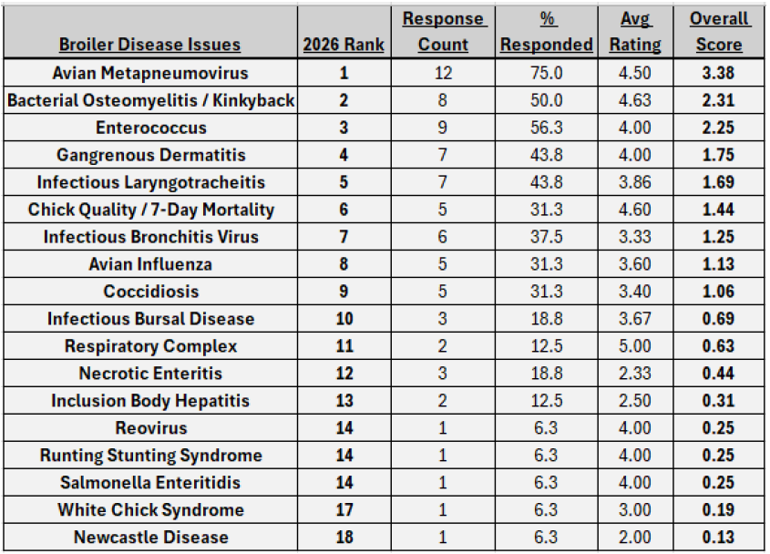

Figure 1: Broiler Disease Issues
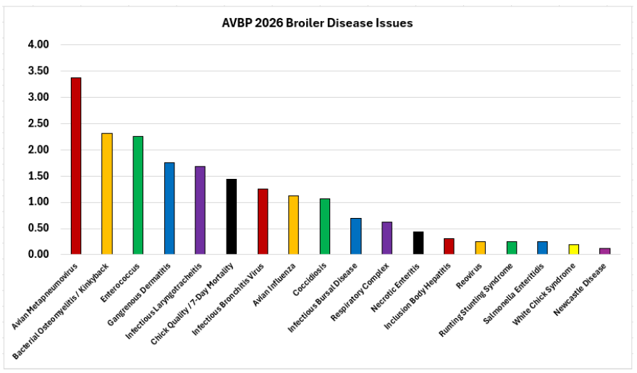

Table 2: Pullet and Broiler Breeder Disease Issues
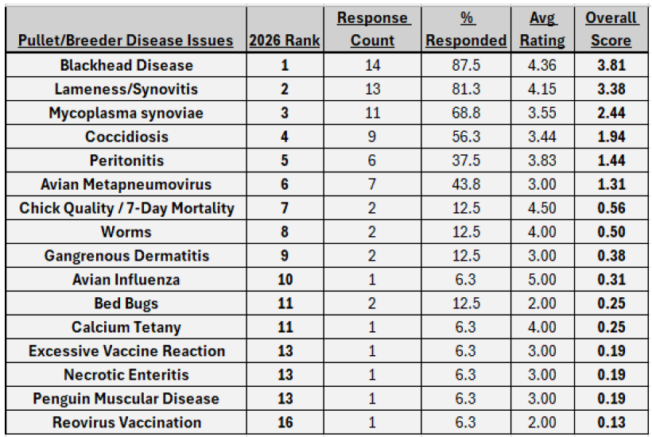

Figure 2: Pullet and Broiler Breeder Disease Issues
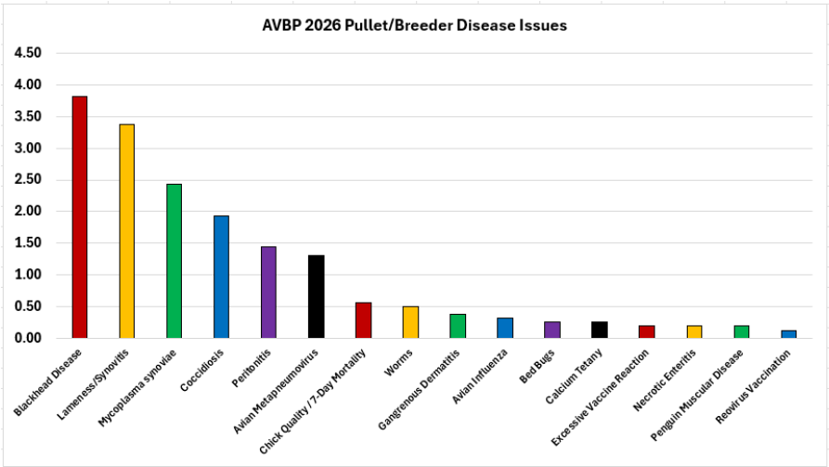

Table 3: Non-Disease Issues
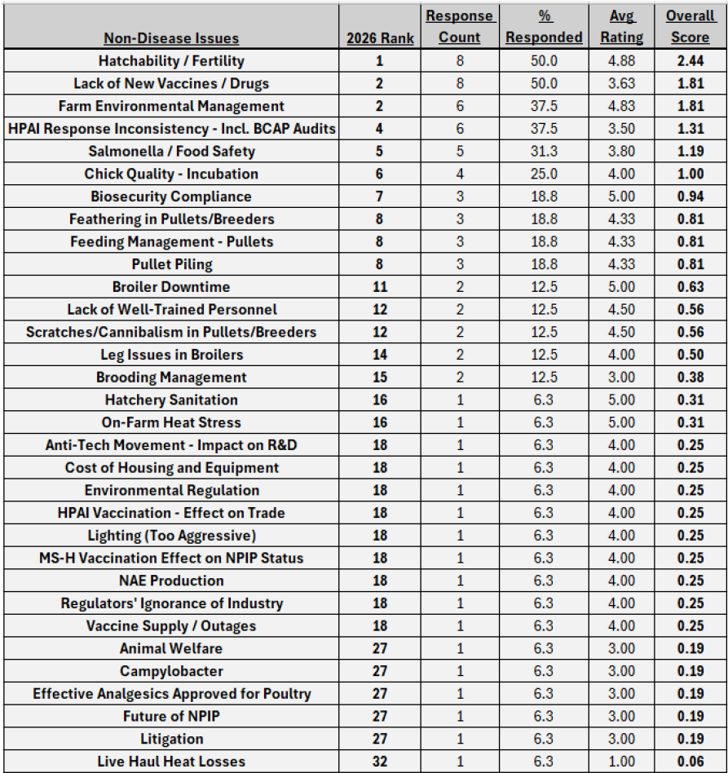

Figure 3: Non-Disease Issues
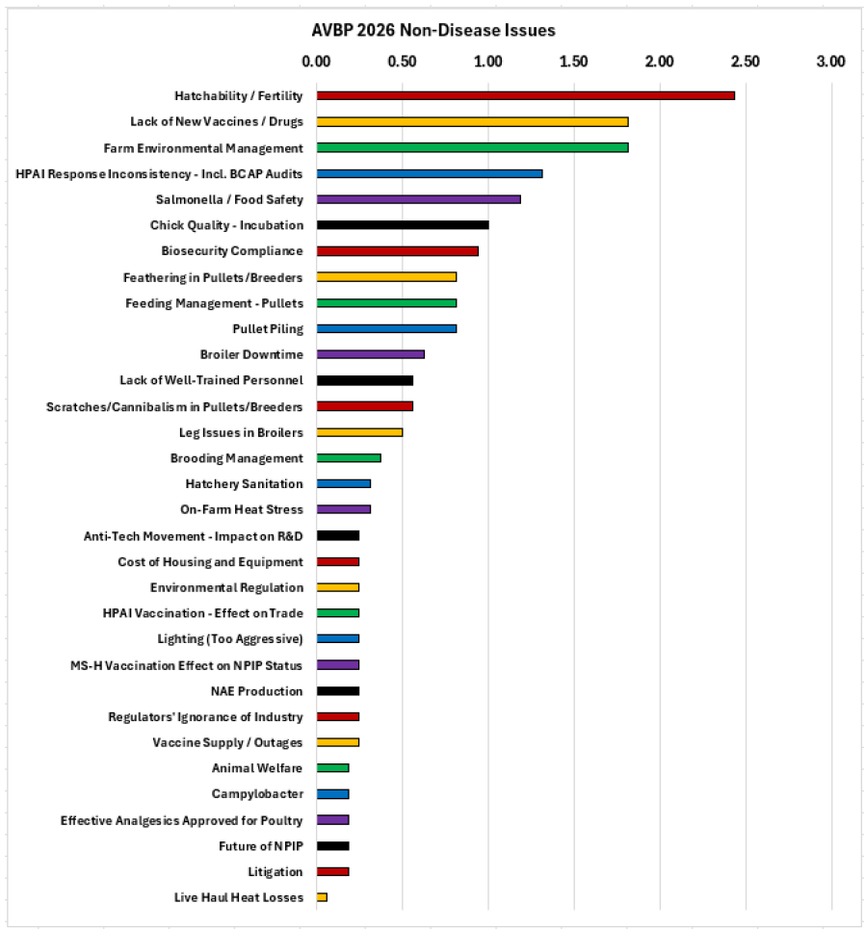

References
1 -https://www.nass.usda.gov/Statistics_by_Subject/index.php?sector=ANIMALS%20&%20PRODUCTS - Accessed 10/1/2026
2 - Agristats, Inc. Page 6.6
3 - https://esmis.nal.usda.gov/sites/default/release-files/795797/pslaan26.pdf - Accessed 10/5/2026
4 - 20https://esmis.nal.usda.gov/sites/default/release-files/795851/htpdan26.pdf25 Summary 04/07/2026 - Accessed 10/6/2026
projected

Table Egg Layer Industry Report
Dr. Fernando Ruiz-Jimenez, Zoetis, Durham, NC.
A poll of members of the Association of Veterinarians in Egg Production (AVEP) based in the United States with a Veterinary-Client-Patient Relationship (VCPR) with layer pullet, breeder, and/or commercial layer flocks in the past calendar year was conducted in October 2026. Respondents answered questions applicable only to the types of birds under their supervision (pullets or layers) and to the types of production systems in which those flocks were housed. For pullets, production systems included conventional, cage-free, and organic. For layers, the categories included conventional, cage-free, organic, and free-range.
For each type of flock and production style in their care, respondents were asked to list the top 5 clinical conditions of importance in that category and to numerically rank each from 1 (least important) to 5 (very important). This question was presented in an open-ended style to avoid biasing potential responses. Responses were sorted, and the conditions listed were ranked first by the number of responses, and then by the weighted importance of each condition. The weighted importance was calculated by dividing the sum of each numerical importance response by the total number of responses listing that condition.
In addition to the ranked clinical condition questions, additional questions relevant to conditions of ongoing importance to the egg layer industry were added to the survey. This year, veterinarians were asked about Avian Metapneumovirus (AMPV) and Salmonella.
For AMPV, a question about the impact and level of concern of Avian Metapneumovirus infection in supervised flocks was included, as well as an open-ended question to list specific impacts and outcomes of concern, and which specific production styles have been most impacted in the respondents’ experience. Additional questions about vaccination against AMPV and the production styles being vaccinated were included as well.
For Salmonella, respondents were asked if they had perceived an increase in Salmonella challenge in flocks under their supervision this year, and which, if any, additional control measures they had implemented.
A total of 22 out of 34 (65%) of polled veterinarians responded to the survey. The results of the disease survey are shown below by category in ranked order of importance as described above. The top 5 conditions in each category are bolded. The weighted importance score and the number of responses listing each condition are included in each table. A column indicating a change in the ranking from last year for each condition was also added.

Conventional Pullets – 17 Respondents

Change |  | Rank | Condition | Weighted Importance | Responses
--- |  | 1 | Coccidiosis | 3.0 | 13
↑ 3 |  | 2 | Chick Quality Concerns | 2.8 | 13
↓ 1 |  | 3 | Infectious Coryza | 3.9 | 9
↑ 10 |  | 4 | Post-Killed Vaccine Reactions | 2.7 | 9
↓ 2 |  | 5 | AMPV | 4.5 | 4
--- |  | 6 | Necrotic Enteritis | 4.3 | 4
↓ 3 |  | 7 | E. coli | 3.8 | 4
↑ 8 |  | 8 | Infectious Laryngotracheitis | 3.3 | 3
NEW |  | 9 | Nutrition Concerns | 2.3 | 3
NEW |  | 10 | MG | 4.0 | 2
NEW |  | 11 | Piling | 3.0 | 2
NEW |  | 12 | Marek’s Disease | 2.5 | 2
NEW |  | 13 | Heat Stress | 5.0 | 1
↓ 5 |  | 14 (tie) | Infectious Bursal Disease | 3.0 | 1
↓ 1 |  | 14 (tie) | Management Concerns | 3.0 | 1
↓ 7 |  | 15 | Infectious Bronchitis | 2.0 | 1
↓ 6 |  | 16 (tie) | HPAI | 1.0 | 1
↑ 1 |  | 16 (tie) | Histomoniasis | 1.0 | 1
↓ 7 |  | 17 | Pecking | 1.0 | 1

Cage-Free Pullets – 22 Respondents

Change |  | Rank | Condition | Weighted Importance | Responses
--- |  | 1 | Coccidiosis | 3.3 | 16
--- |  | 2 | Piling | 3.3 | 12
↑ 3 |  | 3 | Infectious Coryza | 4 | 10
↑ 6 |  | 4 | Chick Quality Concerns | 2.8 | 10
↑ 6 |  | 5 | Management Concerns | 3 | 7
↓ 2 |  | 6 | AMPV | 3.2 | 6
↓ 4 |  | 7 | E. coli | 3.5 | 4
↓ 1 |  | 8 | Necrotic Enteritis | 4 | 3
↑ 5 |  | 9 | Post-Killed Vaccine Reactions | 3.7 | 3
NEW |  | 10 | Infectious Laryngotracheitis | 3.7 | 3
↑ 6 |  | 11 | HPAI | 3 | 3
↓ 6 |  | 12 (tie) | Body Condition Concerns | 2 | 3
↓ 4 |  | 12 (tie) | Infectious Bronchitis | 3.5 | 2
NEW |  | 13 (tie) | Nutrition Concerns | 3.5 | 2
NEW |  | 13 (tie) | MG | 2.5 | 2
NEW |  | 14 (tie) | Marek’s Disease | 2.5 | 2
↓ 5 |  | 14 (tie) | Pecking | 2.0 | 2
↓ 4 |  | 15 | Mechanical Trauma | 2.0 | 2
NEW |  | 16 (tie) | Roundworms | 1.5 | 2
NEW |  | 16 (tie) | Heat Stress | 5.0 | 1
↑ 1 |  | 17 (tie) | Infectious Bursal Disease | 3.0 | 1
NEW |  | 17 (tie) | Immunization Concerns | 3.0 | 1
NEW |  | 17 (tie) | Inclusion Body Hepatitis | 3.0 | 1
NEW |  | 17 (tie) | Cryptosporidium | 3.0 | 1
NEW |  | 17 (tie) | Viral Enteritis | 3.0 | 1
↓ 5 |  | 17 (tie) | Spotty Liver Disease | 3.0 | 1
↓ 5 |  | 18 (tie) | Histomoniasis | 2.0 | 1
NEW |  | 18 (tie) | Aspergillosis | 2.0 | 1

Organic Pullets – 14 Respondents

Change |  | Rank | Condition | Weighted Importance | Responses
--- |  | 1 | Coccidiosis | 3.4 | 9
↑ 2 |  | 2 | Chick Quality Concerns | 3.0 | 6
--- |  | 3 | E. coli | 3.8 | 5
↑ 1 |  | 4 | Piling | 3.0 | 5
↑ 6 |  | 5 | Management Concerns | 2.8 | 5
NEW |  | 6 | Body Condition Concerns | 3.8 | 4
↑ 2 |  | 7 | Infectious Coryza | 3.7 | 3
↓ 1 |  | 8 | AMPV | 3.3 | 3
NEW |  | 9 (tie) | HPAI | 3.0 | 3
↓ 7 |  | 9 (tie) | Histomoniasis | 3.0 | 3
↓ 4 |  | 10 | Necrotic Enteritis | 4.5 | 2
--- |  | 11 | Post-Killed Vaccine Reactions | 4.0 | 2
NEW |  | 12 | Immunization Concerns | 3.0 | 2
NEW |  | 13 | MG | 5.0 | 1
↓ 5 |  | 14 (tie) | Infectious Bronchitis | 4.0 | 1
NEW |  | 14 (tie) | Viral Enteritis | 4.0 | 1
↓ 3 |  | 15 (tie) | Infectious Laryngotracheitis | 3.0 | 1
NEW |  | 15 (tie) | Marek’s Disease | 3.0 | 1
↓ 5 |  | 15 (tie) | Pecking | 3.0 | 1
↓ 1 |  | 15 (tie) | Infectious Bursal Disease | 3.0 | 1
NEW |  | 15 (tie) | Cryptosporidium | 3.0 | 1
↓ 2 |  | 16 (tie) | Roundworms | 2.0 | 1
NEW |  | 16 (tie) | Salmonella | 2.0 | 1

Overview of Pullet Conditions
All surveyed veterinarians had VCPR oversight of cage-free pullets, 77% had oversight of conventional pullets, and 64% had oversight of organic pullets.
Coccidiosis was the top concern across all categories, the same as last year. Necrotic enteritis, which is usually associated with coccidiosis, ranked slightly lower this year, but was still in the top 10 concerns in all categories.
Chick Quality Concerns, which encompass yolk sac infection/omphalitis, starve-outs, non-starters, and beak injuries from IRBT, ranked in the top 5 in all categories.
Infectious Coryza remained a highly important concern in all categories, ranking #3 in conventional and cage-free, and #7 in organic. Some respondents indicated that Infectious Coryza is the primary driver of a condition described as “Pullet Respiratory Syndrome” observed in certain regions of the US. This syndrome causes elevated mortality in young pullets.
Management Concerns, which include issues with pullet training, ventilation, and lighting, ranked #5 in cage-free and organic, climbing six positions from last year.
The AMPV and E. coli rankings were slightly lower than last year, with AMPV declining in all categories, and E. coli declining in conventional and cage-free.
Piling kept being a top concern in cage-free and organic production.
Post-Killed Vaccine Reactions, which include post-vaccination hepatopathy, setbacks in body weight and uniformity, and mortality, ranked a lot higher in conventional and cage-free this year.
Inclusion Body Hepatitis was a noteworthy appearance in the cage-free ranking, as this condition is not typically observed in layer-type chickens.

Conventional Layers – 18 Respondents

Change |  | Rank | Condition | Weighted Importance | Responses
↑ 1 |  | 1 | Infectious Coryza | 3.3 | 12
↓ 1 |  | 2 | E. coli | 4.0 | 11
↑ 4 |  | 3 | Pecking | 3.0 | 5
↑ 1 |  | 4 | Necrotic Enteritis | 3.5 | 4
NEW |  | 5 | Nutrition Concerns | 3.0 | 4
↓ 3 |  | 6 (tie) | AMPV | 2.8 | 4
↑ 3 |  | 6 (tie) | MG | 2.8 | 4
NEW |  | 7 | Coccidiosis | 1.8 | 4
↑ 3 |  | 8 (tie) | Body Condition Concerns | 3.7 | 3
↑ 3 |  | 8 (tie) | Gout | 3.7 | 3
NEW |  | 9 | Late Cycle Mortality | 3.3 | 3
↓ 7 |  | 10 (tie) | Infectious Bronchitis | 3.0 | 3
NEW |  | 10 (tie) | Egg Yolk Peritonitis | 3.0 | 3
↑ 1 |  | 11 | Cloacal Prolapse | 4.5 | 2
NEW |  | 12 (tie) | Restlessness/Hysteria | 4.0 | 2
↓ 3 |  | 12 (tie) | Heat Stress | 4.0 | 2
↓ 2 |  | 13 | Infectious Laryngotracheitis | 3.5 | 2
↓ 8 |  | 14 | HPAI | 5.0 | 1
NEW |  | 15 | Post-Anthelmintic Reaction | 4.0 | 1
NEW |  | 16 | Roundworms | 3.0 | 1
NEW |  | 17 | Clostridial Dermatitis | 2.0 | 1
NEW |  | 18 (tie) | Cloacitis/Vent Gleet | 1.0 | 1
NEW |  | 18 (tie) | Cholera | 1.0 | 1

Cage-Free Layers – 21 Respondents

Change |  | Rank | Condition | Weighted Importance | Responses
--- |  | 1 | E. coli | 4.4 | 15
↑ 1 |  | 2 | Piling | 2.7 | 12
↑ 4 |  | 3 | Roundworms | 2.2 | 9
 |  | 4 | AMPV | 3.2 | 6
↑ 5 |  | 5 | Infectious Coryza | 4.2 | 5
↑ 3 |  | 6 | Body Condition Concerns | 3.4 | 5
↓ 1 |  | 7 | Pecking | 3.0 | 5
↑ 3 |  | 8 | Coccidiosis | 2.5 | 4
↓ 1 |  | 9 | HPAI | 4.3 | 3
↓ 6 |  | 10 | Cholera | 2.0 | 3
↓ 6 |  | 11 (tie) | Necrotic Enteritis | 4.5 | 2
NEW |  | 11 (tie) | Infectious Laryngotracheitis | 4.5 | 2
NEW |  | 12 (tie) | Late Cycle Mortality | 4.0 | 2
--- |  | 12 (tie) | MG | 4.0 | 2
↓ 2 |  | 13 (tie) | Infectious Bronchitis | 3.5 | 2
↓ 9 |  | 13 (tie) | Spotty Liver Disease | 3.5 | 2
↑ 2 |  | 13 (tie) | Cloacal Prolapse | 3.5 | 2
NEW |  | 14 | Egg Yolk Peritonitis | 2.5 | 2
NEW |  | 15 | Egg Drop Syndrome | 2.0 | 2
↓ 2 |  | 16 | Trauma | 4.0 | 1
NEW |  | 17 (tie) | Emaciation | 3.0 | 1
NEW |  | 17 (tie) | Masculinized Hens | 3.0 | 1
↓ 2 |  | 18 (tie) | External Parasites | 2.0 | 1
↓ 2 |  | 18 (tie) | Clostridial Dermatitis | 2.0 | 1
NEW |  | 19 (tie) | Cloacitis/Vent Gleet | 1.0 | 1
NEW |  | 19 (tie) | Post-Anthelmintic Reaction | 1.0 | 1
↓ 6 |  | 19 (tie) | Salmonella | 1.0 | 1

Organic Layers – 15 Respondents

Change |  | Rank | Condition | Weighted Importance | Responses
--- |  | 1 | E. coli | 4.5 | 12
↑ 4 |  | 2 | Spotty Liver Disease | 2.9 | 10
↑ 4 |  | 3 | AMPV | 3.4 | 9
--- |  | 4 | Roundworms | 3.0 | 6
--- |  | 5 | Cholera | 2.8 | 5
↓ 1 |  | 6 | Pecking | 2.4 | 5
NEW |  | 7 | Piling | 3.3 | 4
↑ 1 |  | 8 | Egg Drop Syndrome | 3.0 | 4
NEW |  | 9 | Infectious Coryza | 3.3 | 3
↓ 2 |  | 10 | HPAI | 2.3 | 3
↑ 4 |  | 11 | Infectious Bronchitis | 3.5 | 2
NEW |  | 12 | Nutrition Concerns | 3.0 | 2
NEW |  | 13 (tie) | Heat Stress | 5.0 | 1
NEW |  | 13 (tie) | Restlessness/Hysteria | 5.0 | 1
↓ 8 |  | 13 (tie) | Erysipelas | 5.0 | 1
NEW |  | 14 | Infectious Laryngotracheitis | 4.0 | 1
--- |  | 15 (tie) | Body Condition Concerns | 3.0 | 1
NEW |  | 15 (tie) | Cloacal Prolapse | 3.0 | 1
NEW |  | 15 (tie) | Masculinized Hens | 3.0 | 1
NEW |  | 16 (tie) | Cloacitis/Vent Gleet | 2.0 | 1
NEW |  | 16 (tie) | Histomoniasis | 2.0 | 1
NEW |  | 17 | Focal Duodenal Necrosis | 2.0 | 1

Free-Range Layers

Change |  | Rank | Condition | Weighted Importance | Responses
↑ 1 |  | 1 | Spotty Liver Disease | 3.6 | 9
↑ 2 |  | 2 | AMPV | 3.3 | 8
↓ 2 |  | 3 | E. coli | 4.7 | 7
↑ 5 |  | 4 | Roundworms | 2.6 | 5
NEW |  | 5 | Egg Drop Syndrome | 2.4 | 5
NEW |  | 6 | HPAI | 4.3 | 3
↓ 4 |  | 7 | Cholera | 3.3 | 3
↓ 3 |  | 8 | Pecking | 2.7 | 3
↓ 2 |  | 9 | Erysipelas | 4.5 | 2
NEW |  | 10 | Infectious Bronchitis | 3.5 | 2
NEW |  | 11 (tie) | Infectious Coryza | 3.0 | 2
NEW |  | 11 (tie) | Nutrition Concerns | 3.0 | 2
NEW |  | 12 | Restlessness/Hysteria | 5.0 | 1
↓ 5 |  | 13 | Fatty Liver Syndrome | 3.0 | 1
↓ 7 |  | 14 (tie) | Predation | 1.0 | 1
NEW |  | 14 (tie) | Piling | 1.0 | 1
NEW |  | 15 | MG | 1.0 | 1

Overview of Layer Conditions
A total of 95% of surveyed veterinarians had VCPR oversight of cage-free layers, 82% had oversight of conventional layers, 68% had oversight of organic layers, and 50% had oversight of free-range layers.
E. coli and AMPV remained in the top 5 concerns across all categories. Interestingly, E. coli was no longer the top concern in conventional production, where it was displaced by Coryza, and in organic production, where it was displaced by Spotty Liver Disease and AMPV. E. coli had been the top concern in all categories since 2022. Despite its slightly lower ranking in these two production styles, it still held the highest importance score in all categories. AMPV ranking also dropped slightly in all categories, except for free-range.
Infectious Coryza was the top concern in conventional and ranked #5 in cage-free. Interestingly, it also appeared in the organic and free-range rankings, where it was not typically an issue.
Roundworms were in the top 5 concerns in cage-free, organic, and free-range, and they also appeared in the conventional list of concerns.
Piling remained a top concern in cage-free and was in the top 10 concerns in organic.
Spotty Liver Disease ranking increased in free-range, where it was the top concern, and in organic, where it was #2. However, its ranking dropped significantly in cage-free.
Body Condition Concerns and Coccidiosis were in the top 10 concerns in conventional and cage-free, but they don’t seem to be as prevalent in organic and free-range.
Notably, Cholera was in the top 10 concerns in cage-free, organic, and free-range.

Topical Questions
AMPV
The results of the AMPV topical questions are shown below as graphs, indicating the number of responses for each category. Most respondents had a moderate level of concern about the impact of AMPV on their flocks, with responses nearly normally distributed across the scale from 1 (low concern) to 5 (high concern).
The most impactful outcomes of AMPV infections in flocks were secondary bacterial infections and decreased production. Respondents mentioned that increased mortality is often associated with secondary bacterial infections, such as E. coli, Coryza, and MG. They also pointed out that flocks tend to recover well from AMPV infections if other disease challenges are low.
Respondents indicated that AMPV infections are more impactful in layer flocks than in pullet flocks, with cage-free, organic, and free-range layers being the most impacted. Results also showed that brown birds tend to be more affected by AMPV infections than white birds.
Most respondents were not vaccinating their flocks against AMPV. However, those who did were using mainly live vaccines, either once or multiple times. Only one respondent mentioned they were using an inactivated vaccine once, and none used multiple inactivated vaccines. Vaccination against AMPV was mainly done in the pullet phase, but some respondents indicated they also vaccinate layer flocks (organic, free-range, and cage-free).
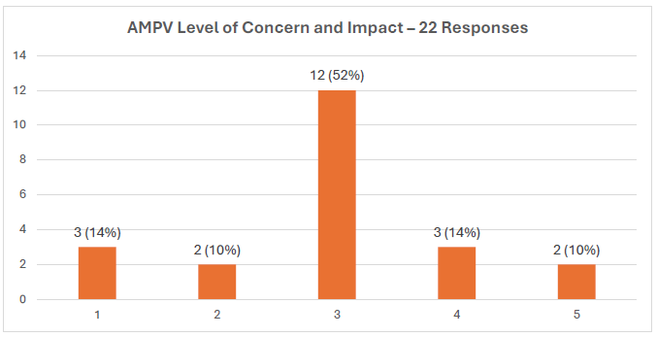

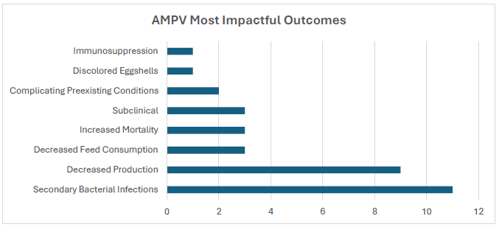

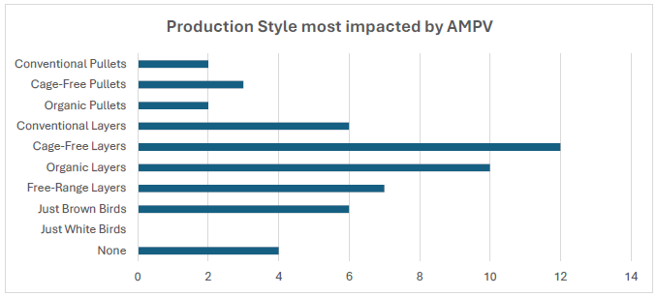

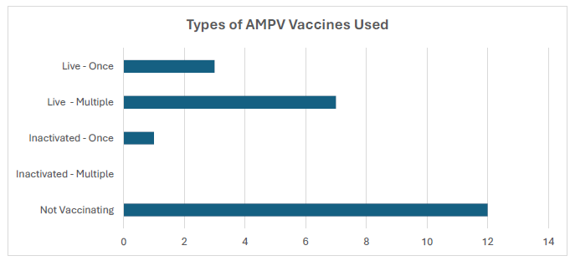

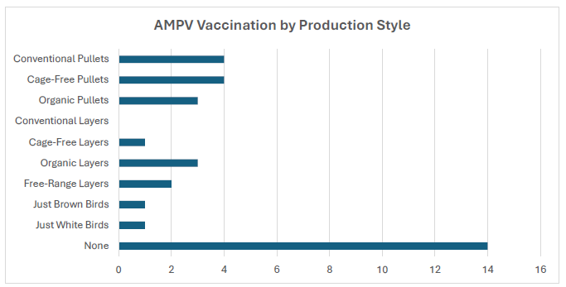

Salmonella
The results of the Salmonella topical questions are shown below as graphs. A total of 14 out of 22 (64%) of the respondents did not perceive an increase in Salmonella challenge in their flocks this year. Most of the respondents did not implement any additional control measures against Salmonella in their flocks. The most commonly implemented control measures were stricter pest control, additional live vaccinations, use of autogenous vaccines, and stricter biosecurity.

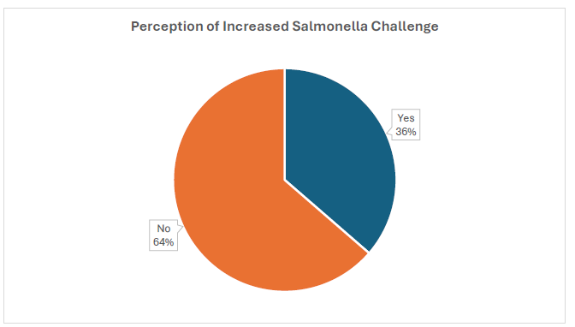

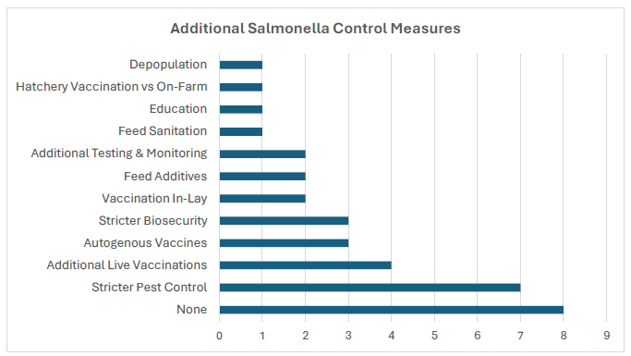
Turkey Industry Report
Dr. Eliza Ripplinger, Swine Services Unlimited Inc., Little Falls, MN.

Current Health Issues Facing the US Turkey Industry
Eliza Ripplinger, DVM, MPH, PSM, DACPV
President, Association of Veterinarians in Turkey Production (AVTP)
Poultry Veterinarian
Little Falls, MN

Carrie Cremers, DVM, MAHM
Manager of Technical Service and Animal Welfare
Past President, Association of Veterinarians in Turkey Production (AVTP)
Jennie-O Turkey Store
Willmar, MN

For the 2026 annual report to the USAHA Committee on Poultry & Other Avian Species, a survey of U.S. turkey industry veterinarians and production professionals (n = 19) was conducted to assess the health status of turkeys produced from August 2025 through August 2026. Surveys were collected by a third party, blinded, and provided to Drs. Eliza Ripplinger and Carrie Cremers for analysis. The 2026 survey represented 165.8 million head—equivalent to 85.5% of the 194 million turkeys reported raised by USDA.

Table 1 summarizes the leading disease and management issues identified (n=39 issues). The top ranked challenges in 2026 were lack of approved, efficacious drugs (#1); Colibacillosis (#2); and Avian Metapneumovirus (AMPV) (#3). The top two challenges increased in ranking from 2025. Lack of efficacious drugs moved from #2 (score 4.4) to #1 (score 4.7). Colibacillosis moved from #5 (score 3.4) to #2 (score 4.0). AMPV decreased in ranking from 2025, moving from #1 (score 4.7) to #3 (score 3.9). Clostridial Dermatitis (Cellulitis) remained at #4, although the score average increased from 3.5 to 3.8. Highly Pathogenic Avian Influenza (HPAI) decreased in ranking from 2025, moving from #3 (score 4.1) to #5 (score 3.8). Enteric diseases ranked mainly in the lower half, except for Coccidiosis (Table 1A). Coccidiosis increased in ranking from #24 (score 1.8) to #12 (score 2.5). Four respiratory diseases appeared among the top 10 overall (Table 1B). Salmonella decreased in ranking from #6 (score 3.2) to #11 (score 2.6).

Reovirus continues as a notable issue in the 2026 survey, with Turkey Reovirus Digital Flexor Tendon Rupture (TR-DFTR) and Turkey Hepatitis Reovirus (THRV) ranked #7 and #8 respectively, from #9 and #11 the prior year. Reovirus infections may be associated with “Leg Problems”, which moved from #8 to #6, and “Bleeders” (aortic, hepatic ruptures), which remained at #25.

Avian metapneumovirus (AMPV) decreased in ranking to #3, likely due to the availability and implementation of imported vaccines. In early 2025, the United States began importing commercial modified live vaccines that are licensed and approved in Europe. The vaccines have shown positive results in protecting turkey health against AMPV. NTF has continued to engage USDA’s Center for Veterinary Biologics (CVB) and encourage extensions of the one-year import permits to continue addressing the disease until USDA approved domestically produced vaccines become available. Secondary infections after AMPV infection are common and often complicate clinical disease. Common pathogens include Escherichia coli (Colibacillosis, #2), Ornithobacterium rhinotracheale (ORT, #10), Pasteurella multocida (Cholera, #13), Bordetella avium (#13), and Mycoplasma gallisepticum (MG, #22).

The lack of approved, efficacious drugs continues to be a challenge for the turkey industry (#1, score 4.7) and is likely a contributor to all turkey health challenges and disease issues that follow it on the ranking list. NTF’s Turkey Health Task Force continues to engage with industry and regulatory agencies to discuss animal health challenges and avenues to advance efforts that bring new animal health products to market for the turkey industry.
Highly Pathogenic Avian Influenza (HPAI) continues to negatively impact the commercial poultry industry as it is in year five of the current outbreak. Since the start of the outbreak more than 207 million birds have been lost, over 23.4 million of which have been commercial turkeys. As of October 15, there have been 52 commercial turkey cases in 2026 resulting in a loss of more than 2.1 million birds. HPAI continues to be a key focus of the full NTF team.

NTF continues to prioritize efforts that align with the Federation’s policy resolution on vaccination and remains engaged with policy makers at the White House, USDA and on Capitol Hill. NTF supports and encourages the release of the completed vaccination strategy and the engagement of formal consultations with major trading partners to assess their views on the potential use of HPAI vaccines in the United States and the safeguards that would accompany any vaccination strategy.

Reported cases of Blackhead (histomoniasis) increased slightly, at 66 in 2026 versus 60 in 2025. Cases of Mycoplasma synoviae (MS), Turkey Coronavirus (TCV), and Mycoplasma gallisepticum (MG) decreased by nearly half from the prior year. Reported cases of AMPV decreased from the prior year (5,964 cases in 2025 to 2,590 cases in 2026). This includes clinical cases as well as cases positive on serology or PCR. The decline in reported AMPV cases is likely due to fewer clinical cases and increased vaccination. Reported cases of TR-DFTR increased by more than double, from 273 cases reported in 2025 to 578 cases reported in 2026. See Table 2 for number of reported cases by disease.

Respondents were surveyed to classify their coccidia control programs and antibiotic programs. See Tables 3 and 4 to compare 2026’s programs to previous years.

Table 1. Turkey health survey (August 2025 - 2026) of professionals in US turkey production (n = 19, head reporting = 165.8 million) ranking current disease issues (1= no issue to 5 = severe problem). Data on file.
Issue | Score Average (1-5)
Lack of approved, efficacious drugs | 4.7
Colibacillosis | 4.0
Avian Metapneumovirus (AMPV) | 3.9
Clostridial Dermatitis (Cellulitis) | 3.8
Avian influenza, High path (HPAI) | 3.8
Leg Problems | 3.2
TR-DFTR (Turkey Reovirus Digital Flexor Tendon Rupture) | 3.0
Heat Stress/Mortality | 2.9
Ornithobacterium rhinotracheale (ORT) | 2.9
THRV (Turkey Hepatitis Reovirus) | 2.9
Salmonella | 2.6
Coccidiosis | 2.5
Bordetella avium | 2.5
Cholera | 2.5
Mycoplasma synoviae (MS) | 2.5
Blackhead (histomoniasis) | 2.4
Tibial Dyschondroplasia (TDC, Osteochondrosis) | 2.4
Poult Enteritis of unknown etiologies | 2.3
Cannibalism | 2.2
Late Mortality | 2.2
Protozoal Enteritis (Flagellated) | 2.1
Breast Blisters and Breast Buttons | 2.0
Mycoplasma gallisepticum (MG) | 2.0
Round Worms (Ascaridia dissimilis) | 2.0
Bleeders (aortic, hepatic ruptures) | 1.9
Osteomyelitis (OM) | 1.9
PEMS (Poult Enteritis Mortality Syndrome) | 1.6
Streptococcus gallolyticus (aka, S. bovis) | 1.6
Avian influenza, Low Path (LPAI) | 1.6
Necrotic enteritis | 1.6
Newcastle Disease Virus (NDV) | 1.5
Fractures | 1.5
Shaky Leg Syndrome | 1.5
Turkey Coronavirus | 1.4
Erysipelas | 1.4
H3N2 (H1N1) Swine Influenza | 1.3
Mycoplasma meleagridis (MM) | 1.1
Mycoplasma iowae (MI) | 1.1
Spondylolisthesis (Kinky-Back) | 1.0

Table 1A. Turkey health survey (August 2025 - 2026) of professionals in US turkey production (n = 19, head reporting 165.8 million): Enteric Diseases Ranking for 2026.

Issue | Score Average (1-5) | Overall Rank (1-39)
Coccidiosis | 2.5 | 12
Blackhead (Histomoniasis) | 2.4 | 16
Poult Enteritis of unknown etiologies | 2.3 | 18
Protozoal Enteritis (Flagellated) | 2.1 | 21
Round Worms (Ascaridia dissimilis) | 2.0 | 22
PEMS (Poult Enteritis Mortality Syndrome) | 1.6 | 27
Necrotic enteritis | 1.6 | 29
Turkey Coronavirus | 1.4 | 34

Table 1B. Turkey health survey (August 2025 - 2026) of professionals in US turkey production (n = 19, head reporting 165.8 million): Respiratory Diseases Ranking for 2026.
Issue | Score Average (1-5) | Overall Rank (1-39)
Colibacillosis | 4.0 | 2
Avian Metapneumovirus (AMPV) | 3.9 | 3
Avian Influenza, High Path (HPAI) | 3.8 | 5
Ornithobacterium rhinotracheale (ORT) | 2.9 | 8
Mycoplasma synoviae (MS) | 2.5 | 13
Cholera | 2.5 | 13
Bordetella avium | 2.5 | 13
Mycoplasma gallisepticum (MG) | 2.0 | 22
Avian Influenza, Low Path (LPAI) | 1.6 | 29
Newcastle Disease Virus (NDV) | 1.5 | 31
H3N2 (H1N1) Swine Influenza | 1.3 | 36

Table 2. Turkey health survey (August 2024 - 2025) of professionals in US turkey production (n = 20, head reporting = 201.4 million): reporting cases of diseases. Data on file.
Cases (##) of | 2026 | 2025 | 2024 | 2023 | 2022 | 2021 | 2020
Blackhead (Histomoniasis) | 66 | 60 | 51 | 61 | 103 | 130 | 82
Mycoplasma synoviae (MS) | 88 | 159 | 161 | 20 | 14 | 34 | 21
Turkey Coronavirus (TCV) | 33 | 54 | 31 | 411 | 459 | 117 | 27
Turkey Reovirus Digital Flexor Tendon Rupture | 578 | 273 | 368 | 487 | 170 | 239 | 548
Mycoplasma gallisepticum (MG) | 33 | 75 | 43 | 12 | 8 | 78 | 31
Avian Metapneumovirus (AMPV) | 2,590 | 5,964 | 2,355 | - | - | - | -

Table 3. Turkey health survey (August 2025 - 2026) of professionals in US turkey production (n = 19, head reporting = 165.8 million) by antibiotic program. Data on file.

 | 2026 | 2025 | 2024
Conventional/Full Use¹ | 61% | 60% | 56%
No Growth Promotants, CRAU/CRAU-like² | 41% | 30% | 25%
NAE /ABF, RWA³ | 17% | 20% | 19%
No Hatchery Injection of Antibiotics⁴ | 21% | 18% | -

¹Conventional/Full Use (any antibiotics, including ionophores, bacitracin, bambermycins, and /or those deemed medically important to humans by FDA), allows in-feed and in-water administration of antibiotics.
²No Growth Promotants, CRAU/CRAU-like (Certified Responsible Antibiotic Use), permits only therapeutic uses of antibiotics.
³No Antibiotics Ever (NAE) /Antibiotic Free (ABF), Raised Without Antibiotics (RWA), uses neither in-feed nor in-water antibiotics. No hatchery injection of antibiotics.
⁴No Hatchery Injection of Antibiotics means that antibiotics were not administered to the turkeys in the egg (in ovo) or as day-old hatchling poults.

Table 4. Turkey survey (August 2025 - 2026) of professionals in US turkey production (n = 19, head reporting = 165.8 million) coccidia control programs. Does not total 100%. Alternatives (phytonutrients) and vaccines may be used to supplement the current ionophore or chemical anticoccidial program, or as the sole program for coccidia control. Data on file. In 2025, due to the blinded nature of this study, it was not possible to verify the unique identity of each respondent. The reported coccidia control programs should therefore be interpreted with the understanding that some duplication of responses may be present.

Program | 2026 | 2025 | 2024
Ionophore | 40% | 29% | 56%
Chemical | 21% | 27% | 41%
Alternative (Phytonutrients) | 12% | 20% | 11%
Vaccine | 16% | 34% | 26%

Live Bird Marketing System (LBMS) Avian Influenza Program FY2025 Working Group Report
Dr. Fidelis Hegngi, USDA-APHIS-VS, Beltsville, MD.

The United States domestic low pathogenicity avian influenza (LPAI) program provides routine surveillance for H5 and H7 LPAI within the Live Bird Marketing System (LBMS) to support prevention and control activities. LPAI H7N2 became endemic in live bird markets in the northeastern United States beginning in 1994. In response, the United States Department of Agriculture (USDA) established a LBMS Working Group in 1999 to assist States in eliminating the virus from affected markets. On October 20, 2004, USDA Animal and Plant Health Inspection Service (APHIS) Veterinary Services (VS) published uniform standards for H5 and H7 LPAI prevention and control in the LBMS, creating a consistent framework for participating States. These LBMS uniform standards were subsequently updated in 2008, 2012, 2016, 2020, and 2024 to incorporate emerging scientific knowledge, surveillance findings, and programmatic needs.
State participation in the program is voluntary. Participating States implement the regulatory measures necessary to ensure compliance across their LBMS, including producers and distributors. All LBMs, producers, and distributors supplying the markets are required to be registered or licensed with the State and must permit Federal and State inspectors’ access to facilities, birds, and records. These entities must also maintain written biosecurity protocols. Veterinary Services coordinates and administers the national program, providing personnel and resources to support States in implementing and maintaining compliance with program requirements.
In FY2026 the LBMS Working Group held its annual business meeting in New York City, New York. The meeting was attended by 96 participants/virtual speakers including 32 USDA, APHIS, VS participants, 4 LBMS/poultry industry stakeholders, 10 university representatives, 1 State animal health diagnostic laboratory representatives and 49 State Department of Agriculture participants representing 31 States. The meeting provides opportunities for continued program development, implementation, and advancement.

The working group also discussed:
(1) 2024 LBMS Uniform Standards
(2) LBMS Status and FY2026 Budget Update.
(3) An update on Initial State Response and Containment Plan (ISRCP).
(4) An update on Cooperative Agreements, Indemnity, and Compensation procedures.
(5) Current HPAI Situation & Response in the United States.
(6) New York LBMS.
(7) States Response to H5N1 HPAI in the LBMS - Challenges and Lessons Learned (California, Florida, and New York).
(8) Epidemiology Summary, Challenges and Lessons Learned - H5N1 HPAI in the LBMS during FY2025.
(9) Pennsylvania Live Bird Marketing System Biosecurity Assurance Program.
(10) Update HPAI Biosecurity Compliance Audit Program (BCAP).
(11) HPAI Response – Surveillance of Commercial premises and Backyard Flocks in a Control Area or Surveillance Zone.
(12) Guidance for Response to a Highly Pathogenic Avian Influenza (HPAI) Detection in a Live Bird Market.
(13) HPAI – Role of Wild Birds & Update-Wild Bird AI Surveillance Projected for 2026 and beyond.
(14) National Veterinary Services Laboratories - Update on Surveillance Testing - Current Nationwide Findings and Status of Current Diagnostics for AI and Newcastle Disease.
(15) Susceptibilities and Viral Shedding of Peri Domestic Mammals and Birds Infected with Clade 2.3.4.4b Highly Pathogenic Avian Influenza Viruses.
(16) Southeast Poultry Research Laboratory Update on HPAI Research and Vaccine.
(17) An Update on the National Poultry Improvement Plan (NPIP), NPIP Authorized Laboratories System and Compartmentalization.
(18) Discussion on Outreach and Education Projects: Defend the Flock (DTF) – Combined Campaign Update: Bird Awareness Week; Flock Defender; and Youth Outreach.
(19) Plans for 2026 LBMS Continuing Education Training Course at Michigan State University College of Veterinary Medicine.
In FY2026 the USDA continued to grow its Defend the Flock outreach and education campaign.
Overall Campaign Performance
The national paid, earned, and microsite outreach activities substantially increased awareness of the Defend the Flock program and USDA biosecurity resources. Paid media efforts generated approximately 16 million impressions, 1 million clicks, and 216,000 website sessions. Earned media activities delivered 1.47 million article impressions, 1,168 radio media tour airings, and 321 audio news release airings, reaching an estimated 2.7 million listeners. Between October 2025 and August 2026, the campaign microsite recorded more than 313,000 page views, with the highest engagement observed on the Resource Center and homepage.
Paid Media Highlights
Paid outreach through social media, search engine marketing (SEM), the Google Display Network (GDN), and YouTube reached backyard flock owners, commercial poultry producers, and youth agricultural audiences nationwide. Paid social channels produced 12.2 million impressions, 193,000 clicks, and 154,000 sessions. SEM generated 720,000 impressions and approximately 19,000 clicks and sessions from high-intent biosecurity-related searches. GDN placements contributed 2.2 million impressions, 47,000 clicks, and 43,000 sessions using updated producer-focused messaging. YouTube instream and Shorts placements generated 880,000 impressions and 795,000 views.
Earned Media Highlights
An updated matte article disseminated during Bird Health Awareness Week produced 1.47 million impressions and 20,000 clicks. The associated radio media tour resulted in 17 interviews, which aired 1,168 times and generated 1.4 million listener impressions. The audio news release (ANR) was broadcast 321 times across major markets, reaching an estimated 1.3 million listeners.
Campaign Resources and Engagement
The campaign continued distribution of educational materials, including bulletins, toolkits, and the Defend the Flock wall calendar, with more than 50,000 calendars disseminated. The annual webinar held on January 30 reached 1,000 registrants, with approximately 480 concurrent participants. New materials produced during the reporting period included the 2027 wall calendar, the Fall 2026 bulletin, a refreshed microsite, and the HPAI Outbreak Response Toolkit. Planning for the Fall 2026 webinar is ongoing.

In FY2026, surveillance within the LBMS remained a high priority. During the first three quarters, approximately 31,621 tests were conducted as part of LPAI monitoring. Diagnostic assays included agar gel immunodiffusion (AGID), real-time reverse-transcriptase polymerase chain reaction (rRT-PCR), antigen capture immunoassay (ACIA), and virus isolation (VI). For VI and rRT-PCR testing, individual samples may represent pooled swabs, with each composite test containing either five or eleven swabs. In FY2026, there was a total of 24 H5N1 HPAI LBM confirmed detections: FL-1; NJ-1; NY-16; PA-5 and RI-1.

National Poultry Improvement Plan (NPIP) 2026 Annual Report
Dr. Melissa Yates, USDA-APHIS-VS-ASEP-NPIP, Conyers, GA.

NPIP Overview:
- 48 Official Agencies
  - 48 States
- 101 Authorized Laboratories
  - In 44 States
  - 44 Also Belong to the NAHLN
- Provisions in 4 Sections of Title 9 CFR and in the Program Standards
  - 145, 146, 147, 56
- General Conference Committee – 7 members
- Hatcheries
  - Egg/Meat Type Chickens – 274
  - Turkeys – 44
  - Waterfowl, Exhibition, Game Bird – 539

NPIP breeding flocks and birds:
- Egg-Type Chickens
  - 469 flocks representing 12,161,288 birds
- Meat-Type Chickens
  - 5,531 flocks representing 108,482,973 birds
- Turkeys
  - 502 flocks representing 4,668,546 birds
- Waterfowl, Exhibition Poultry, Game Birds
  - 6,879 flocks representing 14,202,177 birds
- Meat-Type Waterfowl
  - 177 flocks representing 388,229 birds

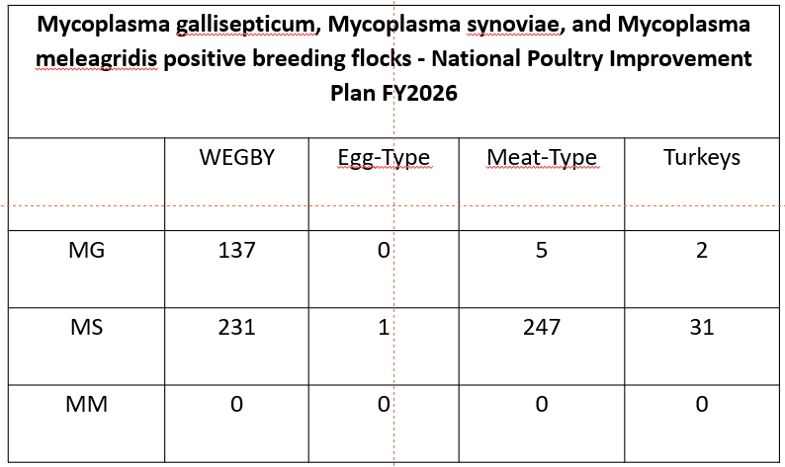

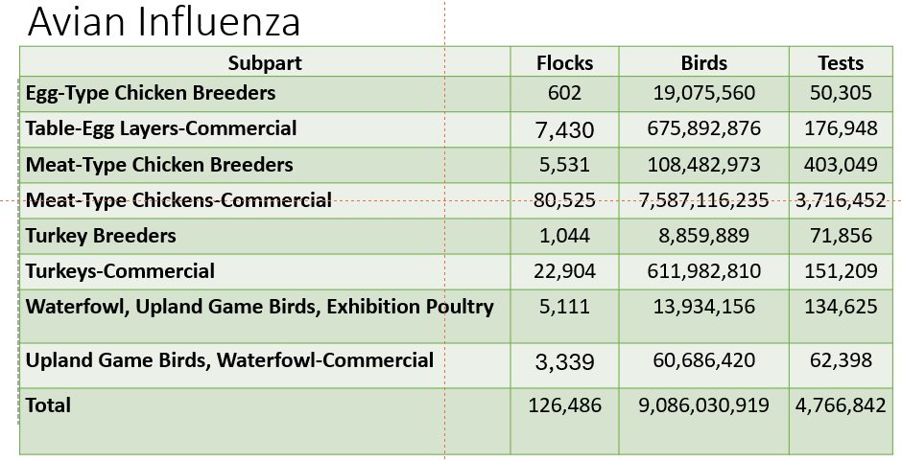

NVSL Bacteriology Diagnostics Report
Dr. Sophia Kenney, USDA-APHIS-VS-NVSL, Ames, IA.

Salmonella serotyping

The Bacteriology section within the Diagnostic Bacteriology and Pathology Laboratory of the National Veterinary Services Laboratories (NVSL) routinely performs serotyping of Salmonella isolates submitted by private, state, and federal laboratories as well as veterinarians, researchers, and other animal health officials. This report summarizes Salmonella serotyping submissions to the NVSL from January 1 through December 31, 2025, originating from poultry.

Salmonella isolates are identified as clinical (clinical signs of salmonellosis from primary or secondary infection) or non-clinical (flock monitoring programs, environmental sources, feed). Serotyping data from isolates submitted for research purposes are not included in the summary.

From January 1 to December 31, 2025, the NVSL received 9,035 isolates for Salmonella serotyping. Of those, 3,445 isolates were from chicken sources, and 305 isolates were from turkey sources. The most isolated serotypes from chicken and turkey are listed in Tables 1 and 2, respectively.

Salmonella Enteritidis

From January 1 to December 31, 2025, 3,445 Salmonella isolates were received from chickens and their environment for identification of serotype. This was a 6% increase in chicken submissions from 2024. Salmonella Enteritidis was identified in 13% of these isolates and remains in the top five serotypes observed in both clinical and non-clinical submissions.

Salmonella Pullorum and Gallinarum

The NVSL received 248 samples for Salmonella Pullorum and Gallinarum serological testing in 2025. No isolates of Salmonella Pullorum or Gallinarum were identified or confirmed at the laboratory in 2025. The NVSL provided 3,560mL of S. Pullorum tube antigen; 1,850 mL of S. Pullorum stained microtiter antigen; and 242 mL of control antisera to testing laboratories between January 1 and December 31, 2025.

Pasteurella

The NVSL received 68 isolates for Pasteurella multocida Gel-Diffusion Precipitin testing. Additionally, 20 isolates were received for P. multocida DNA fingerprinting. The NVSL supplied 17 mL of P. multocida typing sera and 11 cultures to testing laboratories.

Mycoplasma

The NVSL received 52 samples for avian Mycoplasma hemagglutination inhibition testing in 2025. In addition, 532 mL of Mycoplasma control antisera and 245 mL of Mycoplasma hemagglutination antigen were supplied to testing laboratories. Information on Mycoplasma reagents provided is shown in Table 3.

Table 1: Most common serotypes in 2025: Chicken
Clinical Cases | Non-Clinical Cases
Serotype | Serotype
Kentucky | Kentucky
Enteritidis | Enteritidis
Typhimurium | Worthington
Infantis | Senftenberg
Anatum | Braenderup

Table 2: Most common serotypes in 2025: Turkeys
Clinical Cases | Non-Clinical Cases
Serotype | Serotype
Schwarzengrund | Schwarzengrund
Agona | Senftenberg/Enteritidis
Hadar | Agbeni/Johannesburg
Senftenberg | I 3,19:non-motile/Typhimurium
Infantis | Ohio

Table 3: Mycoplasma antisera (mL) and antigen (mL) provided by NVSL
Mycoplasma | Antisera | Antigen
M. gallisepticum | 218 | 100
M. meleagridis | 42 | 35
M. synoviae | 160 | 110
Negative | 112
Total | 532 | 245

Ewing, WH. 1986. Edward and Ewing’s Identification of Enterobacteriaceae. 4th edition. Elsevier Science Publishing Co., Inc., New York, U.S.
Grimont, PAD, Weill, FX. 2007. Antigenic Formulae of the Salmonella Serovars. 9th edition. WHO Collaborating Centre for Reference and Research on Salmonella. Paris, France.

Avian Influenza and Newcastle Disease Sub-Committee Report, SEPRL Updates
Dr. David Suarez, USDA-ARS-SEPRL, Athens, GA.

The subcommittee report is designed to provide an overview of notable international influenza and Newcastle disease outbreaks. The data presented comes from a number of sources including the World Organisation for Animal Health (WOAH), Food and Agriculture Organization (FAO), published manuscripts, online reports, and presentations. Although the goal is to present a representative world view, the information is skewed to Europe because of the in-depth quarterly influenza reports available from the European Food Safety Authority. The two most noteworthy changes in the last year is the spread of the goose/Guangdong lineage H5 highly pathogenic avian influenza (HPAI) to Australia/New Zealand which makes this outbreak in wild birds and sea mammals truly world-wide in scope. The virus shows no evidence of burning out on its own and likely will remain endemic for the foreseeable future. Virulent Newcastle disease continues to be an endemic threat in much of the world, but it has been largely absent in Europe. However, ongoing and spreading outbreaks centered in Poland since 2023 and recently spreading to neighboring countries creates a new cause for concern.

In Europe the H5N1 2.3.4.4b HPAI virus continues to dominate the detections in both wild birds and poultry. Specifically, the DI 2.1 genotype has been the dominant genotype detected in the 2025-2026 season. An earlier DI 2 genotype was also the majority genotype in 2024-2025. The D1 2 genotype has also been found on other continents including as far south as South Africa and east as far as Japan. The number of detections of HPAI in wild birds has greatly increased in the 2025-26 season with a large increase in detections in waterfowl with over 7000 reported cases. Continued high numbers are found in raptors, common cranes, and colony seabirds, but with a large increase in waterfowl and a relative decline in gulls. In poultry, chickens, turkeys, domestic ducks, and domestic geese all have numerous detections. In the last 12 month, Poland had the highest numbers of affected birds with other large countries including Germany, Netherlands, France, Italy and Great Britain have sizable number of affected poultry. Most European countries had HPAI cases in poultry and even more had cases in wild birds. Overall the number of detections in poultry were slightly higher in the 2025-26 season compared to the 2024-25 seasons. The only other H5 subtype commonly found was H5N5, which was primarily found in wild birds and had a unique genotype (EA-2021-I )[1]. There were also detections of H5N1 in wild mammal species with the red fox and racoons being the two most common species with detections.[1]

France continues to vaccinate larger duck flocks (>250 birds) as a control tool. This program was initiated in October of 2023 and the cost is shared by the French government and duck farmers. Ducks are vaccinated at a day of age with an RNA vaccine and a second dose of H5 baculovirus subunit vaccine is provided preferably at 4 weeks, but in some flocks at three weeks of age. A recent study reported that the active and passive surveillance being conducted in France found several cases of low pathogenic avian influenza, but not HPAI. Thus providing evidence of a robust surveillance program, with likely prevention of HPAI in the vaccinated duck flocks.[2] An earlier epidemiologic study supported that vaccination reduced the number of outbreaks in vaccinated ducks since vaccination was started [3]. A study was also conducted to evaluate the antibody response in the vaccinated ducks at different times with the two dose vaccine regimen. It showed the RNA vaccine had only low level of antibody at 28 days, but the boost with baculovirus vaccine pushed most flocks into having acceptable antibody levels (>80%). At the time of slaughter, the overall percentage of antibody was high, but mule ducks had higher overall flocks with adequate titers as compared to Muscovy duck flocks. https://www.anses.fr/sites/default/files/2026-09/Etude-pilote-vaccination-heterologue-IAHP.pdf

A large and ongoing study in the Netherlands that examined 2 different HVT-H5 vectored vaccines given at a day of age with one group also receiving a baculovirus subunit vaccine boost was conducted in commercial layer chickens. The birds were raised in normal field conditions and evaluated for serologic response, and additionally groups of birds were brought into the laboratory and challenged with HPAIV. At 5 weeks of age in birds with just the HVT vaccine, only partial protection was observed with low antibody levels. Because the HVT-H5 vaccines are live vaccines that persist in the host, the immune response did improve over time, and later challenge dates (24 weeks, 54 weeks, and 84 weeks) had better protection. The addition of the baculovirus in one group did improve detectable antibody levels. The study also evaluated transmission into vaccinated direct contact transmission birds, and reduced transmission was observed.
https://www.wur.nl/en/news/vaccines-offer-longer-term-protection-layer-hens-field-study

Several unusual H9N2 events were also reported in Europe. The first detection of the H9N2 G5.5 lineage was reported in Hungary in a backyard flock. This genotype of H9N2 has previously been found in North Africa, the Middle East, and Asia. The concern is that this is a highly chicken adapted strain that causes economically important disease, and it could result in large outbreaks. Fortunately, the outbreak was identified and controlled with no further spread. A human case of H9N2 G5.5 was also reported in Italy. The person had recently traveled internationally and was thought to acquire the infection there. A different H9N2 genotype, G5.6, was reported in Moldova and Moscow, Russia, but this genotype has been reported from Russia before.[4]

The Food and Agriculture Organization continues to provide reports of H5N1 from Africa https://www.fao.org/animal-health/situation-updates/sub-saharan-africa-hpai/en. Sporadic detections were reported in 6 sub-Saharan Africa counties with the highest number reported in South Africa, likely due to higher levels of surveillance and a stronger laboratory system. No further reports of H7N6 were reported in South Africa and this outbreak appears controlled. Egypt remains endemic for H5 HPAI and H9N2 LPAI. One recent report describes a 2.3.4.4b clade outbreak from 2024 in layer hens that was notable because the flock had received 4 doses of vaccine and still had an outbreak with clinical disease.[5]

The situation in Asia, South America, and Antarctica remains little changed from last year. The virus remains endemic with widespread vaccination in countries including China, Vietnam, and Indonesia with reports of detection in multiple other counties in the region. Outbreaks in South America were primarily reported in coastal regions, with ongoing involvement in birds and sea mammals. Continued outbreaks involving birds and sea mammals is ongoing in Antarctica, but surveillance is extremely limited because of the difficulty in procuring and testing samples. The newest region to report outbreaks of H5N1 HPAI was in Australia and New Zealand, with most cases occurring on the southern coasts. Initial data suggests the virus moved in wild birds from Antarctica to Australia, and not from Southeast Asia (personal communication Dr Jasmina Luczo, CSIRO Australian Centre for Disease Preparedness).

Several different types of avian influenza were reported from Mexico in the past few years. The H7N3 HPAIV is still being detected in several Mexican states despite vaccination programs. The H5N1 HPAIV is also being reported from Mexico, but these virus genotypes are thought to be from wild bird introductions and is likely similar to what is found in the U.S. Finally, there were still some reports of H5N2 low pathogenic avian influenza being reported. This lineage of virus has persisted in Mexico and some other central American countries since 1994 and is highly chicken adapted and remains a concern for introduction into U.S. poultry. https://dj.senasica.gob.mx/Contenido/files/2026/abril/ACTPANIAAPene26_PUB_e04c4bf7-1163-449f-807f-80a1a9aa9b3f.pdf

Sporadic cases of zoonotic H5N1 were reported in 2025 and 2026, and include cases from Cambodia and Bangladesh. Genotyping these cases show that multiple genotypes, including clade 2.3.2.1e and 2.3.2.1a, can result in human cinfections. No human detections were reported from the U.S. which had reported the highest number of cases in 2024 related to the bovine H5N1 2.3.4.4b outbreak. A small number of H9N2 detections continue to be reported, primarily from China.[1] It is expected that the actual number of human cases with avian influenza is much higher, and in the case of mild disease diagnostic testing is not often performed and even in cases of more severe disease subtyping of influenza viruses is uncommon.

Although most of the subcommittee report was on HPAIV, important outbreaks of virulent Newcastle disease were reported in Europe. The outbreak of genotype VII.1.1 in Poland that started in 2023 has continued widespread outbreaks in 2025-26 in Poland, but the virus also spread to Germany, Czech Republic, Slovenia, and Lithuania. Germany in particular was severely hit with over 67 farms affected and 4.4 million birds dead or depopulated for the outbreak control (presented at Newcastle Disease Centenary Event Celebrating 100 years of Research and Control: https://www.youtube.com/live/GVwhwf8vVPg ).[6] The concern is that the genotype VII.1.1 has been difficult to control despite the widespread use of vaccination. This highlights the concern that despite NDV being a single serotype, having poorly matched vaccines may provide suboptimal protection. Other NDV outbreaks were reported in Hungary and Spain, although the specific genotypes have not been reported.

References

1. European Food Safety, A., et al., Avian influenza overview June-August 2026. EFSA J, 2026. 24(9): p. e10369.
2. Salines, M., et al., Post-vaccination surveillance during the first year of duck vaccination against highly pathogenic avian influenza in France: Adherence to protocols and first outcomes in terms of viral circulation. Prev Vet Med, 2026. 255: p. 106956.
3. Guinat, C., et al., Promising Effects of Duck Vaccination against Highly Pathogenic Avian Influenza, France, 2023-2024. Emerg Infect Dis, 2025. 31(7): p. 1468-1471.
4. European Food Safety, A., et al., Avian influenza overview March-May 2026. EFSA J, 2026. 24(7): p. e10196.
5. Salaheldin, A.H., et al., Molecular Characterization of H5N1 Clade 2.3.4.4b Virus in Vaccinated Layer Chickens. Viruses, 2026. 18(6).
6. Zlabravec, Z., et al., A Newcastle disease outbreak in backyard and free-range poultry in Slovenia. Front Vet Sci, 2026. 13: p. 1803248.

SEPRL Endemic Poultry Viral Research Report
Dr. John Dunn, USDA-ARS-SEPRL, Athens, GA.

An update was provided on current research within the USDA-ARS Endemic Poultry Viral Diseases (EPVD) Research Unit. The unit has three main projects focused on 1) Herpesviruses: Marek’s disease virus (MDV) and Infectious laryngotracheitis virus (ILTV); 2) Production viruses: Avian reovirus (ARV) and Infectious bursal disease virus (IBDV); and 3) Genomics and host disease resistance. In addition, the unit has started work on avian metapneumovirus (aMPV) and presented the current results on development of a challenge model for evaluating multiple novel aMPV vector vaccines under development using multiple vector backbones, including MDV-3 (HVT), MDV-2 (301B/1) and LaSota Newcastle disease vaccine. These vaccine candidates are successfully expressing aMPV antigens and are ready for evaluation in chickens and turkeys. An update was given on the discovery of vIL-4 in ILTV, which is a viral interleukin-4 homolog found to have a role in interacting with host immune receptors.

Type I interferon is a first line of defense against viral infection, and most viruses encode factors to block that response. We identified two genes with avian reovirus that significantly inhibit the type I IFN response, sigma A and sigma B. This discovery will be utilized for future rationale vaccine development to promote the natural IFN response. We also found that a multigene characterization of mu B, lambda C and sigma C was significantly better than single gene characterization for predicting ARV pathogenesis in embryos. This work found that shifting vaccine design toward sigma B or combined sigma B and sigma C should help broaden protection.

We evaluated a novel approach for recovering IBDV whole genome from FTA cards and found a segment-specific amplification was superior to single primer amplification, which will help allow for better strain identification, virulence prediction, and outbreak monitoring. Finally, we evaluated immune checkpoint blockade of T cells and showed that the blockade alone was not effective against MDV tumor development but may be a valuable adjuvant tool for future vaccines or vectors.

USDA-APHIS Updates, HPAI Report
Dr. Alan Huddleston, USDA-APHIS-VS, Washington, D.C.
Dr. Huddleston gave an overview regarding current staffing at USDA and an overview of the current HPAI status including updates on vaccination strategy.

BCAP and NPIP Report
Dr. Lisa Rochette, USDA-APHIS-VS-ASEP, Raleigh, NC.

The presentation outlines recent staffing updates within NPIP and provides an overview of the Highly Pathogenic Avian Influenza (HPAI) Biosecurity Compliance Audit Program (BCAP). BCAP now requires commercial poultry premises infected with HPAI to pass an in-person biosecurity audit before restocking, and premises in control-area buffer zones must complete a virtual audit before moving poultry onto their farms to remain eligible for federal indemnity. The program clearly defines which commercial operations fall under these requirements.

The BCAP audit tool evaluates written biosecurity plans, farm-specific documentation, and on-farm implementation. These audits complement NPIP’s existing biosecurity principles, with BCAP adding more frequent verification of actual practices, particularly during outbreaks.

The presentation also introduces the Poultry Biosecurity Incentive Program, which reimburses producers—up to 75 percent—for correcting biosecurity deficiencies identified through BCAP audits or voluntary assessments such as BIFAs or wildlife biosecurity evaluations. Reimbursement levels vary by flock size. The final section explains how producers can request audits or assessments and submit documentation for reimbursement.

ID State HPAI Outbreak Overview
Dr. Scott Leibsle, ID State Department of Agriculture, Boise, ID.

Idaho identified the first case of H5N1 in dairy cattle in March 2024. The spread of the virus has continued to persist throughout Idaho’s dairy industry, with seasonal ebbs and flows, ever since. In the original wave of affected dairies, the classic symptoms were observed (i.e. – febrile, decreased milk production, decreased feed intake, increased somatic cell count, etc). In subsequent years/seasons, the observed symptoms of affected dairies continued to change. In 2025, when Idaho first established it’s NAHLN laboratory and began it’s National Milk Testing Strategy (NMTS), owners of dairies were surprised to hear their facilities were positive for H5N1. Most cattle on those dairies were asymptomatic and were at full/normal production capacity. In 2026, cattle are once again showing symptoms, but the symptoms are atypical for the “classical” H5N1 presentation in dairy cattle. Minimal respiratory or production symptoms….but a notable decrease in conception rate and increase in abortions & stillbirths has been reported by several dairies. All cases of H5N1 in Idaho in dairy cattle have been confirmed to be B3.13. In the initial outbreak in 2024, most poultry H5N1 detections were identified as B3.13. and had some connection to an affected dairy either through shared workers or proximity. In 2026, H5N1 has been confirmed in 2 commercial poultry facilities and 5 backyard facilities…..two of which were confirmed as B3.13 and were located in close proximity to a simultaneously affected dairy. From the beginning of this event in 2024, Idaho has only implemented movement restrictions on lactating cattle on affected dairies. Lactating cattle from affected farms have and still are permitted to move direct to slaughter within the State of Idaho. No human illnesses have been reported or associated with workers or veterinarians involved with affected facilities. There has been a “seasonality” to Idaho’s affected dairies that cannot be explained. Despite the original case in 2024 being sourced back to shipment of cattle that arrived in late April and subsequently spreading to multiple facilities over the next 2 months….that same seasonality of increased detections has remained constant. In 2025 and 2026, Idaho has experienced a significant increase in dairies affected by H5N1 from April to June, with a subsequent fall off immediately thereafter. Due to many factors, it is the opinion of the presenter that biosecurity measures alone are insufficient to control the spread of the virus and meaningful, long-term control of H5N1 will similarly not be achieved until a vaccine becomes available for dairy cattle. Until vaccines are widely deployed, the spatial coexistence of dairy and poultry operations remains a significant challenge. Additional response strategies—such as greater physical separation of premises—are recommended for the poultry industry. The take home message, especially for states that have yet to experience detections in their dairies is that you must ensure the response and the solutions implemented to manage future affected dairies are not more burdensome or costly than the actual impact of the disease itself to the producers and their facilities.

AI/NDV Surveillance Update
Dr. Mia Torchetti, USDA-APHIS-VS-NVSL, Ames, IA.

Overview: Avian Influenza and Newcastle Disease in the United States
This summary highlights how genomic sequencing and phylogenetic analysis are being used by USDA APHIS VS National Veterinary Services Laboratories (NVSL), with the National Animal Health Laboratory Network (NAHLN) and other UDSA and state partners, to monitor virus spread, identify emerging genotypes, distinguish independent wildlife introductions from lateral transmission events, and support disease response activities.
HPAI H5 Clade 2.3.4.4b Evolution and Genotyping
Since its introduction into North America in late 2021, HPAI H5 clade 2.3.4.4b has undergone extensive reassortment with North American influenza A viruses, resulting in more than 150 genotypes. The USDA-developed GenoFLU (GitHub - USDA-VS/GenoFLU: Influenza data pipeline to automate genotyping assignment · GitHub) pipeline classifies these viruses using all eight influenza gene segments and tracks the emergence of new reassortants over time. Genotypes are grouped according to their ancestral introductions, with A genotypes representing wholly Eurasian viruses and B, C, and D genotypes representing reassortant descendants of the major introductions. Recent years have seen a shift from early A- and B-lineage predominance toward D-lineage viruses derived from the A3 introduction.
Current HPAI Situation in the United States
As of October 2026, and based upon the work of the Interagency Wild Bird Surveillance and other state efforts, HPAI has been detected in more than 20,000 wild birds representing over 200 species and has been identified in all 50 states and Washington, D.C. The virus has also been detected in over 800 mammals from at least 49 species across 42 states. Surveillance indicates that genotype D1.1 remains a dominant lineage, although newly emerging reassortants of the D1-lineage are increasing in frequency and appear to be replacing D1.1 in some regions. Different genotypes are beginning to predominate within different migratory flyways, reflecting ongoing viral evolution and regional spread patterns.
NVSL leverages a combination of whole-genome sequencing, bioinformatics pipelines, and high-resolution phylogenetic analysis to characterize virus detections in poultry, wildlife, livestock, and mammals. Under normal workflows, sequence analysis and reporting to state and federal officials occur within approximately 9 to 12 days after sample receipt, with public sequence release with limited metadata following shortly thereafter; additional metadata are added after field response is complete. Expedited sequencing can significantly shorten this timeline when needed. These analyses provide detailed genetic relationships among virus detections and support outbreak investigations.
Genotype D1.1 currently represents one of the most prevalent HPAI lineages in North America, replacing the B genotypes by late 2024, and is widely distributed across all migratory flyways. This genotype has affected poultry as well as three independent spillover events from wildlife into dairy cattle in Nevada, Arizona, and Wisconsin.
The predominant strain affecting dairy cattle continues to be genotype B3.13, which is associated with a single spillover event into dairy cattle followed by dairy-to-dairy transmission. Genetic and epidemiologic evidence indicates that several poultry outbreaks involving B3.13 resulted from transmission from infected dairy cattle into poultry populations, with only limited subsequent poultry-to-poultry spread. This example illustrates how genomic analysis can clarify transmission routes across animal sectors.
Beyond the H5/H7 subtypes, NVSL continues to monitor and sequence all detections of influenza A in poultry and wild birds. Recent wild bird-origin detections include an H6N2 associated with Texas live bird markets, H6N8 in California quail, H9N2 in Indiana turkeys, and swine-lineage H1/H3 viruses identified in turkeys. These findings demonstrate the diversity of influenza viruses circulating within domestic and wild avian populations.
Newcastle disease and other avian paramyxovirus serotype-1 (APMV-1) viruses
Vaccination is widely practiced to protect commercial poultry against (APMV-1 viruses; however, the potential for incursions from other countries exist and there are species adapted lineages such as pigeon paramyxovirus serotype-1 (PPMV-1) and Class II genotype Va virulent viruses maintained by cormorant colonies that may impact poultry. NVSL performs confirmatory testing and genetic characterization of all qualifying detections through whole-genome sequencing or fusion-gene sequencing. Current U.S. detections are dominated by vaccine-like Class II viruses, PPMV-1, and cormorant-associated genotype Va viruses, reflecting the diversity of APMV-1 viruses.

The USDA epidemiology dashboard Dr. Torchetti shared can be viewed at: https://www.aphis.usda.gov/livestock-poultry-disease/avian/avian-influenza

NAHLN: NMTS Lessons Learned, Future Outlook
Dr. Keith Poulsen, Wisconsin VDL, Madison, WI and Dr. Ashley Hill, CAHFS, Davis, CA.

Dr. Poulsen presented on capacity and logistical challenges within the Wisconsin VDL, but stressed that NAHLN has a strong network and has not reached capacity with current testing requirements.
Dr. Hill similarly presented on bottlenecks encountered during surge and continuous testing of California poultry and dairy facilities. Dr. Hill discussed how they shared samples between different laboratories in order to ensure needed testing capacity.

Due to the blinded nature of this study, it was not possible to verify the unique identity of each respondent. The reported headcount should therefore be interpreted with the understanding that some duplication of responses may be present.
USDA, ERS, Livestock & Meat Domestic Data, Turkey Sector: Background & Statistics: https://www.ers.usda.gov/newsroom/trending-topics/turkey-sector-background-statistics
Due to the blinded nature of this study, it was not possible to verify the unique identity of each respondent. The reported coccidia control and antibiotic programs should therefore be interpreted with the understanding that some duplication of responses may be present.

